Experiment: #4:


Combinational Logic Circuits

Marlon Myers
Digital Control
EMT1250
Professor: Prof. Patrick

Table of Contents:

Objective | 3
Equipment | 3
Discussion | 3
Schematic | 4
Questions | 6
Charts | 7
Conclusion | 9

Objective:

- Many times in the application of Boolean algebra, you have to reduce a particular expression to its simplest from or change its form to a more convenient one to implement the expression most efficiently. The approach taken in the lab is to use the basic laws, rules, DeMorgan’s theorems of Boolean algebra to manipulate and simplify an expression.

- After performing this experiment, you will able to simplify a combinational logic circuit to its minimum (simplest) form.

Equipment:
- 5V DC Power Supply
- Digital Trainer (logic probe)
- Breadboard
- DIP Switch
- 7400 NAND gate
- 7402 NOR gate
- 7408 inverter
- 7408 AND gate
- 7432 OR gate

Discussion:
- The basic rules and laws of both Boolean algebra and Demorgan’s theorem are used to reduce a given expression to a simplified form so that the number of gates are minimized to as far as possible to produce the same output.

- A Truth Table defines how a combination of gates will react to all possible input combinations.

- A Logic Probe is a piece of test equipment which displays the logic level at a point in the circuit. 0 to 0.8V = Logic 0 and lights the L indicator. 2.0V to 5.0V= Logic 1 and lights the H indicator. Invalid Logic voltage levels light neither indicator.
Schematics:
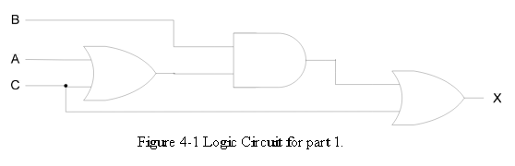

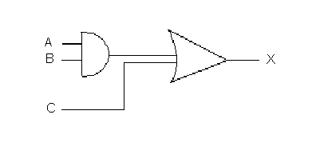

Figure 4-2 Logic Circuit part 1
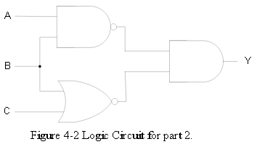

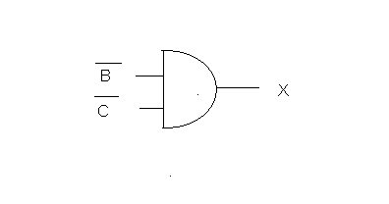
Figure 4-2 Logic Circuit part 2

Va (volt) | Vb (volt) | Vc (volt) | A | B | C | X | Vx (volt)
0 | 0 | 0 | 0 | 0 | 0 | 0 | .41
0 | 0 | 5.06 | 0 | 0 | 1 | 1 | 3.48
0 | 5.06 | 0 | 0 | 1 | 0 | 0 | 0.41
0 | 5.06 | 5.06 | 0 | 1 | 1 | 1 | 3.48
5.06 | 0 | 0 | 1 | 0 | 0 | 0 | .41
5.06 | 0 | 5.06 | 1 | 0 | 1 | 1 | 3.47
5.06 | 5.06 | 0 | 1 | 1 | 0 | 1 | 3.48
5.06 | 5.06 | 5.06 | 1 | 1 | 1 | 1 | 3.48
Table 4-1 Truth table and volts measured for input/output for Figure 4-1

A | B | C | AB | AB + C
0 | 0 | 0 | 0 | 0
0 | 0 | 1 | 0 | 1
0 | 1 | 0 | 0 | 0
0 | 1 | 1 | 0 | 1
1 | 0 | 0 | 0 | 0
1 | 0 | 1 | 0 | 1
1 | 1 | 0 | 1 | 1
1 | 1 | 1 | 1 | 1
Table 4-2 Simplified

Va (volt) | Vb (volt) | Vc (volt) | A | B | C | X | Vx (volt)
0 | 0 | 0 | 0 | 0 | 0 | 0 | .41
0 | 0 | 5.06 | 0 | 0 | 1 | 1 | 3.48
0 | 5.06 | 0 | 0 | 1 | 0 | 0 | 0.41
0 | 5.06 | 5.06 | 0 | 1 | 1 | 1 | 3.48
5.06 | 0 | 0 | 1 | 0 | 0 | 0 | .41
5.06 | 0 | 5.06 | 1 | 0 | 1 | 1 | 3.47
5.06 | 5.06 | 0 | 1 | 1 | 0 | 1 | 3.48
5.06 | 5.06 | 5.06 | 1 | 1 | 1 | 1 | 3.48
Table 4-2 Input/output for simplified 4-1

A | B | C | x | y
0 | 0 | 0 | 0 | 0
0 | 0 | 1 | 1 | 1
0 | 1 | 0 | 0 | 0
0 | 1 | 1 | 1 | 1
1 | 0 | 0 | 0 | 0
1 | 0 | 1 | 1 | 1
1 | 1 | 0 | 1 | 1
1 | 1 | 1 | 1 | 1
Comparison table

Va (volt) | Vb (volt) | Vc (volt) | A | B | C | X | Vx (volt)
0 | 0 | 0 | 0 | 0 | 0 | 1 | 3.43
0 | 0 | 5.06 | 0 | 0 | 1 | 0 | .50
0 | 5.06 | 0 | 0 | 1 | 0 | 0 | .50
0 | 5.06 | 5.06 | 0 | 1 | 1 | 0 | .50
5.06 | 0 | 0 | 1 | 0 | 0 | 1 | 3.43
5.06 | 0 | 5.06 | 1 | 0 | 1 | 0 | .50
5.06 | 5.06 | 0 | 1 | 1 | 0 | 0 | .50
5.06 | 5.06 | 5.06 | 1 | 1 | 1 | 0 | .50
Table 4-3 Truth table and volts measured for input/output for Figure 4-2

Vb not(volt) | Vc not (volt) | B not | C not | X | Vx (volt)
5.06 | 5.06 | 1 | 1 | 1 | 3.44
5.06 | 0 | 1 | 0 | 0 | .50
0 | 5.06 | 0 | 1 | 0 | .50
0 | 0 | 0 | 0 | 0 | .50
4-4

A | B | C | x | y
0 | 0 | 0 | 1 | 1
0 | 0 | 1 | 0 | 0
0 | 1 | 0 | 0 | 0
0 | 1 | 1 | 0 | 0

4-4 compare

Question:
- Why is Boolean algebra used for combinational Logic circuits?
- To reduce a given expression to a simplified form, so that the number of gates are minimized to as far as possible to produce the same output
- What are three laws for Boolean algebra?
- A + 1 = 1
- A + 0 = A
- (A)(0)= 0
- Why is DeMorgan’s theorem important in the simplification of Boolean equation?
- DeMorgan's theorem may be thought of in terms of breaking a long bar symbol. When a long bar is broken, the operation directly underneath the break changes from addition to multiplication, or vice versa, and the broken bar pieces remain over the individual variables.
- Using DeMorgan’s theorem, you can prove that a NAND gate Is equivalent to an OR gate with inverted inputs
- Using DeMorgan’s theorem, you can prove that a NOR gate Is equivalent to an AND gate with inverted inputs

Conclusion:
In conclusion, in many applications of Boolean algebra, you have to reduce a particular expression to its simplest from or change its form to a more convenient one to implement the expression most efficiently. The approach taken in the lab is to use the basic laws, rules, DeMorgan’s theorems of Boolean algebra to manipulate and simplify an expression. The basic rules and laws of both Boolean algebra and Demorgan’s theorem are used to reduce a given expression to a simplified form so that the number of gates are minimized to as far as possible to produce the same output. In my experiment, the voltage measurements were all between the 5 and 0 volt threshold.

