Experiment: #2:


Basic Logic Gates

Marlon Myers
Digital Control
EMT1250
Professor: Prof. Patrick

Table of Contents:

Objective | 3
Equipment | 3
Discussion | 3
Schematic | 4
Questions | 6
Charts | 8
Conclusion | 10

Objective:
To investigate the operation of the NOT, OR and AND Gates.

Equipment:
- Equipment/Parts Needed:
- 5V DC Power Supply
- Digital Trainer (Logic Probe)
- Breadboard
- DIP Switch
- 7404
- 7408
- 7432

Discussion:
- NOT, OR and AND gates are the basic logic gates. All other logic functions can be derived from these three.

- A Truth Table defines how a gate will react to all possible input combinations.

- A Logic Probe is a piece of test equipment which displays the logic level at a point in the circuit. 0 to 0.8V = Logic 0 and lights the L indicator. 2.0V to 5.0V = Logic 1 and lights the H indicator. Invalid logic voltage levels light either indicator.

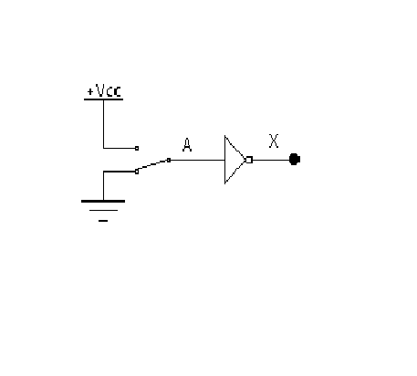
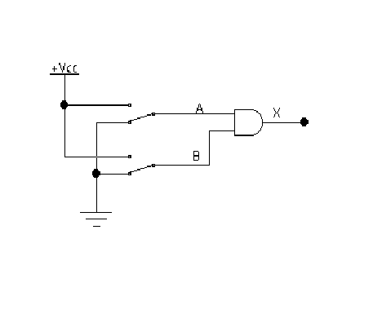
Schematics:

Figure 2-1 Schematic for Not Gate
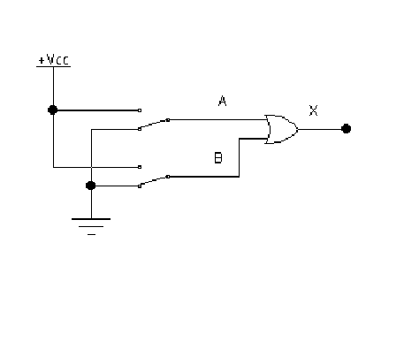

Figure 2-2 Schematic for Or Gate

Figure 2-3 Schematic for Or Gate

Questions:
- What are the Boolean expression for the Not, OR and gates?
Ans: AND = (x = AB)
OR = (x = A + B)
Not = (x = A)

- Under what input conditions is the output of a 2 input OR gate LOW? Under what input conditions is the output of a 2 input AND gate High?
Ans: a) When both inputs are low, or gate is low
b) When both inputs are high, and gate is high

- We are given a 3 input AND gate and want to use it as a 2 input AND gate. Two inputs to the AND gate are connected to the two signals. How would you connect the third gate input?
Ans: Connect third to VCC

- If one input to a 3 input OR gate were accidentally connected to VCC (shorted to VCC), how would the output of the OR gate react no matter the other 2 input levels might be?
Ans: High

- If one input to a 3 input AND gate were accidentally connected to Ground (shorted to Ground), how would the output of the AND gate react no matter the other 2 input levels might be?
Ans: Low

Chart:
Truth Table
A | X | A(volt) | X(volt)
0 | 1 | 0 | 3.47
1 | 0 | 5.5 | 0.39

Figure 2-1 Schematic for Not Gate

Truth Table |  |  | Volts Measured
A | B | X | A(volt) | B (volts) | X(volt)
0 | 0 | 0 | 0 | 0 | 0.44
0 | 1 | 1 | 0 | 5.06 | 3.46
1 | 0 | 1 | 5.06 | 0 | 3.46
1 | 1 | 1 | 5.06 | 5.06 | 3.46

Figure 2-2 Schematic for Or Gate

Truth Table |  |  | Volts Measured
A | B | X | A(volt) | B (volts) | X(volt)
0 | 0 | 0 | 0 | 0 | 0.49
0 | 1 | 0 | 0 | 5.06 | 0.49
1 | 0 | 0 | 5.06 | 0 | 0.49
1 | 1 | 1 | 5.06 | 5.06 | 3.22

Figure 2-3 Schematic for Or Gate

