Larry Molina
Arch 2480
Prof. Mishara

Heavy Timber

Heavy Timber: A type of construction requiring noncombustible exterior walls with a minimal fire-resistance rating of two hours, solid or laminated interior members, and heavy plank or laminated wood floors and roofs.
Source : http://www.dictionaryofconstruction.com/definition/heavy-timber.html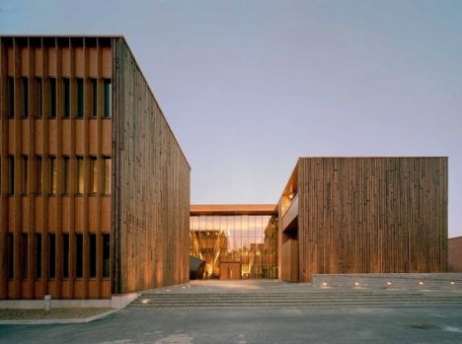
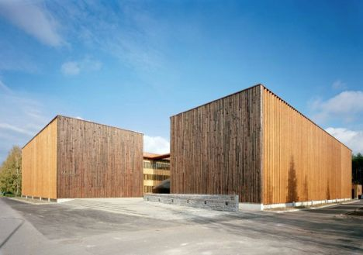

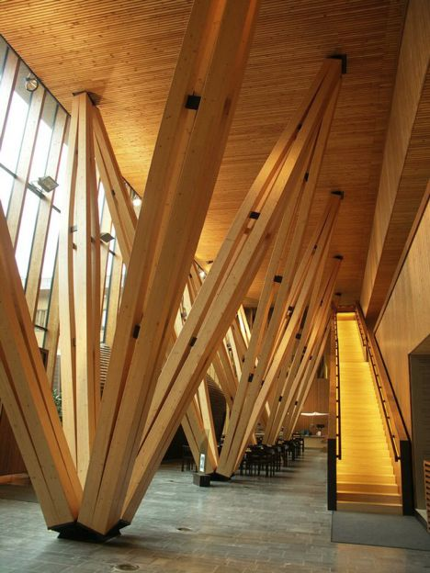

Architects: SARC Architects
Location: Joensuu, Finland
Building Owner: Senaatti-kiinteistöt
User: The Finnish Forest Research Institute, Joensuu Forest Research Institute
Building consultant: ISS Proko Oy (Engel Rakennuttamispalvelut Oy)
Constructed Area: 7,650 sqm
Project Year: 2004
Photographs: SARC Architects
Source: http://www.archdaily.com/15951/metla-forest-research-centre-sarc-architects/

