Visual merchandising Term Paper

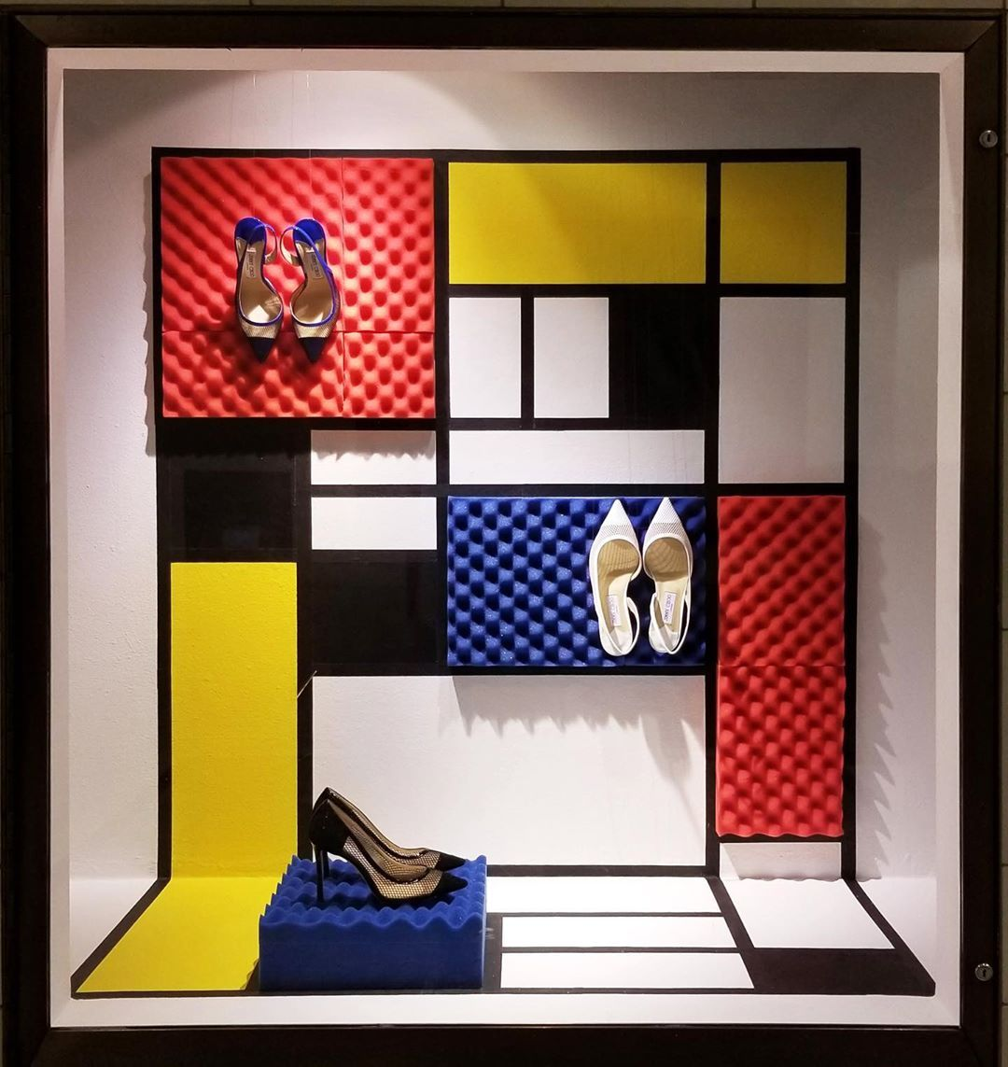

Miriam Martinez Lima

Professor Robert woods

12/1/2020

Table of contents

table of contents 1

About the author2

visual merchandising term paper

Exterior windows3-11

interior windows12-19

Works cited 20

cover letter21

JOB LISTING22

RESUME23

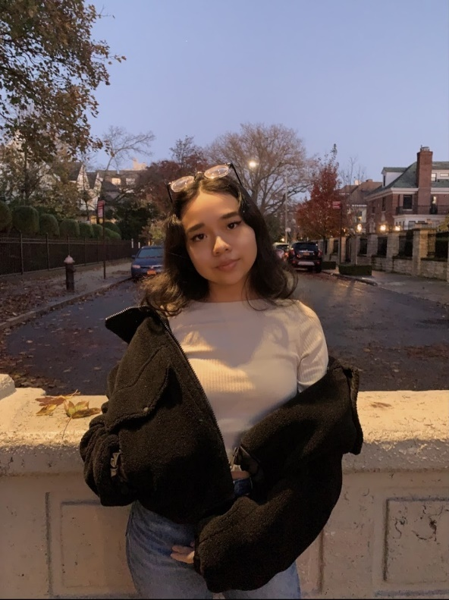

**About the author:**

My name is Miriam Martinez Lima and, in this world, filled with many wonderful distractions, fashion is one of my favorites. Fashion allows people to express themselves creatively and be themselves. Fashion is not just about clothing there is more to it than that. There is a world of textiles that allows you to use your imagination, your touch and create something astonishing for your next successful project.

Sewing is one of my favorite things to do. When I am not sewing or sketching, I am always on the lookout for the latest trends. Looking through Pinterest or scrolling on Instagram is something that I do often and in many times I’m on the profiles of major fashion influencer companies like Vogue, Fashion icons like Harry styles, Beyonce, Zendaya and many more. Fashion icons like Harry styles and Zendaya teach us a lot of things and that is to be yourself, and to create your own image , disregarding what other tell you to wear because fashion and clothing is for everyone. I create my own style and try to make own style unique through the way I present myself. One being the way I dress , now a days many people care of having the most on trend shoes and the most expensive brand of clothing and then they would say they are fashionable and stylish. The way I see fashion is creating a style unique to you wearing and creating clothing that may be out of your comfort zone. The fashion industry is filled with many opportunities and once I graduate, I hope to make an impact on it.

In visual merchandising there is a lot of things that go into consideration when brainstorming and building a successful display. Whether it be the shape of the props, the fixtures, lighting they all tie together into creating a successful visual merchandising display.

Many factors are taken into consideration when creating a display that would create the most profit to a business. Factors that are taken into consideration when creating a display includes selecting the best source of the lighting that would best suit the display. Many times, the colors in a display can either make or break it. The way a display is set up can either catch the attention of a customer or may cause you to lose a customer. Therefore, it is important to follow the basic components of visual merchandising.

Traditional outside window or main mall entrance windows from a department store or large specialty store

Figure :Bloomingdale's display Located in New York City

The visual merchandising display as shown on Figure 1 has numerous factors and key elements in its display that allows for it to not only look pretty, but to also generate sales. This visual merchandising display from the department store Bloomingdales tells us a lot just by glancing over. Your eye is automatically caught by the bright neon colors of display. Now that this display has caught the attention of an onlooker they would stop and check out the display. There is a lot of things to look at on this display you can either look at the mannequins sitting in the spherical chairs or you can look at the merchandise displayed in the snow globe like display.

Something that makes this display successful is the lighting. The lighting of this display is well lit. This display includes LED lighting which we can clearly see everything that is displayed. A well-lit display makes it easier for a person looking at the display to see in detail the items.

Lighting plays a key role, and in this display, we see that in each of the spheres includes a blueish spotlight making the merchandise that is inside pop out. For example, we can clearly see the pink and orange bag in the upper left corner. In the display we see the background of the display lit with purple, pink and a hint of green and orange.

The window shown is a traditional rectangular window and with a window like this putting rectangular fixtures and displays would cause the window to feel dull. This window tells us a lot about what the store has to offer the lighting and the way that these items are displayed tells us that it is store of luxury. The way that the items are encased in the globes tells us that these items are luxurious. The display isn’t overcrowded which by looking at this display you can already tell that the inside of the store is the same clean and organized store, These factors allow for a customer to be drawn to the display and find something the like and go into the store and purchase something which is the purpose of this display.

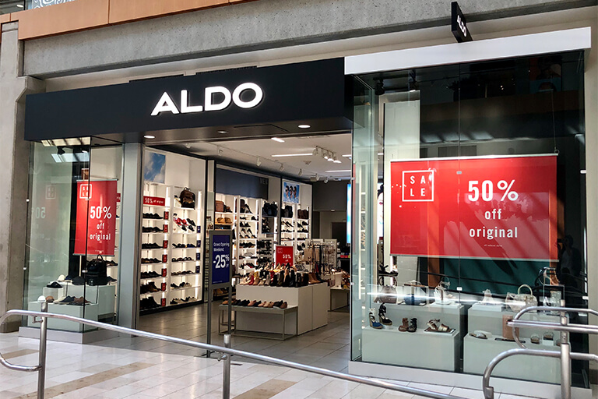

Figure 2:ALDO store located in Kings Plaza Mall New York

Display from a chain or small fashion specialty store.

Visual merchandising is a key element to derive sales to a store and a company and one way that many visual merchandisers do this is through signage. In figure 2, we see a display in which signage is one of the most eye-catching components of the display. Being that once you walk by the sign is a bright red color indicating that there is a sale going on This display is from a store that mainly sells shoes and accessories and footwear. The display windows are an arcade style window with and an open back to see some of the merchandise inside. This window was meant to inform the onlooker of a sale of 50 percent of all the items. Each sign placed on each side of the window was an appropriate sign size and appropriately centered in the windows.

Whilst the purpose of this window was meant to draw customers into the store and look at what they have to offer, you can clearly see some of the merchandise and shoes on display. Underneath the sign there is a shoe display, the shoes on display are properly demonstrated since in the back you can see some of the shoes are presented on clear plastic risers to give the customers an clear display of what they are looking at. The shoes on the windows were organized by women’s shoes and accessories on the right window and men’s shoes and accessories on the smaller left window. By the way that they decided to showcase their items on the window already tells us a lot that they have a larger shoe selection for women than they do for men. If a male customer was walking by and the first thing they see is the window on the left they would automatically see that they only have a selection of shoes for women.Therefore, I would suggest placing shoes for both men and women on both windows. Overall, this display has a high selling potential due to the main reason which is to draw customers to make a purchase because of the sale going on.

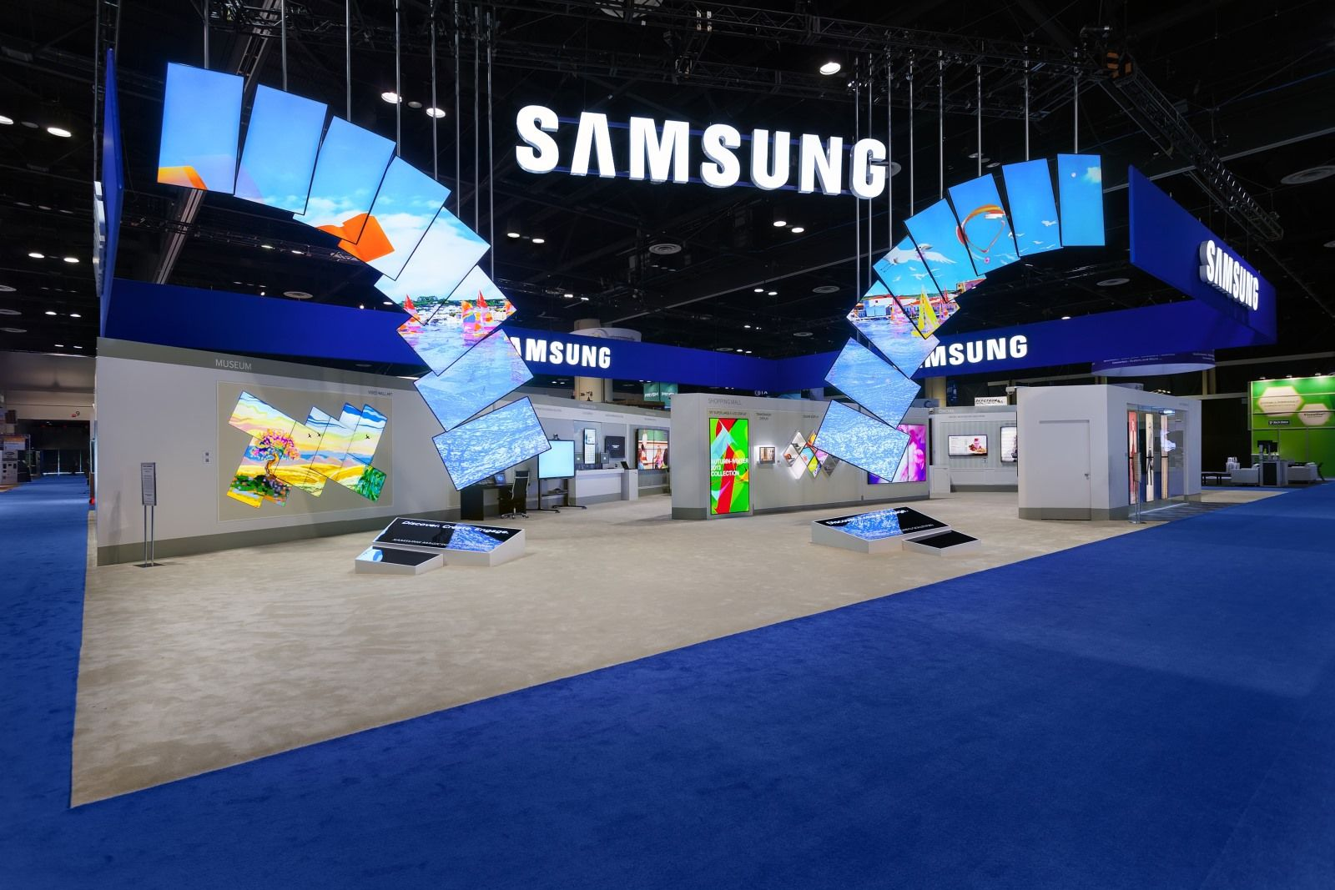

Figure 3:Samsung tradeshow booth

Display from an appliance or electronics store

Lighting, shapes, and Thinking outside of the box are some of the most successful tools when creating a successful visual merchandising display. As shown in figure 3, displaying electronics in a way that does not look like every appliance store that has a television mounted on a white surface with other televisions surrounded by it is hard.

The purpose of an electronic store is for you to walk in and be able to purchase a television that would best fit you home. This display makes best use of shapes and angles. For example, the televisions are displayed to show that they are descending towards the ground. This display makes it easier for customers standing from any location to be able to see the television. Whether you are tall or short you can see it any eyelevel. Displaying an appliance is not about how it looks but more so about the quality of the item. Therefore, it is important for a visual merchandiser to place the item at eyelevel. Making it easier for a customer to determine whether the quality of the item is good or not, allows for the customer to easily make a purchase. This display also tells us more information about the appliance itself. For example, the television is placed at slight angles therefore telling us that the television display looks crisp and clear at any angle you place it.

Also, the colors surrounding the television do not draw the attention out towards other items that are not for sale. For example, the LED Samsung logo is placed in the middle informing us that, that is the name of the company. Also surrounded is a blue strip with the Samsung logo surrounded automatically know what store they are walking into. This open layout store allows for people walking by to come into the store and walk around freely automatically know what store they are walking into. The lighting and the layout in the display of this Samsung store creates for a much certain sale since this display is accessible to everybody

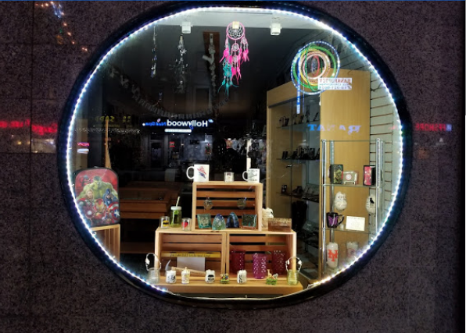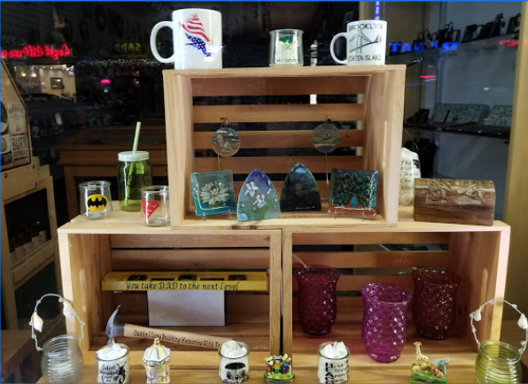

Figure 4:Things on Third located in Brooklyn, New York

Another factor that visual merchandisers take into consideration when it comes to creating a successful visual merchandising display is balance and symmetry. As shown in figure 4, balance is something that this display lacks.

Overall, looking at the display my eye is naturally drawn to the fixture in which the merchandise is displayed on. Which in this case is not-for-sale the thing that is being sold are the items on the display which includes the cups and mugs. This display lacks balance. There is some balance on the display but if you look straight in the middle it lacks symmetry there is one mug that is bigger than the other. On the lower right of the display there is three purple glass cups all the same color, but since the display is poorly lit the cups in the back look like as if they were darker purple color. There is a lot of things that this display is missing. For a person walking by it very difficult to see what they are selling since the objects on the display are so small. This display is not at all proportionate. The color scheme shown is not clear. The arrangement of the merchandise is very awkward and unbalanced.

The best solution into making this display work would be to display the items in a tall glass showcase fixture and inside the fixture there is individual spotlight lighting in which you would be able to see every item in detail and their true colors. In this glass showcase it would be easier to organize the items by categories under which they fall under, including glassware, glass artwork, and ceramics.

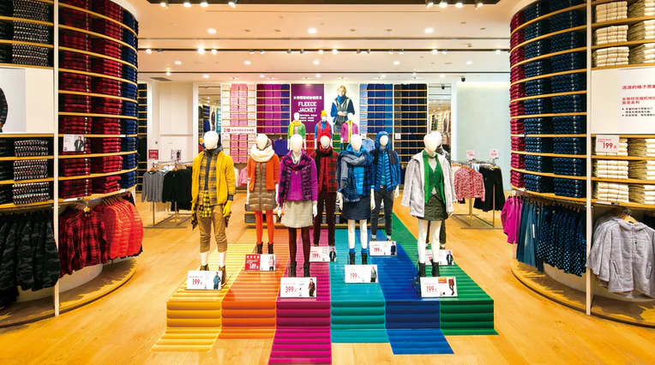

Figure 5:Uniqlo display located in Shanghai, China

Fashion display with mannequin

Mannequins are often used to make it easier for a customer to see how an article of clothing looks whilst on the body. This mannequin display is staggered in a way that you can see all the pieces no matter in which direction you ae walking from. This display include color that are for everyone no matter whether you like more muted color or like bright colors.

The color coordination of this display was more focused on bright reds, oranges, yellows, greens, blues, and violets as well as some neutral colors in the display. Not every single customer is comfortable wearing bright colors. For example, on the mannequin with the bright yellow you can find some beige pants, as well as on the mannequin all the way on the right wearing a green shirt you can find the mannequin wearing a green shirt that was combined by a grey jacket . This display is a proper example of how natural colors can be combined with a bright color group.

The mannequins used in this display can be used during anytime and the since the displayed shown are all the same shape and sizes customers of any gender are able to see that the article of clothing adheres to everyone’s gender. The white color of the mannequins also creates a contrast between the article of clothing and makes them stand out drawing the attention to the pieces rather than the mannequin itself

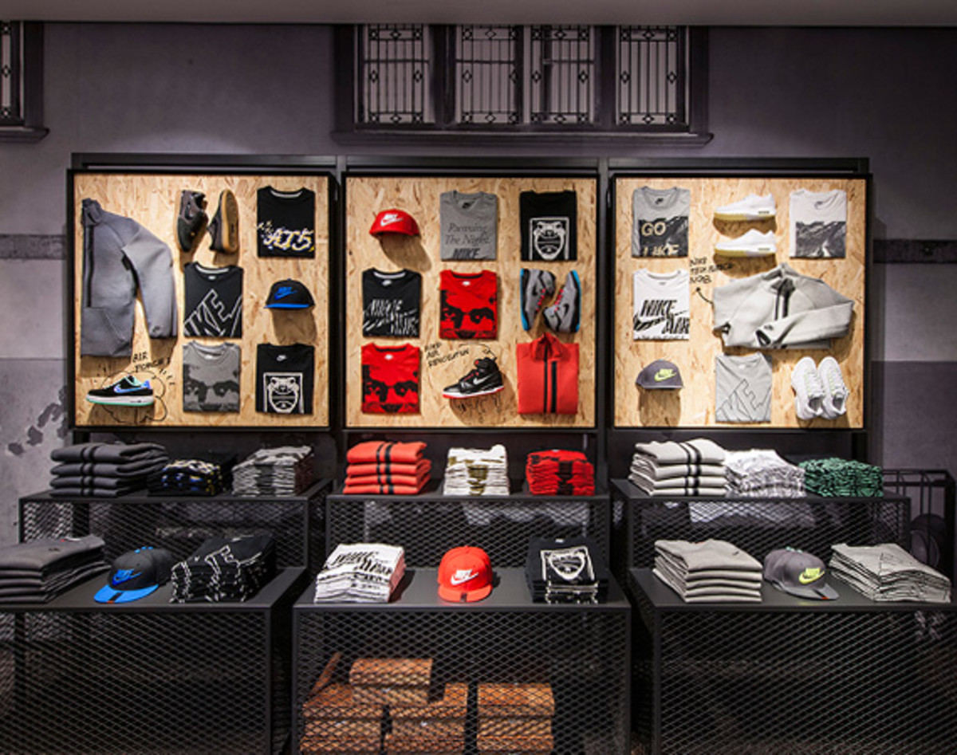

Figure 6:Nike Kicks Lounge located in Shanghai, China

Fashion display without mannequin

Displaying clothing without a mannequin is difficult because it is harder to show the full article of clothing. The display shown in Figure 6 does a good job displaying the most important piece of the item. For example, on the left we see a sweatshirt displayed you do not need to necessarily display the whole item because the other side of the piece is symmetrical. You can also pick up the item on the display. Also, the way that the t-shirt was displayed was creative instead of displaying the whole shirt you see the most noticeable print on the shirt.

The light and the colors of the display creates a high selling point for this brand. This display includes neutrals with a hint of bright colors. This display is balanced when looking at and has unity. The display is balanced being that there are three boards in which the merchandise is displayed on. The middle of the display contains a bright red colored shirts and sweaters. And the display on the left and the right are mainly neutral colors including grey and black. If we were to place the display with the red items all the way on the left the display would seem unbalanced and attracting the customer and the eye only towards the left side of the display. The spotlight lighting of this display draws the attention towards the items on display which can be visible from a far; allowing you to go over and take a closer view of the items displayed. This display has high selling potential since it’s a creative way of displaying items without the use of a mannequin.

Figure 7:Kit Kat display located in supermarket

End of aisle supermarket display

At the end of a supermarket aisle you may stumble upon a display that only contains one single item.

For example, in figure 7, we see the display of this kit kat. The display has many factors allows it to have high selling potential. One being the creativity and the uniqueness of the display. This display is unique because it showcases the item in a larger scale. The kit-Kat bar is enlarged to show the customers on how it looks like. Another thing that makes this display successful is the color scheme. The display isn’t all over the place with the colors and draws the attention to product. The display main color focus only being red tells us that the product is associated with the color red. The display also contains shelfs of multiple levels allowing for anyone of any height to easily pickup up the item and purchase it.

The kit kat prop is placed in the middle allowing for it to be balanced and serving as a divider for the items on the shelf. The kit kat bars on the shelf are displayed at angle for customers to be able to see how they look like without having to pick it up. This display is very likely to have customers to purchase a kit kat. One being because the bright red color draw attention to the display, another reason is because the display contains a prop that is used to enhance the item being sold.

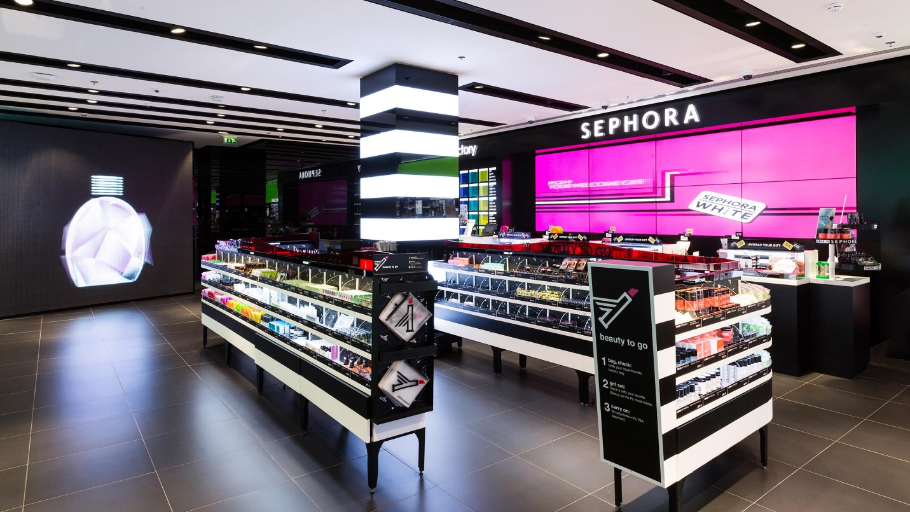

Figure 8: Interior of Sephora store, located in Brooklyn, New York

Point of purchase impulse display

Reaching the end of your shopping experiences waiting in line to finish up your transactions can be one of the most time-consuming parts. Therefore, many businesses have designed their stores to include Point of purchase impulse displays. These displays are meant for a customer to be able to continue to shop while waiting in line as well as impulsively purchasing something.

As shown in figure 8, this Sephora fixture is designed for you to walkthrough a great deal merchandise while you are waiting to finalize your purchases. The display contains merchandise that are clearly visible and easy for you to pick up. The items are organized in clear bin containers for you to easily see from a distance. No matter where in line you are standing you will be surrounded by products. You can clearly see the products and is not difficult to determine what the items are. This display is also well organized something that a customer is more prone to look at and appealing to the eye. A well organized and clean display allows for customers to also think that the products are clean and fresh.

The design and color of the display is something that makes display work. The display is primarily white and black color that don’t draw the attention out of the items displayed. There is also LED lights included on the display that are placed on the lower two level of the display so you would also be able to see the item clearly. This point of purchase display is very likely to make a sale since the design is unique and organized.

It is important to take into consideration all of the factors when it comes to creating a visual merchandisng display.Signage,lighting, colors and shapes on a visual merchandising display can allow for onlookers to step into the store and make a purchase. Therefore it is imporant for visual merchandise to carefully plan out what they would like the main the purpose and reason of the display.

Works cited

Bell, Judith A. *Silent Selling: Best Practices and Effective Strategies in Visual Merchandising*. New York: Fairchild Publications, 2001.

[Figure 1] Morton, C. (2020, June 15). The Best Christmas Window Displays Around the World. Retrieved December 02, 2020, from <https://www.cntraveler.com/galleries/2015-12-03/the-10-best-holiday-window-displays-in-the-world>

[Figure 2] Aldo Shoes. (2020, July 7). The Bellevue Collection. <https://bellevuecollection.com/tenant/aldo-shoes/#/>

[Figure 3]“Pin by Fern Expo on Booths, Graphics, Exhibits: Tradeshow Booth, Digital Signage Solutions, Booth Design.” *Pinterest*, 3 May 2020, [www.pinterest.com/pin/206250857911646733](http://www.pinterest.com/pin/206250857911646733)

[Figure 4] *Things on Third - Bay Ridge - Brooklyn, NY*. (n.d.). Yelp. https://www.yelp.com/biz/things-on-third-brooklyn-2

[Figure 5] Reuters. (2020, March 25). *Uniqlo Reopens Stores in China After Coronavirus Outbreak*. The Business of Fashion. <https://www.businessoffashion.com/articles/retail/uniqlo-reopens-stores-in-china-after-coronavirus-outbreak>

[Figure 6:Nike kicks lounge Shanghai China]. (n.d.). Retrieved from <https://www.freshnessmag.com/2013/11/05/nike-kicks-lounge-shanghai-china/>

[Figure 7] Sevren, S. (n.d.). *Stores {P.O.P} | Supermarket display, Point of purchase, Supermarket design*. Pinterest. https://www.pinterest.com/pin/367887863284994367

[Figure 8] Keyes, M. (2016, December 4). Pure Sephora: the cult beauty store. Style | The Sunday Times. https://www.thetimes.co.uk/article/pure-sephoria-the-cult-beauty-store-xxj

|  |
| --- |
| 7408 3rd Ave  Brooklyn, New York 11209  (347)-356-0995  miriammartinezlima@gmail.com |
| **Miriam**  **Martinez Lima** |
| Victoria's Secret  New York, NY |
| Dear Victoria’s secret,  I am writing in interest of this wonderful design internship with Victoria’s secret. The fashion industry is filled with many opportunities for people to learn and grow, just like this one! Growing up I always had a passion for fashion. I am always on the lookout for the latest trends and always pay close attention to every detail that many of fashion icons are wearing. When I am not social media looking for the latest trends, I am sketching something for my next sewing project. I am currently a student at New York city of technology working towards my Bachelor’s in business and Technology of fashion. With my skills in photoshop and my knowledge in design and fashion concepts, I feel as if I would be a great candidate for this internship. Thank you for taking the time to consider me for this internship. You are welcome to reach me anytime during the week either through phone or email. I hope to hear from you soon!  Sincerely, Miriam Martinez Lima |

Summer 2021 Design Internship with Victoria's Secret, Beauty, and PINK

Victoria's Secret

New York, NY

Full-time

Description

GENERAL SUMMARY:

Victoria’s Secret, Beauty, and PINK are looking for a summer intern to support the Design team! As an intern, you will work closely with direct managers who give guidance and provide learning opportunities to develop key skills needed to be successful within Design.

Principle Responsibilities

• Assist in the creation of brand-right, commercial packaging/bottle/label designs that reflect the conceptual direction and business strategy

• Be an idea generator, presenting multiple designs to the creative team

• Log all samples as they come in and maintain sample storage

• Work with Photoshop and InDesign to assist with seasonal concepts

• Assist with building concept and mood boards

• Identify and present current consumer, cultural and fashion/beauty trends

• Support the Design team during the product development process

• Attend key meetings to understand the creative process of developing product

• Conduct research on fashion trends/competitive intelligence and report back to designers

• Assist with the preparation of presentation concept boards and tableaus

• Assist with organizing design archives

QUALIFICATIONS/CAPABILITIES:

• Working towards a bachelor’s degree with an academic focus on any of the following: Fashion Design and/or FMM Product Development; Fine Arts; Graphic Design, Fabric Styling; Textile Design; Packaging Design; Color and Print Design

• Demonstrate passion for retail and the beauty industry

• Embrace collaborative and inclusive environments

• Have high energy, be self-motivated, and can handle multiple tasks

• Possess strong Photoshop, InDesign, and Illustrator skills

• Possess excellent attention to detail, strong communication and organizational skills

• Demonstrate leadership skills and relationship-building aptitude

An equal opportunity employer, we do not discriminate in hiring or terms and conditions of employment because of an individual's race, color, religion, gender, gender identity, national origin, citizenship, age, disability, sexual orientation, marital status or any other protected category recognized by state, federal or local laws. We only hire individuals authorized for employment in the United States.

Category: Internship

|  |  |  |  |  |
| --- | --- | --- | --- | --- |
| 7408 3rd Ave  Brooklyn, New York  347-356-0995  MiriamMartinezLima@gmail.com | | | | |
| **Miriam**  **Martinez Lima** | | | | |
|  | | | | |
| **Fab scrap Volunteer** | | **Social Media Marketing Manager** | |
| Fab scrap  2018 - Current |  | Envy Advertising  2019- current |  |
| Handling textiles and fabrics organizing and sorting fabrics. Maintained inventory of the fabrics in stock. Assists clients in selecting the right fabrics for their projects. | | Creating and handling social media accounts of clients. Created successful ad campaigns on social media platforms like Instagram and snapchat Used social media as a form of marketing to increase sales  **SKILLS**   * **Photoshop** * **Spanish** * **Fashion Design** * **Bilingual Spanish and English** * **Time management** * **Detail oriented** * **Leadership** | |
| **Bachelor of Business and Technology of Fashion** |
|

New York City college of Technology

Expected graduation 2023