New York City College of Technology
Miriam Martinez- Lima
Final Paper
May 22, 2023
Professor Sutton

Sustainability in the Beauty Industry
The beauty industry plays an important role in shaping society and impacting consumers. Issues within the industry that often go unnoticed and unaddressed, indicating that many companies are not doing enough. An issue that has gone unnoticed is sustainability in industry.
According to Oxford Language sustainability is “the avoidance of the depletion of natural resources in order to maintain an ecological balance. Sustainability is essential to the quality of life. With the many products that are created and consumed in the beauty industry, many brands don't take into account the importance of sustainability.
Unfortunately, there is a limited number of beauty brands that prioritize sustainability.
Such brands are actively including sustainable practices in their operations. Beauty Brands are doing so through their packaging. The way that they formulate products using eco-friendly ingredients, and the creation of cruelty-free products. In addition, they have taken measures to reduce their environmental footprints. There are also few new brands that are proactively addressing sustainability concerns by adopting personalized product approaches, aiming to minimize waste production(Burns, 2023).
Reducing Plastic and reducing waste is an important sustainability practice. In 2021, L’Oréal, utilized approximately 144,430 metric tons of plastic in their packaging materials ...Furthermore, the United States recycles only 4% of its plastic waste (Sangal,2023). Many brands and retailers focus on the recycling component and don’t narrow down on the issues that come through the supply chains, manufacturing and shipping. Issues such as waste and pollution, these issues are caused before they reach the hands of the consumer (Sangal, 2023).

Therefore, it is also important for beauty companies to achieve net zero emissions by 2050 or even earlier , in order to achieve the goal set by the Paris Agreement to limit global warming to 1.5°C. (Shoaib, 2023). Currently there are very few companies making an effort to reduce their greenhouse gas emissions. Like food ,many skincare products have expiration dates. After the expiration dates , skincare products may lose their effectiveness or even cause skin irritation. (Robin, 2022).Which results in the need to dispose of products after products have not been sold or expired. Brands often put a high priority on boosting revenue, resulting in a cycle of overproduction and the eventual release of unsold or out-of-date/discontinued products into the environment.
Sustainability also takes into account the ingredients of a product. There are many products out there in the market, which when discarded are not easily disposed of. Many of the ingredients are not biodegradable. For example glitter, which is popular amongst many makeup products, these microplastics can easily enter the environment. Ingredients currently destroying the coral reefs include Oxybenzone and Octinoxate.( March, 2018). These two ingredients are commonly found in sunscreens , they contribute to coral bleaching which destroys the coral reef. This ingredient is currently banned in Hawaii. Parabens is a chemical that is also found in many beauty products, used to preserve the product. According to the Environmental working group they can cause reproductive issues in animals.(Lallas, 2021).

Sustainability in my Everyday Routine
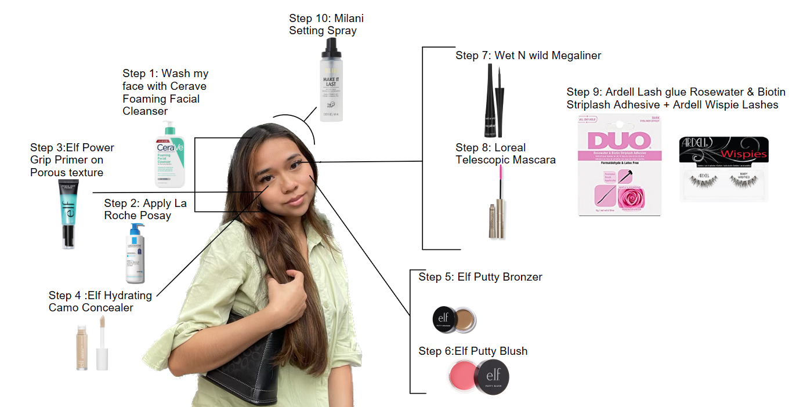
Figure 1: Visual representation of products used.

Researching and learning more in regard to sustainability, made me realize and want to dig deeper. I wanted to learn more about the brands that are put on my face. I explored a few brands which I use daily.
As part of my everyday makeup routine, I start by ensuring my face is clean and fresh.
In order to achieve this I do this by washing my face with the CeraVe Foaming Face Wash.
When it comes to sustainability CeraVe utilizes plastic packaging for their products , which in some areas are not recyclable. The use of non- recyclable plastics can lead to an increase in pollution and waste, affecting the environment. Additionally, the brand uses some ingredients that are considered environmentally controversial such as dimethicone, a common palm oil derivative( Carroll, 2022).
In addition, the brand CeraVe is putting their sustainability concerns in the hands of The L’Oréal Group. In which they stated “the company intends to reach complete carbon neutrality by 2025 and use 100% recycled or bio-based plastics by 2030”. While this demonstrates the brand's intentions and future plans, some may question why immediate action is not being taken. Considering the potential developments and challenges that may arise between now and those target dates, it is reasonable to advocate for proactive measures and the implementation of sustainability practices without delay.
My next step in my makeup routine consists of hydrating my face with Lipikar AP+M Triple Repair Body Moisturizing Cream for Dry Skin. La Roche Posay is a company that falls under L’Oréal as well. Scrolling on their website they too have the same plans when it comes to sustainability. It seems like their company is doing more effort compared to CeraVe by providing customers with more sustainability options, Such as purchasing some of their products in a cardboard tube. Additionally, they are giving consumers the option to purchase 400 ml Lipikar ecological refills. These efforts can be effective by only needing to purchase once and then refilling reducing the amount of plastic used.
The third step in my makeup routine consists of the makeup application itself. I first applied the e.l.f. Power Grip Primer to prime my face, then the e.l.f. Hydrating Camo Concealer to my under eyes. To add some color and tint to my face I then apply the e.l.f. Putty Bronzer and e.l.f. Putty Blush on my cheeks. E.l.f. is one of the brands in which the majority of my products are from. Therefore it is important to find out whether or not it is a brand which I should continue supporting or should switch up their products. According to e.l.f their third party- manufacturing facilities are Fair Trade certified. Fair trade certified means that the products made for ELF were made in a factory with safe working conditions and in a place that keeps the environment protected. In addition, with every purchase from the e.l.f Beauty company, they will make a contribution directly back to the workers who made the product.
The seventh step into my routine includes applying the Wet N Wild Megaliner. According to Wet N Wild cosmetics “wet n wild® NEVER tests on animals. We are proud members of PETA’s “Beauty Without Bunnies” program, which is committed to eradicating animal testing.” Wet N Wild claims to be 100% cruelty free, meaning they do not test on animals as emphasized on their website page. However, they are yet to fully incorporate more environmentally friendly practices to become a more sustainable cosmetic brand. Their lack of incorporation of more sustainable practices could be a result of their being a more affordable drugstore brand. It is also important to note sustainability in the cosmetic industry is still developing, which could be another contributing cause to why they are not yet committed to sustainability.
The eighth step to my routine is applying the L’Oréal telescopic mascara to prep my lashes. The ninth step to my routine is my lashes which are applying Ardell Lash glue Rosewater & Biotin Strip lash Adhesive and the Ardell Wispie lashes. Although some of Ardell’s packaging is not sustainable. The lash company Ardell introduced a new product with the name “eco-lashes”. These new lashes are crafted with sustainable fibers and are available in multiple styles. In addition to the materials used to create the product, its packaging is also eco-friendly, being designed with “biodegradable paper carton and printed with soy ink”, indicating that the lashes' manufacturing process and materials are earth-friendly and less harmful to the environment. . Ardell's Eco-Lashes show the company's dedication to minimizing its environmental impact by using eco-friendly packaging materials and printing techniques in addition to sustainable fibers for the lashes. This strategy enables customers to take advantage of their preferred beauty items while making more responsible decisions. (Mahas,2022)
To keep the makeup from moving around my face , I use the Milani Make It Last Setting Spray Prime + Correct + Set. According to TreeHugger, Milani does not use sustainable materials in their packaging to reduce plastic pollution. The company, however, does not use plastic microbeads in their formulas. Some personal care products include small plastic microbeads, which can contribute to the plastic contamination of rivers. Milani exhibits a commitment to lowering plastic waste and its effects on the environment by refraining from using plastic microbeads ( Young, 2022)
By delving deeper into the brands I use and considering these factors, I can make more conscious choices in my everyday makeup routine. It makes me feel more comfortable knowing that some of the brands that I use are making efforts to help the environment such as joining an organization advocating for sustainability.
Brands Committed to Sustainability
There are a few brands which are committed to sustainability. Those brands include Love Beauty and Planet, ILIA and Function of Beauty,
Love Beauty and planet offer a range of products that are environmentally friendly . They offer shampoos and conditioners made with naturally derived ingredients and are free from parabens, silicones, and dyes. All of the products in which they sell are made of eco-friendly materials and recyclable packaging
The Love beauty and planet monitors and shares data on their greenhouse gas emissions, the waste they produce, and water they consume throughout the creation of their beauty products. These practices allow them to track and decrease their carbon footprint. Through this process they then calculate the amount of greenhouse gas emissions that are produced in which they then charge themselves a Carbon tax. For every carbon ton they produce they must contribute $40 to a carbon tax fund. Which then goes to a third party program that helps reduce carbon emissions and landfill waste. Such practices allow for an effective understanding and their impact on the environment.
By including these measures, Love Beauty and Planet takes responsibility for their environmental impact and actively works towards offsetting their carbon footprint. Love, beauty and planet significantly to the collective efforts aimed at creating a greener, more sustainable future for all. When it comes to makeup , many brands out there mainly focus only on the cruelty free component part. Not taking into account the chemicals that are put into the products nor the impact that they have on the environment. An example of a brand that stands for sustainability is ILIA.
According to Better Goods, there is no such information that their products themselves are sustainable for the environment. There is no evidence of how they are making efforts to reduce their carbon footprint .They do take a stand in helping create a more sustainable environment. The way in which the brand ILIA is taking a stand in sustainability is by working with Pact Collective. The organization helps recycle beauty products properly so that they don’t end up in landfill. They do this through the ILIA website. All you would have to do is provide your address, name and details. They would then provide you with a free prepaid packaging label. With that packaging label you can then send off your 10 makeup products to be recycled. (Better Goods, 2022)
One brand that not only caters to the needs of the consumer, but is also creating sustainable products is Function of Beauty. The Function of beauty allows for you to create and customize your own product. From the bottle to the ingredients the product is customized to your needs. When purchasing from the Function of beauty website you get asked a series of questions in order to create hair products to suit your hair needs. They ask you your natural hair type if you have straight or curly hair, hair structure, scalp moisture, whether your hair has been treated or not , and what are your preferred hair goals. They then ask you what your preferred natural fragrance is whether you would like a fruity, herbal, floral scent or scent free. From there they create a personalized shampoo for you . Customers are more likely to use and value products that are especially created for them, which allows them to reduce waste by developing products that are suited to individual needs.
In addition, according to Function of Beauty their shampoo and conditioner bottles are made of 100% recycled plastic. They have reduced their greenhouse gas emissions by about 44%. That’s an annual reduction of about 43 tons. Having a personalized product can also reduce the tendency to buy items that might not be suitable for your hair, therefore reducing overall consumption and having fewer adverse effects on the environment.
Ways to practice Sustainability.
When purchasing beauty products, it is important to conduct thorough research. It is important to look for beauty brands that comply with the ambition to ensure that their products are sourced and produced sustainably. Therefore, the Responsible Mica Initiative and Roundtable on Sustainable Palm Oil are there to help guarantee that the mica used in their products is ethically obtained. In addition, the palm oil used in many products is responsible and sustainable sources.
Explore brands and products on websites like TreeHugger, which focus on sustainability and provide information about environmentally-friendly and ethical beauty options. These platforms can help you discover brands that align with your sustainability values.
Finding products in Eco-friendly Packaging is also key to sustainability. Look for recyclable, biodegradable, or refillable packaging options. By choosing products with sustainable packaging, it allows you to contribute to reducing the amount of plastic waste that ends up in landfills. Before making a purchase, research the ingredients used in the products. Look for brands that prioritize natural, organic, or cruelty-free ingredients. Avoid harmful chemicals, such as parabens, microplastics and sulfates. Databases which can help provide information on product ingredients and their potential impact on health and the environment. Websites such as INCIDecoder, SkinSort, and SkinCarisma all analyze ingredient lists, which can be helpful when choosing what products to buy. These key points will help in being informed and making responsible decisions when purchasing beauty products.

References
Beauty and the environment: Eco-friendly choices made easier. Harper’s BAZAAR ] (2021, March 12). https://www.harpersbazaar.com/uk/beauty/a19848167/beauty-environmental-impact-sustainability/
Carroll, C. (2022, April 21). Is Cerave cruelty free, vegan, and sustainable?. Treehugger. https://www.treehugger.com/cerave-cruelty-free-vegan-5213848
Frequently asked questions. FAQ’s | Function of Beauty. (n.d.). https://www.functionofbeauty.com/faq/#:~:text=All%20of%20our%20products%20are,%25%20vegan%20and%20cruelty%2Dfree!
How to check the expiration date on your skincare products. BYROE. (n.d.). https://byroe.com/blogs/posts/how-to-check-the-expiration-date-on-your-skincare-products#:~:text=Generally%2C%20most%20skincare%20products%20can,10%2D12%20months%20after%20opening.
The oxford english dictionary: Oxford languages. The Oxford English Dictionary | Oxford Languages. (n.d.). https://languages.oup.com/research/oxford-english-dictionary/
Robin, M. (2022, March 8). Yes, your skin-care products will eventually expire. Allure. https://www.allure.com/story/do-skin-care-products-expire
Sangal, A. (2023, April 6). The $500 billion beauty industry’s “green” ambitions are a patchwork at best. and they’re falling short. CNN. https://www.cnn.com/style/article/beauty-skincare-climate/index.html
These 6 common cosmetic ingredients are harming dolphins, sea otters, and other wildlife. Brightly. (n.d.). https://brightly.eco/blog/cosmetic-ingredients-harmful-environment
TREND HUNTER Inc. (2022, March 2). Sustainable false lashes. TrendHunter.com. https://www.trendhunter.com/trends/eco-lashes
Young, O. (2022, April 28). Is Milani cruelty free, vegan, and sustainable?. Treehugger. https://www.treehugger.com/is-milani-cruelty-free-5248702

