Individual Work
Task: Work individually and share as a class in open lab under inverse functions. (This is part of the project).
Professor Smith is an engineer and I saw him printing something in his 3d printer. I was curious to see what he was doing, and I took the video shown in the previous slide. He printed the solid shown below. He wanted it to cover a whole with dimensions shown in the picture below. He printed it in blue plastic 20% density.
Than he thought that it’s nice to print the cylinder part in steel, because that is the part that shows. The rest he would print in plastic and glue them together.
He checked the steel material available. He realized that he has 30${cm}^{3}$ steel.
- Does he have enough material for the piece?
- If he wants to increase the height (thickness)of the piece, using all the material that he has what would it be?

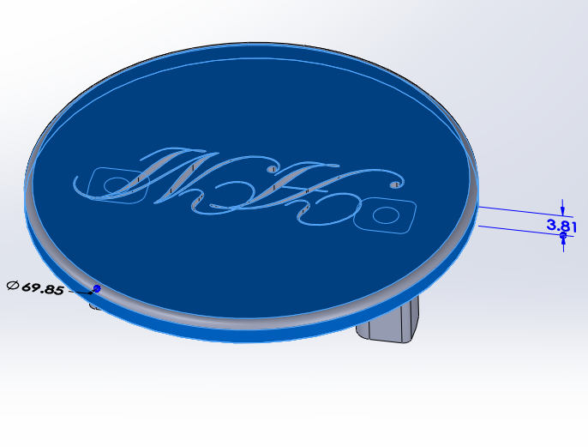 Diameter of the circle: ø =69.85 mm
Hight of the cylinder (Thickness): h=3.81 mm

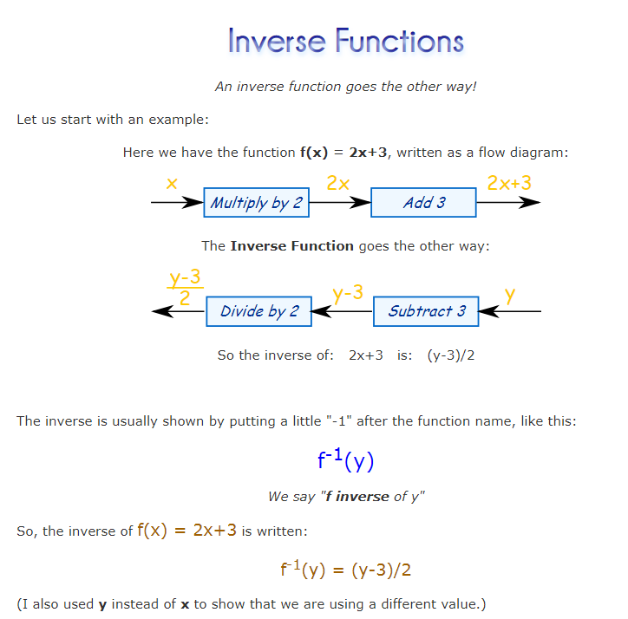
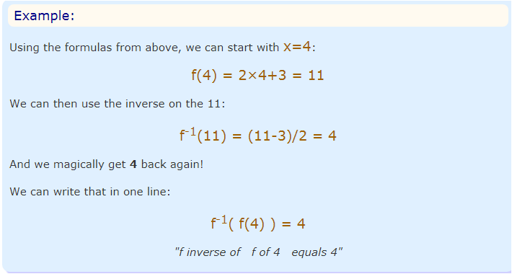
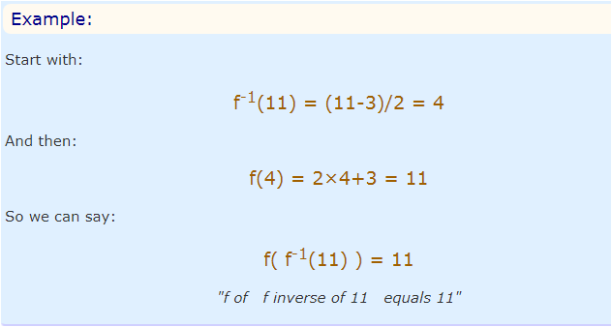
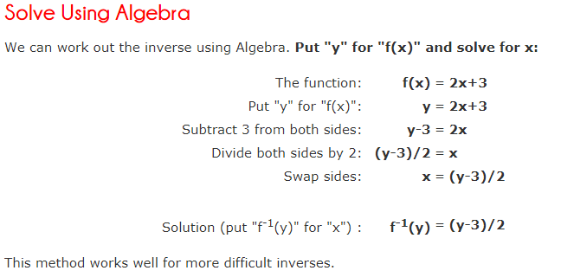
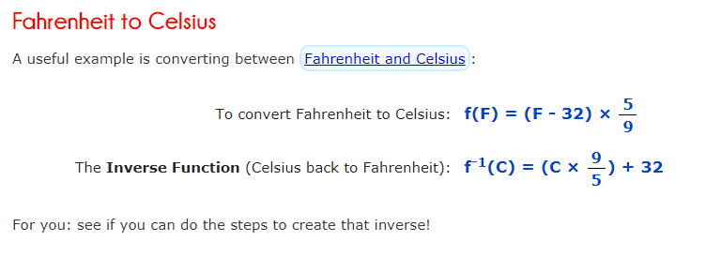
Using the method above solve the problems below:
