Enchanted
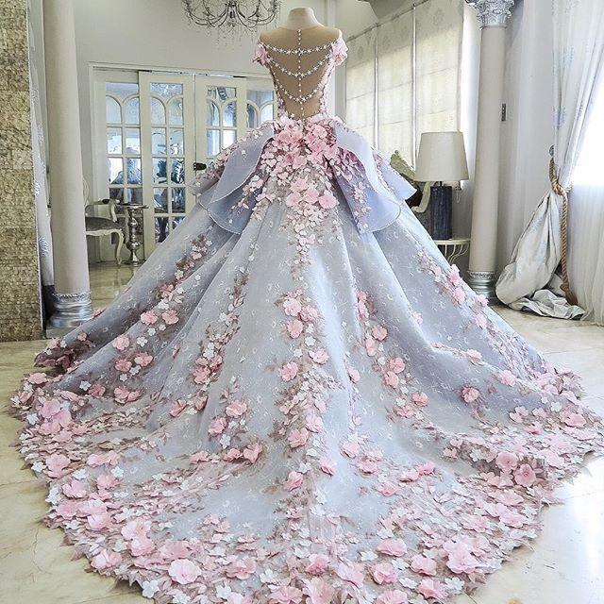
Professor Robert Woods

By: Miranda Hiralall

Table of Contents

Page 1-2-----------------------Letter from Editor----------------------------------

Page 3-----------------------Letter to the Reader------------------------------------

Page 4-----------------------About the Company------------------------------------

Page 5-----------------------Customer Profile----------------------------------------

Page 6-8--------------------Market Segmentation----------------------------------

Page 9-10----------------------------Locations-----------------------------------------

Page 11-15-----------------------Historical Facts-----------------------------------

Page 16-18------------------Evaluation and Inspiration-------------------------

Page 19-21----------------Color Palette and Fabrics-------------------------------

Page 21-22---------------------Generating the forecast-------------------------------

Page 22-26------------------------Fashion Show------------------------------------------

Page 26-35-----------------------Fashion design-------------------------------------------

Page 36-------------------------------Citations---------------------------------------------

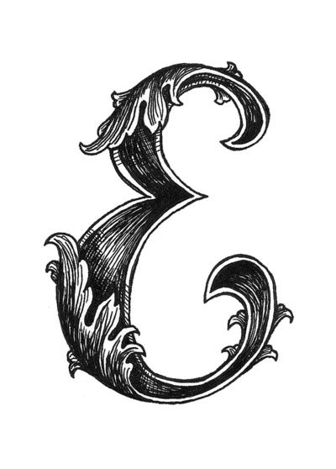
Letter From Editor

Miranda Hiralall

Time
9005 West Big Rock Cove Court
Wallingford, CT 06492
October 17,2018

According to this article “The White Dress That Change Wedding Dress History” it explains the break out of the wedding dress that Queen Victoria accomplished. An explanation on not just a wedding dress but the style, the color and the fabric that impacted the whole situation. The off shoulder white lace ball gown wedding dress. It implies the purity and a sense of sexiness in the details.

This article brought to my attention wedding dress went through a transition through the years. Red was mention to be one of the colors that was used in an wedding dress before the color white came along. Red being a bright color it stood for a scandalous color. White represented everything pure so beginning a new life it just fits perfect.

My opinion with the past wedding dress history I can see the style comes back in the future. Queen Victoria dress has been a long time and designers still use some details from that exact dress to create the present trend. Wedding dress have many styles. A old style of wedding dress is ball gown. It looks like it will become a trend for 2019.

Sincerely

Miranda Hiralall
Enchanted
miranda.hiralall@gmail.com
7187265008

Letter to the reader
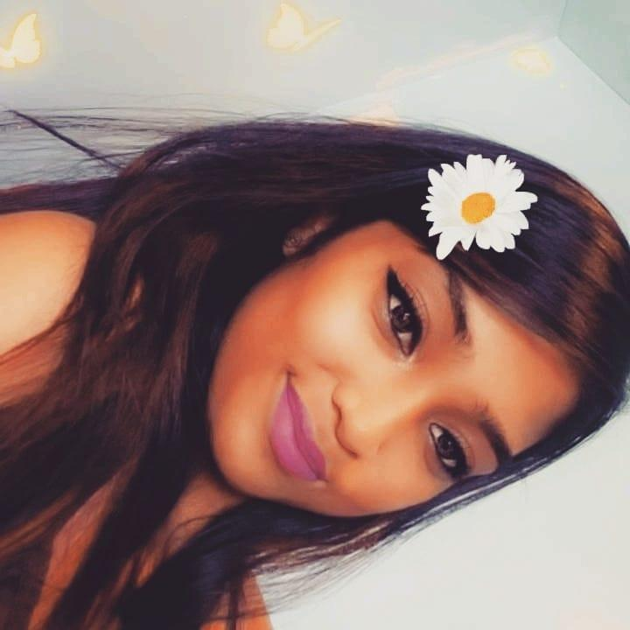
The researcher name is Miranda Hiralall. She is 22 years old . Her major is fashion merchandising. She loves fashion and she will like to spread her passion through her work. She has her associate degree in fashion marketing. Wedding dresses are one of her favorite type of dresses. Every wedding dresses has a different silhouette, neckline and color which gives the dress a magical look. The forecasting has change from the traditional ball gown to a mermaid style but the past always relives in the future. Vera Wang is known for wedding dresses but she is hoping to be way different than Vera Wang.Fashion is a big world and she can’t wait to see what the future holds for her.

About the company
(Enchanted)

This is an company that creates ball gown wedding dresses. These ball gown dresses will not be in the typical colors but will be in more lighter colors such as purple,blue, pink and white. They will be known for their ball gown wedding dresses but will provide other silhouettes. Customers will be able to give their input for any changes to their dresses. This company will be located in a popular city which is New york. We will have face to face meetings with our clients to prepare them for their wedding dress. We want to make sure we give them what they want at all times.
Our logo will be an scripted E with a floral design on the ending and top of the capital E. It will be in an bold black font. Their will be a pink box around it to just create a girly look to it.The wedding dresses will range from 500 dollars to 1,000 dollars. This company is defined by its name itself Enchanted. The gowns are magical and will make you feel beautiful. The Wedding day is an important day so making it magical it will be our number one goal. Another goal for this company is becoming international. Once we become successful we will like open up at least another shop in Florida, Miami.
Customer Profile
The target market are ladies that are in their early 20’s. This company name is Enchanted and it will be known for his name. It is created to make more beauty. She wants to create fairytale ball gowns wedding dresses for young ladies. She want the target market to believe there is a such thing as a magical fairytale and what you put your mind to, it can come true. Just like the designer Marchesa, she want to create the same idea but with wedding dresses.
The target customer usually love to go shopping, into cosmetic and be very artistic. Their education status should be college educated and have a job. This person typically would not have any kids. The social networks would be instagram, pinterest and twitter. The marketing strategy is to create an online store for the wedding dresses. This will also be connected to instagram so people can follow our new styles. Instagram will be a good platform for our customers to tag us in the wedding dresses and would be able to display it to other customers. It will be able to show the fabric, style and the comfortability in the dress. Another good strategy will be to work with other business that can sponsor our company to gain recognition such as caters and photographers.
Market Segmentation

Ladies in the early 20’s of age that are college educated and are self employed is a quality of this dress. They do not have kids and usually live in an single family home. They usually are love couples that are cohabitating with each other. Pets are not in the equation. Ethnicity is going to be diverse from white, black, asian, hispanic and indian. Body types are going to average size and the height can transitions. Variety hair color are preferred.
Their hobbies are into the pop culture, art and outdoor activities such as shopping. Social network is a big impact on the target customers. Vogue would be the most liked websites for these customers. When wearing my product not only it will be affordable but it has great quality for a great price. It will help a lot of ladies feel confident and fell stress free on trying to figure out what they would be wearing for their wedding. It will be easy access since the company will start the brand in New York. We will make appointments with clients for fittings.Enchanted would be able to give great customer services and would have their own assistant to help them with their dream dress.
A concern customer problem may have with the brand Enchanted it will be that it is unfamiliar. Enchanted being an unknown brand it may have an issue with sales so promotion/advertising have to be done right to be able to spread the brand name. Like I said before social media and flyers can help to promote.A customer can referred this brand to another
friend because it is affordable and we have great quality. We also have an customer service 24/7 if anyone has any questions. We want our customers to feel like family, in other words to feel comfortable and be able to let us know how they feel about our dresses.
The best ways to reach the customers will be through instagrams and pinterest.We will have a different promotion on every 2 weeks. A loyal customers will have a variety of coupons in their email. They would also know when new dresses are coming out to recommend it to a friend or family member. Customers love to be helped so everyone will have their own assistant to help them through the wedding dress picking and fitting. A potential change I can make to further my customer interest I can allow customers to customize their own dress. If they also want to customize like small thing such as the embellishment and patterns they can. Their assiant they are assign to will help them out.

According to this graph below the time series of marriage growth has grow from 1970 to 2017. Ages from 21 to 27 the rate of marriages has raised .
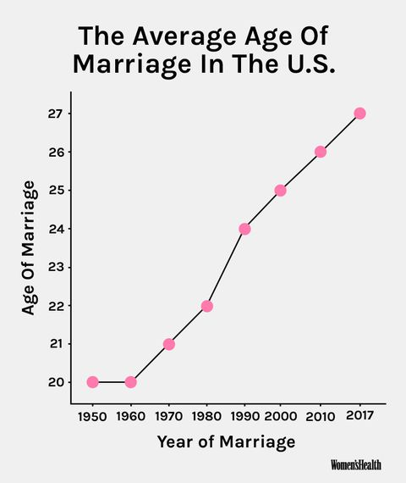
In this next graph it show how many millennials was ready to get married. Majority of them we're confident in what they want to do which shows they are the perfect target market for this company.
Locations:

Enchanted first location will be in New York, Soho. It will be located next to a bakery that makes wedding cakes. On the other side there should be a wine shop so they can do wine tasting. I want this location to be convenient for my customer. Once the customer look up the location I want them to see they can get their fantasy gown, cake and wine. Everything a bride needs which makes the process less stressful. In the picture below you can see I want my colors of my shop to be all neutral colors so when the dress is display it gives an different environment. I want my logo to be above and have the two open windows aside of it. As we go below it has clear windows to show the hottest wedding dress.

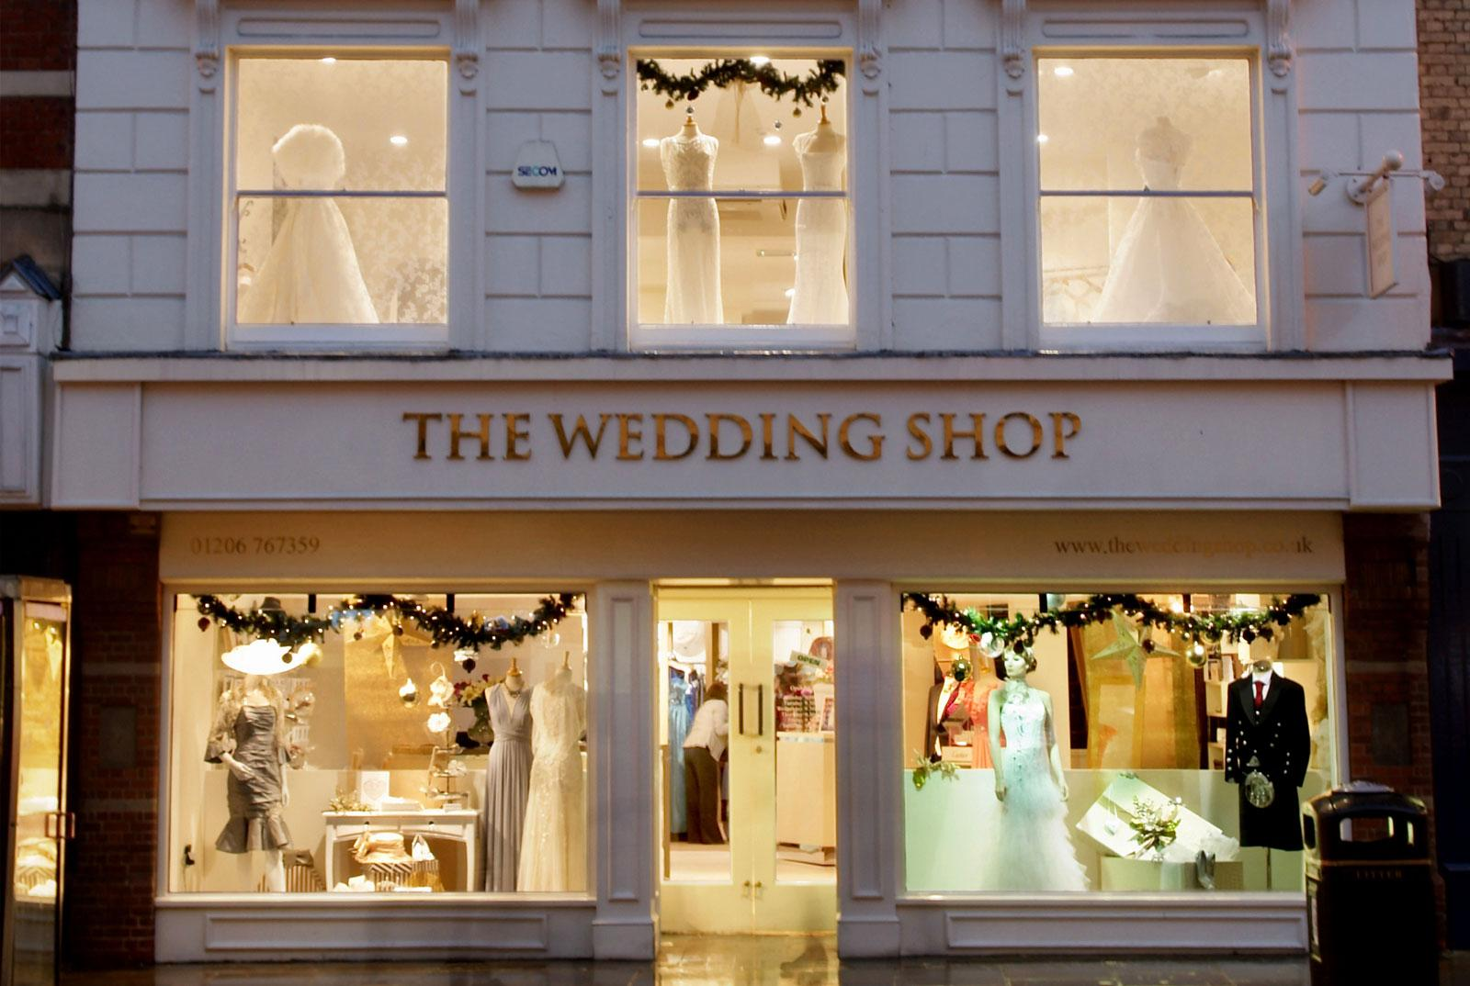
Enchanted
Inside of the location their will be a upstairs and downstairs. The downstair will have their receptionist to make appointments. There will be two mannequins with two upcoming wedding gowns.It will have 2 register and two fitting rooms. The color of the room will be a neutral pink. The store will have an inspiring floral look. Their will be mirrors filled all around the fitting area. The upstairs will have all of the gowns. It will also have mirrors diagonal from each other. To keep the client comfortable we will have rooms that you can have a private time with your family to discuss about your dress. We will also be selling bouquets and headwears.
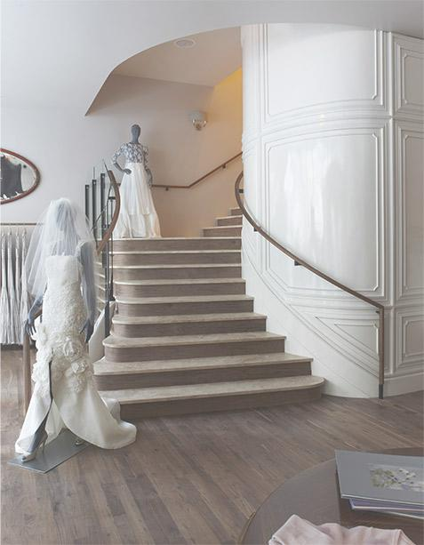
(downstairs)
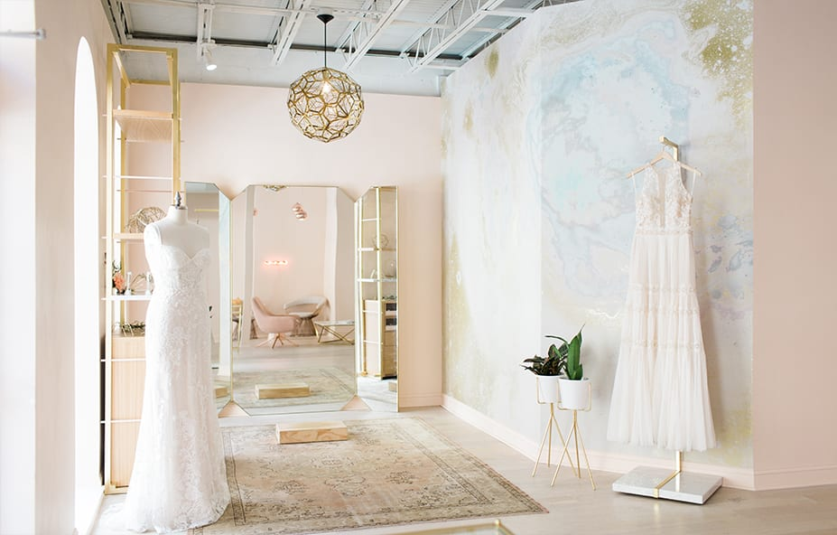
(upstairs)
Historical Facts

Ball gown wedding dresses were a fad in the history. The past replays itself in the future. Celebrities like Sofia Vergara, Ciara and Kim Kardashian all have worn a ball gown wedding dress. Each celebrity got married in a different year. It went from 2012 to 2015, to 2016 so I do believe it will come back to 2019. As shown in image (1) Kim Kardashian is shown with a white semi sweetheart neckline ball gown wedding dress. Image (2) shows you Sofia Vergara showing the sweetheart neckline with a pattern ball gown dress. It looks like a damask fabric. In image (3) you can see Ciara with a long sleeve ball gown dress. In this image you can see lace was used in this dress.These are three different style I predict that will be trending in 2020 wedding gowns.

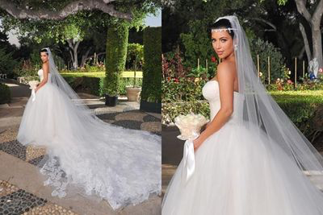
Image 1 (Kim Kardashian) 2012
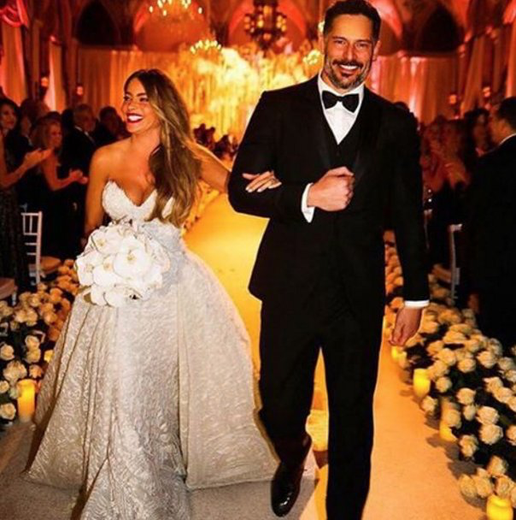
Image 2 (Sofia Vergara) 2015
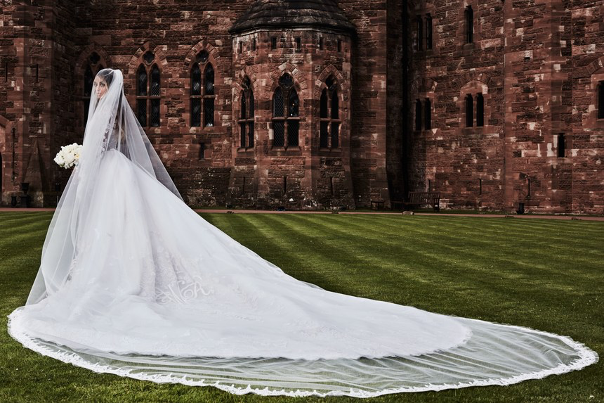
Image 3 (Ciara) 2016
The ball gown silhouette can fit everyone's body type unlike the other silhouettes. The ball gown wedding dress comes in different necklines but has a very loose bottom half. It fits you perfectly and gives you a good shape. We all know that wedding dress looks beautiful in white but have you seen it in other colors? Famous figures like Elizabeth Taylor in 1959 wore a pink dress for her wedding. Gwen stefani wore a pink ombre ball gown dress in her wedding in 2002.Sarah Jessica Parker also stood out and wore a black ball gown in 2013. In the 2019 Reem Acra fashion show they portrayed a model at the end in a light blue ball gown wedding dress. So I believe they are testing out everyone reaction from that runway. 2020 will be the year ball gown wedding dresses will be more diverse and have a huge selection in colors.
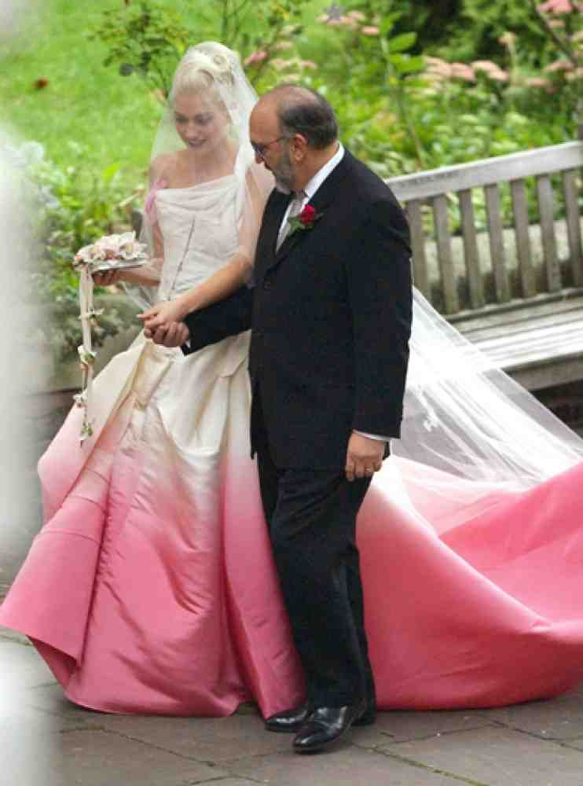
(Gwen Stefani In 2002)
A well known fact about wedding dresses is they are known to be white. White is a pure color for a day to start a new life. Queen Victoria was one of a famous figure that created a white dress traditional for weddings. The wedding dress was a statement. Before that time people would just wear the best dress they have in any color. By 1840 that time period change how women would dress on an occasion. During the Great Depression it was hard for people to purchase a dress that would not be worn again so they decide to wear darker colors dress for their occasion. During the 19th century they didn't have any laundromats so they had to maintain the white wedding dress. A white wedding dress become the dream of every girl. Internationally the colors are changed and represent a different meaning. For example in India they wear red which stands for strength.
The royalty family are known to be a popular key to promote the style of wedding dresses. It started with Queen Elizabeth to princess Diana to princess kate and princess megan. Every one of them got married in a different year and they wore long sleeve wedding dress with a different neckline.The traditional veil worn in weddings is to be protected from the evil spirits. Princess Diana is seen here with a ball gown dress and I believe it will be trending in 2019 again.

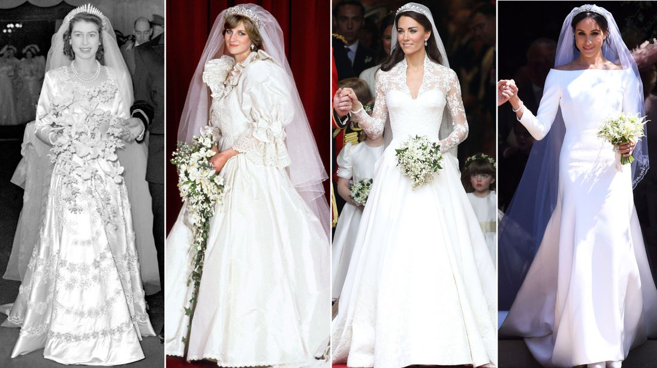

Evaluations

What are the changes?

Over the years wedding dresses has changed from different fabrics, to different silhouette with different lengths and has increased in selection of color. Pastel colors and a bold red colors are used in weddings in today's world. Every bride looks different on their big day. Each of these factors create a huge impact on the style. A Lot of people wear a wedding gown traditionally or just for beauty. The world we live is very diverse. We share our culture and beliefs. In the photo below it shows six different cultures on their wedding day. There's only one photo the bride is wearing white and the guy is wearing black. The first photo shows a couple from Ghana with bright printed colors. The next couple is from Japan but they are wearing the same colors we are usually use to but in a different style. For the next couple, they are from India and the bride is wearing a legna and the guy is wearing a sherwani. The other three cultures you can see what signified each and one of them. One is known for the color, one is known for their headgear and the other one is known for the gold embellishment.

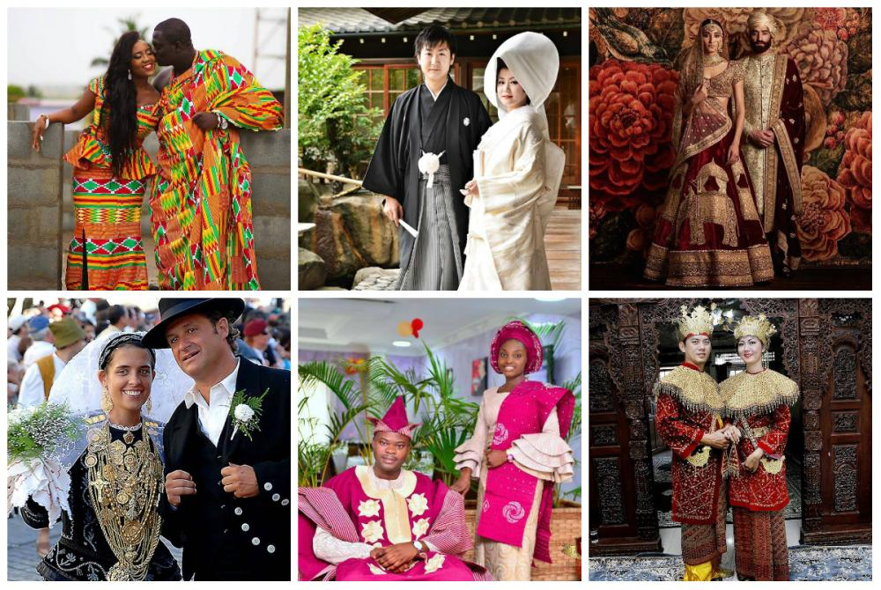

What are the cultural factors?
In the previous picture you can see the jewelry,makeup,colors and the outfit comes from religion and beliefs. It was all unique but it means the same thing. So just using different things from each culture you can make your future trends. The change in color of wedding gowns will be a glow up for the millennial culture.
A known factor of wedding dress was in the 1840. Queen Elizabeth made white dresses a priority to weddings. During World War 1 the dresses were less fancy and more like an ordinary gown. In 1947 Queen Elizabeth wore another wedding dress that was embellished with pearls and crystals. Following down the royalties in 1981 princess Diana wore a ball gown dress with a 25 foot train and embellished with pearls. Just like princess Diana, in 1993 Mariah Carey wore a similar dress but it had an off shoulder silhouette. You can see as the years pass by each style of the wedding dresses reuse an fabric or silhouette but in a different way.

Inspirations:

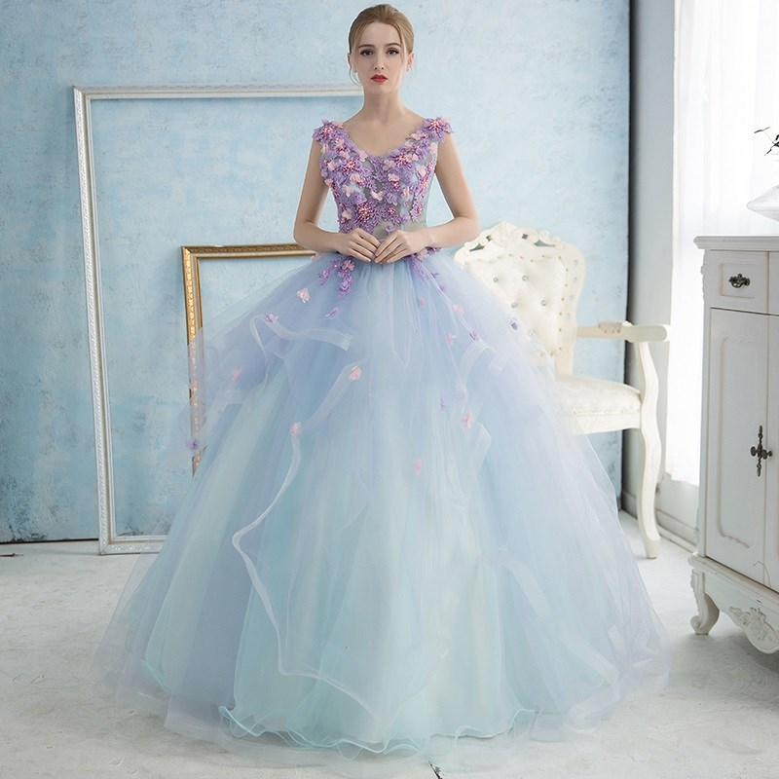

The Colors and Styles

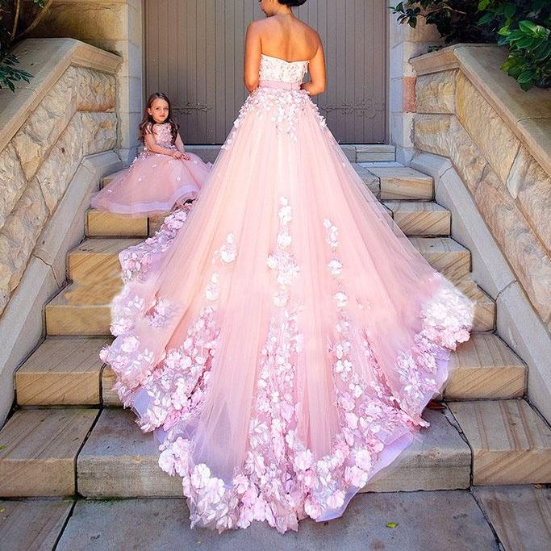

Color Palettes

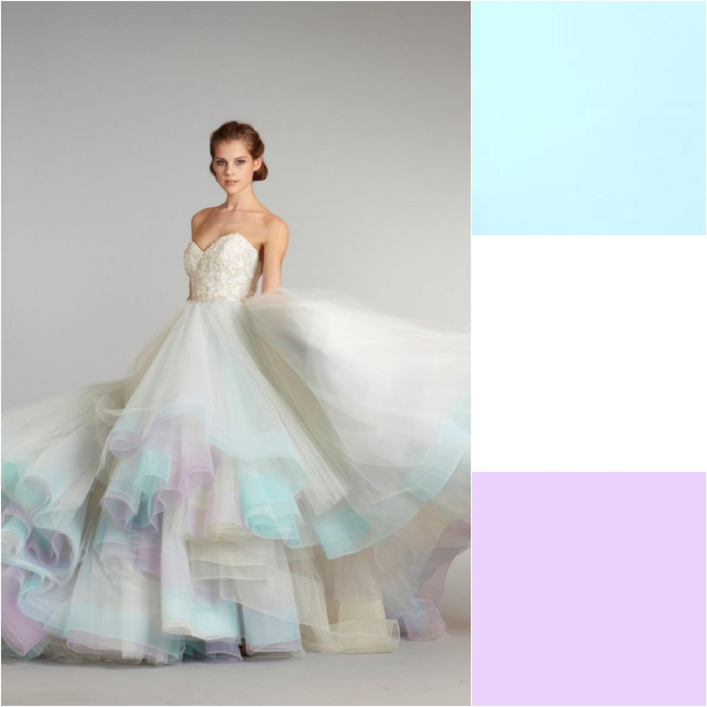
The colors in this palette represent love and emotions. White is define of purity. Lavender define as royalty and beauty. Pink represent affection and blue represent confidence.

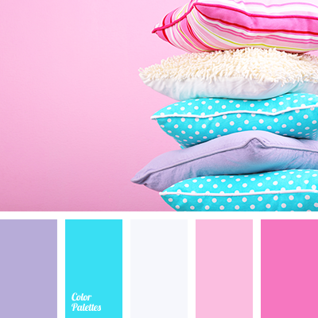
Fabrics

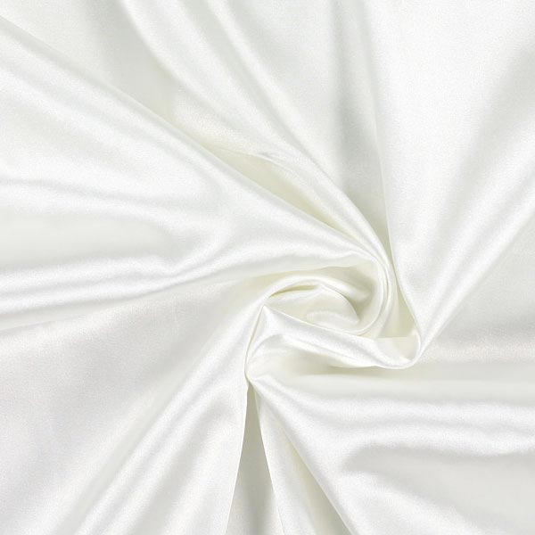
Satin
A silky fabric that can give the wedding dress a good shape and look. This will be used on the upper part of the dress. It is also use on parts of the veil.

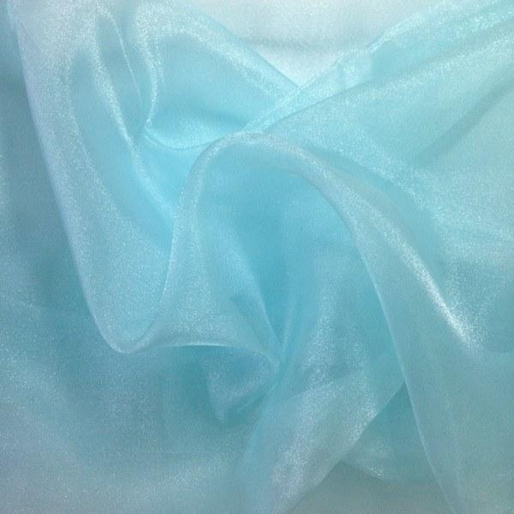
Organza
This is the material that gives the bottom half of the gown a nice puffy bottom. This is what’s going to make the wedding gown stand out.

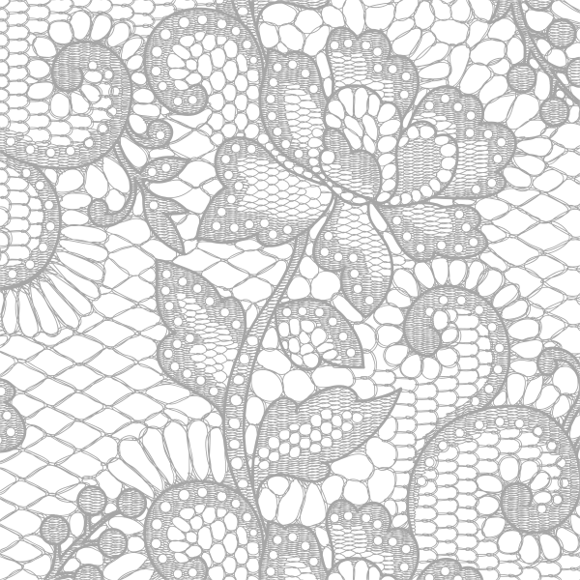
Lace
This material will be thread on the gowns to increase the beauty. It will be used for the floral designs and the see through aspects of the gown. The lace is used on the top to the veil and the trimming of the ball gown dress.

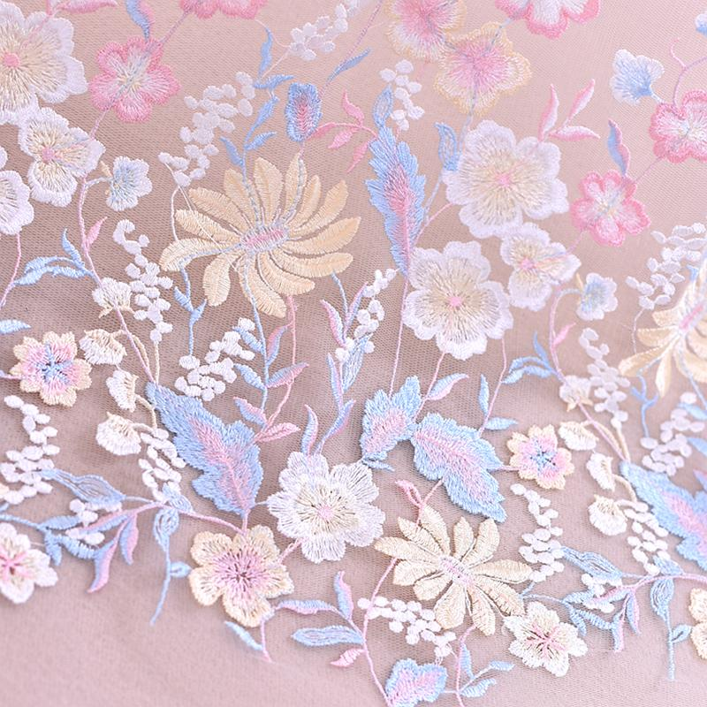
embroidered polyester
This will be used to embellishment majority of the gown. The designs on the silhouette and the necklines with this embellishment make it unique.

Generating the Forecast

The fabrics that are best used on ball gowns are satin, chiffon, organza and lace. Satin is used perfect for ball gowns for pleats or drape. So it will give the dress a sexy look. Organza is also made from silk so it gives the dress a more of structure. Chiffon is used on the ball gown dress to give it a lightweight look. This is what makes the ball gown dress looks full but it is very light. The silhouette of the ball gown dress looks hard to walk in but with these fabrics it allow you to move freely.Overall when lace is added it gives the ballroom dress a more detailed look.

Just like the past we can use the same fabric but now we can design in a different style. The past usually replays in the future. Just like the ball gowns that princess Diana wore it will come back but in different colors and different embellishment. Right now see through fabric and tight wedding dresses are predicted to be in this trend now. The pendulum swing in this wedding dress I believe it will be more lace and embellishment. Now there's a larger selection of wedding dress people start matching the dresses towards their personality. A ball gown wedding dress is definitely seen in two years from now to be a trend. Fashion innovators and leaders like the royalty family or celebrity it increases the popularity of the dress.

Fashion Shows

In 2019 the Pronovias show in Barcelona the wedding dresses on the runway were all white. It was very glittery and see through fabric. Their was off shoulder,strapless and v neckline. Their was also lace and a long train.The silhouettes was a trumpet style. Through the fashion show you see it transition from trumpet to mermaid to ball gown silhouette.The dresses were more revealing. They had white flat shoes on. Most of them had their hair down with a floral headpiece in their hair.

In 2019 Maggie Sottero have a lot of lace and see through fabrics. They stuck to one color which is white. They had a floral theme too. They had a different silhouette just like Pronovias. They did not only showcase one style but variety from sleeves to strapless.

Reem Acra has the models in veils and all of the dresses look like an A line silhouette. They also have a floral headband and a floral stick in their hand while they walk. The overall color was white until the end there was one model in a light blue dress and it had a ball gown style with puffy sleeves. Unlike the rest she had an tiara on her head.

From these fashion show lace is going to play a big part in wedding dresses for the new trend. A lot of see through fabric and different neckline is also another factor that will be playing a role. I think we will definitely see more of that style. I think an floral inspiration can be part of the new trend too. It looks like it will be incorporated into the wedding dresses. In the shows I also saw a lot of open back dresses.

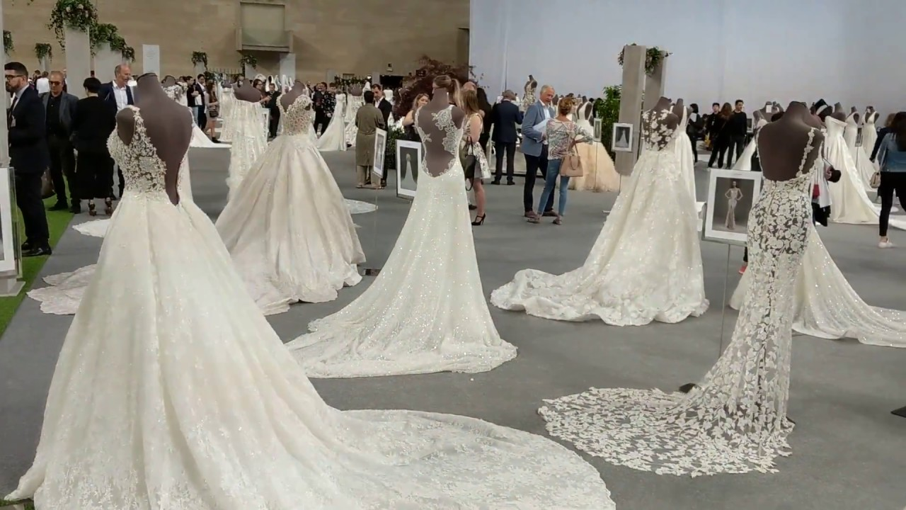
Pronovias 2019

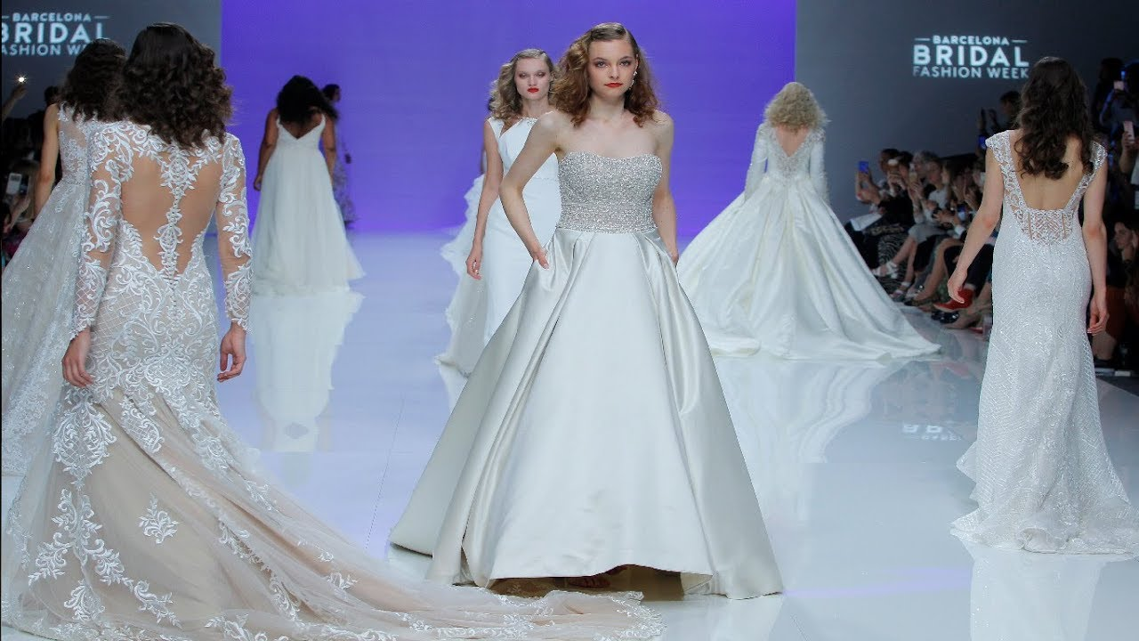
Maggie Sottero 2019

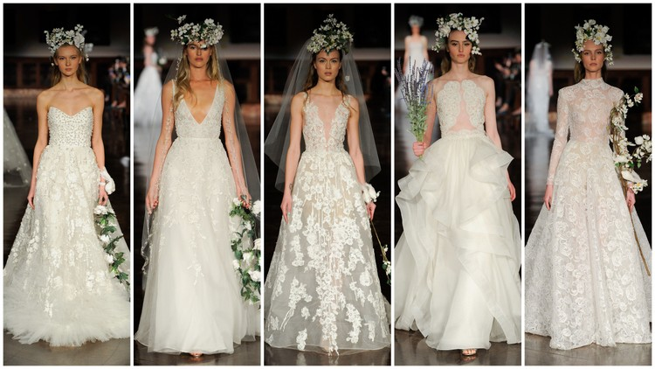

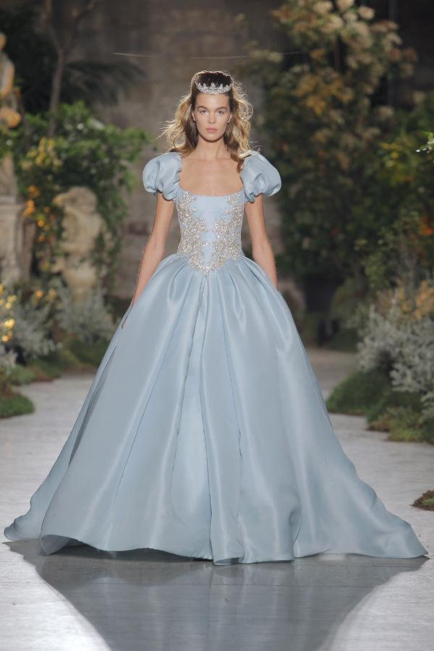
Reem Acra 2019

Citations

MacDonald, G. (2016, October 24). 17 Things You Didn't Know About Your Wedding Dress. Retrieved from https://www.brides.com/gallery/cool-facts-about-wedding-dresses-brides-magazine

Vera Wang. (2014, April 02). Retrieved from https://www.biography.com/people/vera-wang-9542398

Charlie Atkin @charlieatkin18. (2015, October 02). 100 years of wedding dresses in 3 minutes. Retrieved from https://www.independent.co.uk/video/People-and-culture/100-years-of-wedding-dresses-in-3-minutes-a6676561.html

Pantazi, C. (2017, April 12). How wedding dresses have evolved over the last 100 years. Retrieved from ://www.thishttpsisinsider.com/wedding-dress-every-decade-evolution-2017-4#barely-there-dresses-with-see-through-detailing-are-also-huge-in-bridal-fashion-15

BHLDN's Fall Wedding Dress Collection Is Every Bride's Dream. (n.d.). Retrieved from https://www.instyle.com/weddings/bhldn-fall-2016-wedding-dress-collection-photos

4 Fabrics Used in Making of Ball Gown Wedding Dresses | JJsHouse. (2017, December 10). Retrieved from https://www.jjshouse.com/blog/archives/4-popular-fabrics-used-making-ball-gown-wedding-dresses

Floersch, A. (2017, December 29). Wedding wow: Bride and groom fashion trends for 2017. Retrieved from http://www.grandforksherald.com/news/4288036-wedding-wow-bride-and-groom-fashion-trends
-2017

Why so many brides wear white on their wedding day. (2018, May 03). Retrieved from https://www.cnn.com/style/article/history-white-wedding-dress-royal-wedding/index.html
https://www.youtube.com/watch?v=QVgYxkiW5bQ

https://www.yhttps://www.youtube.com/watch?v=KvuZSmLn7r4&t=642s

outube.com/watch?v=_87ci_iBgSA&t=727s

