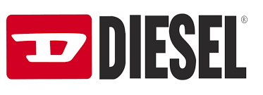

Haluhi Kato, Minji Kim, Miranda Hiralall, Moeko Hashimoto
Brand Image Marketing 3500
Professor Jackson
May 9, 2019

About Diesel

Mission Statement
Diesel is an Italian luxury brand located in Breganze, Italy and founded in 1978. The mission statement is “to create an apparel line perfect for individual people who follow their own unique path in life and for those who style matters can express their individuality by the way they dress”. The brand carries two different lines Diesel kid and Diesel Black Gold. It offers clothing, footwear, and accessories.The main focus is on denim under each individual line.

Vision Statement
After losing money over six years on annual sales and losing money due to theft fraud, the company has no choice but to close down. The company main focus is to bring back the business they once had before.They are known for expensive jeans with good quality but many consumers can't afford it anymore. The change of business strategy will target price points, collaboration, interaction with consumers, brand extension and the location. This can initial give the brand the right attention it needs which can help create sales.

Brand Characteristics
Diesel is an innovative lifestyle company producing a wide- ranging collection of jeans, clothing and accessories. The brand has always sought to stand out from traditional identity models of jeans and to create a belonging thanks to unique relationship with their customers. Renzo Rosso, the Diesel’s owner embodies a rebellious spirit in his creation. It also embodies modernity, creativity, bravery, anticonformity.

Evaluation and Brand Audit
The brand has suffered bankruptcy like other well-known luxury brands, such as Versace. Unlike other luxury brands, the brand has focused on denim with quality as its unique main product. However, this has been one of big factors to cause its bankruptcy. The denim product line has a very high quality, but it is not trendy and very high priced. In other words, the brand’s style is not fitted into today’s trend. The brand’s old style is only about ten percentage of top customers awareness of the brand. Not only its main product line, but its own systems and strategies have also contributed to its financial crisis.
According to Picchi, a journalist at CBS News the brand has wasted a large amount of money on visual display while the company has been in financial problems. The brand also has suffered many incidents, such as thefts and frauds resulting in additional losses of 1.2million dollars over the past three years. Based on our research and its own problems to survive again with our new suggestion we took a look for the brand’s competitors below.

Positioning Strategy

Competitors
Diesel was founded in 1978 in Italy by Renzo Rosso as a luxury brand. Since its bankruptcy currently it has maintained its brand value and strategies as luxury brand. The brand is changing its strategies to survive. To keep operating its business in the market and the industry they need today’s fashion style. They need to change the target market from wealthy and traditional ones to the young, rich and street fashion that the brand Supreme already has taken a huge part.

Supreme opened its first store on Lafayette Street in downtown Manhattan in 1994, became the home of New York City skate culture. The brand grew to embody downtown culture, such as skaters, punks, hip-hop heads. It adopts the young counter culture at large. Over 25 years, the brand has expanded form its New York City origins into a global community. They started working with generations of artists, photographer, designers, musicians, filmmakers, and writers. Supreme is a streetwear brand designed to fit urban teen culture compared to Diesel is a luxury brand that seeks innovative lifestyle. They both are brands that have a different identity.
Between the popularity and customers acknowledgement of the brand Diesel is regarded as a modernity, creativity, bravery but a little of top class is aware of the brand. Whereas Supreme is well known among publics, especially between young generation because the brand is regarded as a cool, cultural (hip hop culture), modern, unique, and urban brand for cool kids and limited quality production. Based on both brands identities they each has different marketing strategies too.
Supreme mainly use guerrilla marketing, promotion and advertising using publicity with low cost. In addition to it, the brand uses fashion show one of the ways of promotions. The remarkable example is the fashion show with Louis Vuitton. The brand was successful of appealing its consumers and making its customers regard the brand as high-end brand. Using this strategy the brand expanded target consumers too. Furthermore, the brand uses skateboard magazine such as grind and sense to advertise its new collection to its original target consumer.
In contrast, Diesel mainly uses flagship stores than a fashion show. As a global corporate based on Italy, Diesel has launched its flagship stores in many countries like Rome, Paris, London, Japan, New York and Mexico. Throughout the flagship stores the brand has shown its denim products manufactured only in Italy. The brand’s products manufacturing in Italy causes its items priced as premium price which is the highest price in mass market brands but lower than luxury brands. After having the flagship stores the brand opened an online store in 1995. Its online store started home delivery service to attract more customers. Diesel having flagship stores and online stores the brand offers illustrated catalog as one of marketing strategies. If Diesel’s most competitor Supreme is a streetwear brand launched its business in New York first, there is another big competitor which started its business in London.
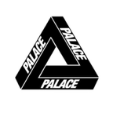
Palace is a brand launched by Lev Tanju. He has started his business in London in 2009. Initially he started to sell clothings from independent retailers in the UK and opened the first flagship store in London’s Soho district “around the corner from Supreme’s flagship”(Li, 2019). The brand’s long line and instant sold out were remarkable for Supreme and its customers. That became one of the trigger which became popular in the UK and worldwide. They have developed the similar street brand such as Supreme, Stussy, and Bape for nine years. The brand gets inspiration from skating and UK pop culture. Currently they are known as one of the leader brands of streetwear and favored by people who like pop-culture. Unlike Diesel and Supreme the brand has an unique identity which is its logo “Tri-Ferg” designed by a British designer Fergus Purcell. Due to this unique logo the clothings use this logo as a reconignization for the brand by consumers. As Palace has different brand identity than Diesel and Supreme the brand uses a different marketing strategy too.
Unlike Diesel and Supreme, Palace heavily relies on celebrities. For instance, the biggest style influencer such as A$AP Rocky, Jay-Z, Drake, Virgil Abloh and Rihanna, wore Palace clothings. The strategy has made Palace famous to the world. In addition to celebrities, the brand has made the Skate team under its supports. In the first team, Blondey McCoy, Lucien Clarke and Benny Fairfax were chosen. The unique collaborations with other brands also contributed to the brand’s marketing. The brand has collaborated with Adidas in Wimbledon and Ralph Lauren before. Although the brand has collaborated with other brands, the brand offers pretty lower prices ranged from fifty dollars to two hundred fifty dollars than its competitors. The price is not the only thing but the brand has made simple aesthetic designed products by the brand’s itself or by collaboration. After using these strategies the brand has attracted many consumers. If Palace and Supreme are categorized as low priced streetwear and pop cultural brands, there is an exceptional brand which is categorized as luxury brands like Diesel.
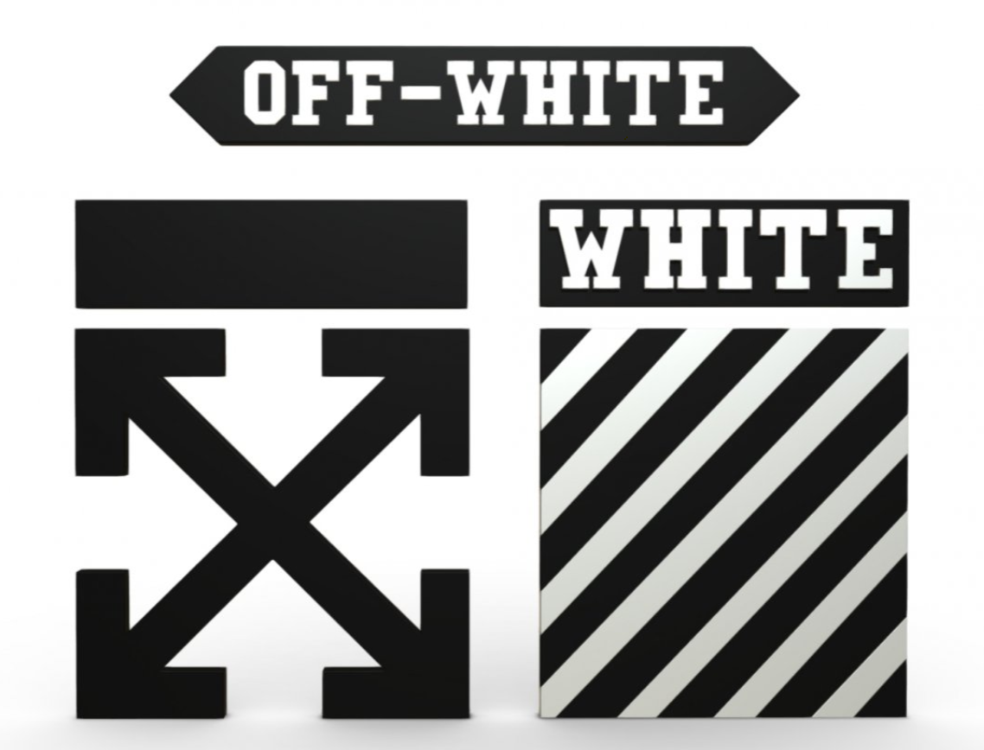
Off-White is a luxury streetwear fashion brand based in Milan, Italy in 2013 and is place below Givenchy and Balenciaga and upon other streetwear brand, such as Supreme and Undercover. The founder of Off-White, Virgil Abloh explained the brand as “the grey area between black and white as the color Off-White”. After they launched the brand, they were success in a short period in worldwide. Previously mentioning Palace’s identity logo Off-White’s identity is based on his logo too. Its logo plays a significant role to make the brand identity to consumers. The brand name on the products which includes diagonal lines and a limited color scheme tells to consumer the product is Off-White and people easily recognize what kind of brand is that. It allows to consumer follow the brand. As with other competitor brands Off-White uses similar marketing strategies.
The brand mainly uses celebrity and collaboration with other brands. Kanye West, who is a close friend of Virgil wore on a flannel check shirts putting on Off-White stripe logo on the back. These kinds of marketing using celebrities is effective for Off-White target market. Kendall Jenner and Michael B Jordan also wears Off-White clothings and contribute to advertise Off-White. Off-White has collaborated with several kinds of brands. For example the brand collaborated with Nike, Champion Ikea, and Remora. The brand chose not only clothing brands but also furniture and luggage brands. Through these collaborations the brand is success to expand its target customers and spread its high popularity in worldwide. In addition to collaborations although Off-White is also luxury brand like Diesel there is a big difference between both. Off-White sells its products between three hundred and eight hundred dollars and its pop-stores are located in worldwide like Milan, New York, Sydney, London and Hong Kong cities were known as the center of fashion. However unlike Diesel that still sticks to its old style Off-White fits into today’s fashion which is new, unique, and streetwear. This means customers’ lifestyle and their interest is changed too. Based on our research and competitors analysis, we suggest Diesel plan a new target so it can adjust to today’s trend.

TARGET MARKETING

As streetwear is becoming more popular among young generation, we recommend the brand expands its target groups who are male and female and are from 16-30 years old. At that age they are either single or married but have no kids, are college students who have part-time jobs or internships and are full-time workers. Since some target groups are college students with part-time jobs they make over 12K dollars in a year whereas the rest groups who are full-time workers make over 40k dollars in a year. Based on their income our target can be all ethnic group that lives in urban. In addition to their age and income because they are categorized as young generation. They prefer something new and innovative.
Our target market loves street fashion, Pop, R&B music and are interested in photography, architecture, museums, paintings. They also always check fashion magazine, fashion post on instagram, and other medias about fashion. The inspirational love they have for fashion they are susceptible to fashion and trends but enjoy new trends that are something different from others. Based on their hobbies and lifestyle they have strong desire for self actualization but esteem for celebrities or high brand. As the new target’s interest and lifestyle are changed to survive in a changed society and the market we suggest Diesel changes its strategies and recommend co-branding with other brands as one of new strategies.

Brand Repositioning, Relaunching, and Revitalization

Growth Strategy
Diesel has collaborated with other brands like Adidas. However it has no distinctive feathers at all because brands like Adidas is well known for sportswear and streetwear too, but collaborating with brands like mainly working on sportswear can restrict its design and product lines. So Diesel needs a certain brand which can bring something very unique, new, and has diverse lines but has collaborated with many brands. So we suggest KITH for co-branding. We are sure that if Diesel works with KITH then Diesel will attract and expand more younger target who is fashion-forward and willing to spend.

About KITH
KITH is a retail store based in NYC founded by sneaker designer, Ronnie Fieg in 2010. Initially it started with two locations in Brooklyn and Manhattan currently KITH has expanded to eight locations in fashion capital cities such as Los Angeles, Miami and London as well as an online store. KITH sells a range of its own apparel, footwear and accessories. Especially the brand is known for collaborations with a number of renowned streetwear brands and major athleisure brands such as PUMA, ASICS, New Balance and more. Many of collaborations bearing the KITH name have proved popular, leading to recurring collaborations. Recently KITH collaboration expanded into luxury markets and even beauty industry to help brands repositioning into streetwear trend and market younger demographic. Here are some recent collaboration KITH revitalized brands below.

Collaboration with Versace in February 2019
Price : $75 to $4500
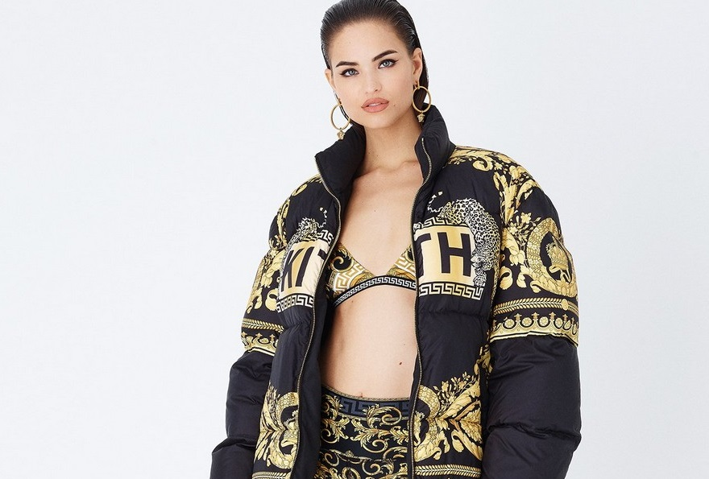

Collaboration with Tommy Hilfiger in FW 18 ( September and December)
Price : $75 to $500
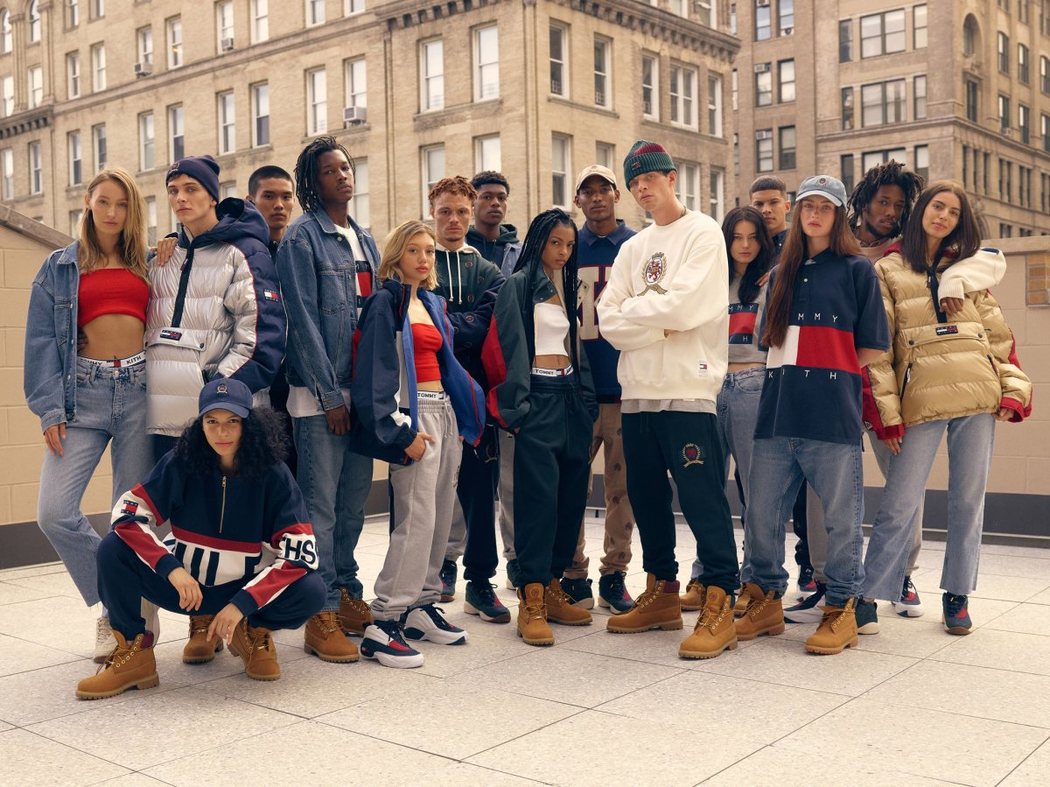

Co-branding with KITH helps repositioning Diesel to target millennial market and shifts brand image to street culture which market demands and trend are. Price will be about $80 to $400. Categories is broken up from T-shirt for $80 to $100, logo hoodie for $150, denim jeans for $250 to $300, denim jacket for $400 and more. It is important for Diesel to focus on selling apparel especially denim products which the brand’s significantly known for to stand out from competitors. In addition to co-branding with KITH we recommend more new strategies for Diesel for Fall 2019.

Proposal

Recommendation for Fall 2019
As we suggested Co-branding with KITH before is to attract more targets for more sales. We recommend the brand change its image from luxury to premium brand and into young street fashion. The brand has positioned as luxury brand itself but it actually sells products and works as a premium brand. As the luxury brand image with its actual offers as premium does not make sense because the brand system has confused some customers and has made customers feel unfamiliar. Also for its luxury image, since the brand keeps its extremely high price the former targets who were students or workers had no willing to purchase its products which led its bankruptcy. If the brand changes its brand image into premium not only its brand will be familiar to publics and customers but its products price will also go down and will lead customers the willingness to spend. However co-branding with KITH and changing its brand image are still not enough for Diesel. The brand needs to expand its product lines too.
Diesel has focused on denim products like jeans, jackets, and accessories. If the brand focuses on only one product line the brand cannot survive in modern society. The society expects brands and companies to work and operate more so that customers can satisfy their needs. As we mentioned before, to adjust to today’s trend which is young and streetwear we recommended working on with KITH. We also mentioned customers interest is changed now in our target marketing. Customers today are more interested in their lifestyle like home, health, leisure. To adapt to customers new interest a brand like Zara has already expanded its lines called Zara Home. We recommend Diesel expands its brand or product line for Home too which can help them attract different consumers.
For home decoration consumers want furnitures like sofa and other stuff with a nice quality and design but at a moderate price. Items of luxury brands or mass market brands like H&M are not satisfying to consumers wants because luxury brands are too expensive and mass market brands items have bad qualities. In this case after Diesel changes its brand image and systems to premium Diesel can offer furnitures and kitchen stuff with nice design, qualities, and moderate price. Then customers will have a willingness to purchase stuff for home decoration at Diesel than other brands since customers have created a nice image for Diesel as valued brand. To expand more in our target and make more benefits we decided to plan on how to spend the budget based on our research and strategies.

Marketing Budget Total

To make our strategies more effective, we suggest and plan four active marketings and their budget; Advertising Plan, Editorial Ad campaign, Influencer marketing, and In-store Party/Events.

Advertising Plan
Based on our target market, we are going to focus on digital advertising; Hypebeast and
Highsnobiety.
Hypebeast (Cost per page: $4,000)
Brand Footprint:
- 9 .3MM Followers Across All Platforms
- 9.4MM Unique Monthly Visitors
- 6.5MM Instagram
- 44M page
Community:
- 75% Male
- 18-35 Years Old
- 32% New Visitors
Through these feature of hyper beast, we can say using hyper beast is the best choice for rebranding Diesel company. Our target market is 16-35 years old male and female they can fit perfectly for our target market and we believes that especially male have strong interest on streetwear. Furthermore in order to create our new brand image and expand target market we have to expose our collaboration with KITH to a wider kinds of audience.

Highsnobiety
This is the same reasons that we adopt HYPER BEAST as the main advertising for
our new brand marketing. We decided to use Highsnobiety as another advertising.

Editorial Ad campaign
The editorial ad campaign will keep the same message like every ad they had because it shows originality and personality of each person which can communicate to the consumers on a lifestyle. This is what makes Diesel different from the other brands. So, we plan 250,000 dollars for editorial ad campaign.

Influencer marketing
To market on social media platform, we will have partnership with influencers below to advertise to variety of audiences on instagram.

Micro influencer : Anna Nadim Saber
Instagram handle: @oursecondskin Followers: 24.2K
Niche: Fashion Cost per post: $800
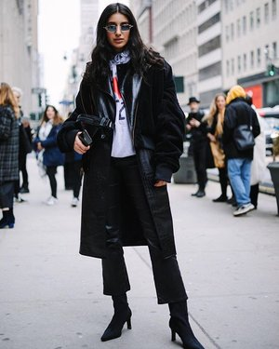

Macro influencer : Luka Sabbat
Instagram handle: @lukasabbat Followers: 1.8M
Niche: Fashion Cost per post: $4000
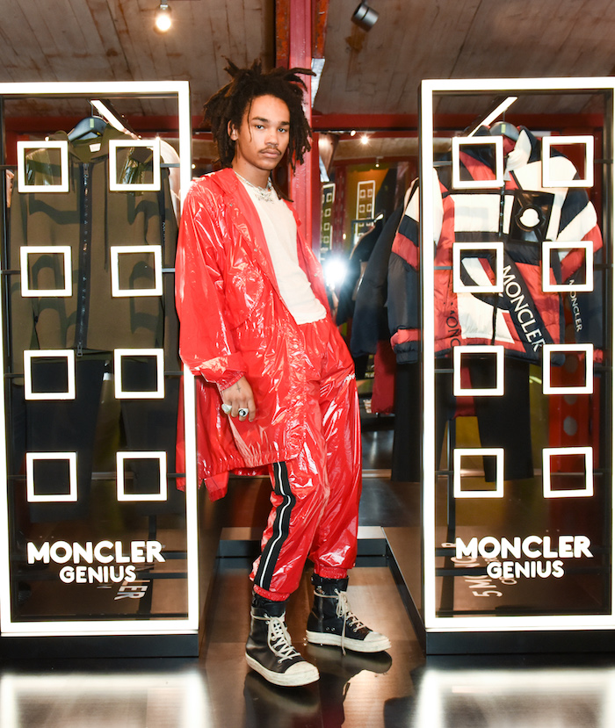

In-store Party/Event
Diesel heavily focuses on its flagship store events or displays as one of its strategies. In most case the brand had spent a huge amount of money to celebrate for opening new flagship stores in big cities in countries such as re-opening a store in Dusseldorf, Germany. Collaborating with other brands and celebrities, Diesel Black Gold flagship store cocktail parties for new collections, such as in London, UK in 2014 the company has suffered financial crisis. It seems like the brand tries to have less events and parties now. But we are sure the brand will maintain flagship store events and parties for a while. So we are planning to use 50,000 dollars for In-store Party/Event to create a more of relevance acknowledgement of the product of the brand.

Conclusion
Based on our research Diesel has collaborated with some brands, such as adidas to increase more sales. But, it seems like it does not work well. In addition to collaboration Diesel had many problems comparing to its competitors like Supreme, Palace, and Off-White. The biggest problem was Diesel had sticked to its traditional strategy which is not today’s style. In this case of its competitors especially Supreme and Off-White have followed today's trend that customers and a society seek. Because of Diesel’s old systems and style, the brand is having a hard time like some other luxury brands which had experience a hard time before. So, we’ve suggested some new strategies which can reflect and satisfy a need of customers and a society. So, we hope Diesel considers our recommendation and can have a better result based on our suggestion and better strategies for Diesel.

References

Bailey, C. T. (2016, August 09). Palace: Why the London skatewear brand is trending right
now. Retrieved May 7, 2019, from
https://www.wgsn.com/blogs/palace-skate-why-the-london-brand-is-trending/
Diesel. (n.d.). Retrieved May 8, 2019, from https://www.facebook.com/pg/Diesel/events/
Edwards, W. (2018, February 11). Off-White Brand Report. Retrieved May 8, 2019, from
https://issuu.com/williamedwards93/docs/_report__official__no_bleed_
Fisher, L. A. (2018, May 03). Off-White Launches More Affordable Collection For Those
Not Wanting To Spend $800 On A Hoodie. Retrieved May 8, 2019, from
https://www.harpersbazaar.com/fashion/designers/a14782810/off-white-affordable-co
llection/
Fisk, P. (n.d.). Diesel. Retrieved May 7, 2019, from
https://www.thegeniusworks.com/gamechanger/diesel/
Outlaw, A. (2018, November 13). Palace Skateboards: Everything You Need to Know.
Retrieved May 7, 2019, from
https://theidleman.com/blogs/news/palace-skateboards-x-facts-need-know
Palace Skateboards: Breaking News, Latest Collections and Brand History. (n.d.). Retrieved
May 7, 2019, from https://www.highsnobiety.com/tag/palace-skateboards/
Picchi, A. (2019, March 06). Diesel, jeans company known for pricey denim, goes bankrupt.
Retrieved May 1, 2019, from
https://www.cbsnews.com/news/diesel-bankruptcy-jeans-company-denim-chapter-11/
Silbert, J. (2019, May 03). New Product Imagery for the Off-White™ x Nike Zoom Terra
Kiger 5 Has Leaked. Retrieved May 8, 2019, from
https://hypebeast.com/2019/5/off-white-nike-zoom-terra-kiger-5-collab-official-image
ry-leak
Tuzio, A. (n.d.). The Complete Guide To Palace Skateboards. Retrieved May 7, 2019, from
https://www.nssmag.com/en/fashion/18156/guida-completa-a-palace-skateboards

