“Caring For the Aging Mouth”

By: Michelle Barreto, Jennifer Devivo-Baptiste, Gehan Ibrahim, Mary Lewis, Meily Gomez, Theresa Ramsay
Introduction
For our learning service learning project we decided to provide a PowerPoint presentation at community senior center. We presented to group of about 30 seniors, all the attendees were ages 65 and up. Our primary focus was to educate this elderly population on the importance of oral self-care, provide vital information as to the changes that occur in the oral cavity during the aging process, discuss the link between oral and systemic health and provide examples of physiotherapy aids that can be helpful for each individual and their particular needs.
Initially, we contacted the community center via phone for an informal introduction and to set up an appointment to meet the supervisor of the program and assess the facility. We were told that the majority of the seniors were having dental issues and have been having trouble with their dentures. We then agreed that this segment of the population needed basic knowledge regarding denture care, while also providing general oral health education. Some of us have elderly parents and family members, therefore we felt passionate about choosing this population for our project. Since geriatrics is the fastest growing portion of the population and are living much longer than in the past, it is essential that we educate the elderly and communicate the significance of preventive treatment in order to avoid expensive and complex dental work.
Most elderly have a common misconception that they should only visit the dentist when there is a problem, or that losing teeth is part of the normal aging process. We strived to alter these attitudes by offering oral health education in an attempt to increase healthy behaviors. We handed out surveys in order to test the knowledge of our viewers and to have insight regarding what topics need more attention during our presentation. Ultimately, we left the senior community center with a feeling of accomplishment knowing that we able to deliver educational guidelines to a segment of the population which is in dire need.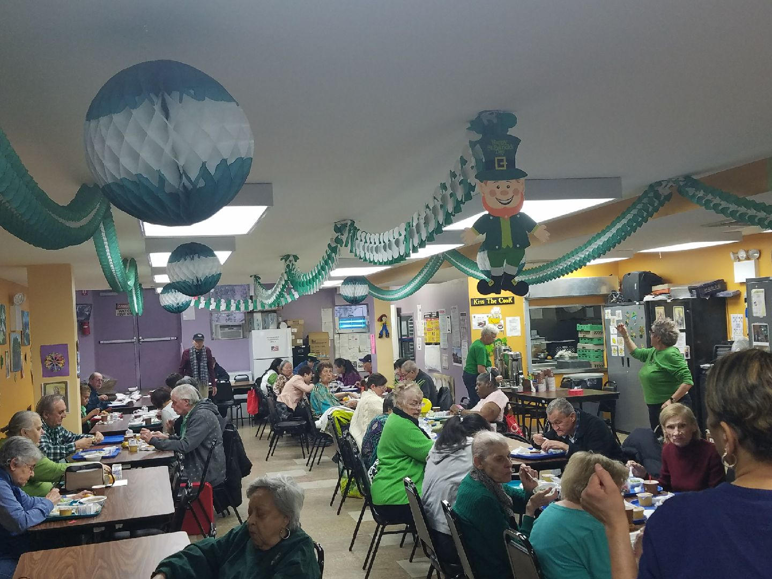
Assessment
The target population for this project is the elderly community. More specifically, the demographics of this population include an age range of 50 years or more, although it is possible that some patients were younger than this. The idea for accomplishing our goal was to gather a large enough sample of the target population to educate the overall oral health. Out of the all the possible methods to reach out to members of this population, we chose to devote our time and efforts to a community senior center in Brooklyn.
Currently, the status of the oral health of the overall target population is subpar to say the least. Specifically, this population had typical attrition and decay (what you would normally expect in the elderly), along with serious recession and root decay. Although we were not able to observe the overall care given, we were able to observe their concerns. Based on the oral health, we were able to conclude that they are in need of a combination of a more restrictive diet (one that further reduces the amount and frequency of sugar intake) and better oral hygiene (increase fluoridation, increase oral hydration, use of antibacterial mouthwash), all of which must be formulated into a simple program that can be implemented on a daily basis.
In addition to our observations, our arguments are supported further by published journals in official medical databases. More specifically, we found that “statistics from the Center for Disease Control (CDC) for 2014 show that 2.3% of adults 18-44 years old were missing all of their natural teeth. For the age group 65-74 years old, this rate jumps to 16.4%. For the population of American adults over 75, the rate of total tooth loss is 26.8%” (AZ Family Dental). In addition, “dry mouth can result from physical changes within the body as it ages, but can also be caused by medications. According to the Centers for Disease Control and Prevention (CDC), over 400 commonly used medications can contribute to dry mouth. This increases the risk for oral disease, as saliva helps kill bacteria and rebuild enamel” (Pena). Also, “Poor oral health in the elderly is associated with malnutrition, cognitive decline, and a higher risk for cardiovascular disease and infectious respiratory diseases” (Tze-Fang et al.). With this in light, “nurses are frequently unaware of the importance of oral health care within holistic care and are unable to carry it out. Psychological barriers to working in another person’s mouth are widespread among caregivers. Practical training for nurses and auxiliary care staff has frequently been recommended as a way of improving oral health care for functionally dependent elderly. Previous studies which were done on the elderly population in Bangalore city show that the oral health status is very poor among this group, and there is a need for some oral health programs” (Khanagar et al.). In addition to this, “The prevalence of elderly who lacked dental care
[were] approximately >90% in homebound elderly in the USA” (Tze-Fang et al.). Therefore, multiple published articles fully compliment our suggestion to implement an oral hygiene program in elderly facilities.
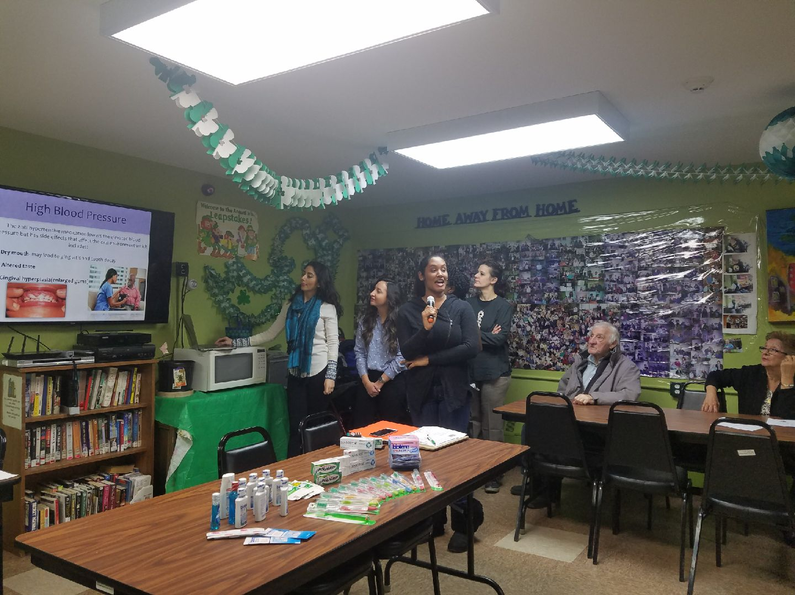

Planning
This community independently visits the facility daily for entertainment and social activities. They are responsible for their own medical and oral hygiene care. For this reason, it is actually very practical to educate this community and raise awareness to the oral health, which can influence their overall health. In order to accomplish this, we had to develop specific goals and a measurable objective to ensure that it would be beneficial to them, and that they are on the receiving end of the objectives. Specifically, we have narrowed the list of goals to exactly three to keep it concise, practical, and efficient for easy implementation.
The first goal is to maintain a daily cleaning routine. Brushing is the first defense against bacterial buildup, tooth decay and gum disease. In addition, elderly patients are more susceptible to tooth decay and gum disease, so maintaining a consistent cleansing cycle is key to bettering the overall oral health. In this program, we will recommend that patients brush at least twice a day with fluoride toothpaste and cleaning between the teeth with dental floss (or another tool that will accomplish the same task). In addition to this, dentures need cleaning every day, just like natural teeth, using a product specifically designed for cleaning dentures. “Dentures also need to be taken out each day to help maintain healthy gums. The tissue on the inside of the mouth needs at least a four-hour break from the dentures each day” (AZ Family Dental). This goal, although one of the most basic, is arguably the most essential steps to take toward better oral hygiene.
The second goal is to be aware of decrease of salivary flow (xerostomia) and steps taken to improve it. “Dry mouth can accelerate tooth decay and cause dentures to fit poorly and irritate the skin underneath them” (AZ Family Dental). “Dry mouth can result from physical changes within the body as it ages, but can also be caused by medications” (Pena). With this being said, a patient can develop this condition and may not even be aware of it. However, by adding a moisturizing mouthwash to the daily oral hygiene regime, this can be improved and managed.
The third goal is to maintain a healthier diet – one that not only works for the patient’s digestion but also to better their oral health. “Maintaining a healthy diet, including fresh fruits and vegetables, will help keep your teeth and gums in good shape” (AZ Family Dental). In addition to this, “Fluoride continues to be an important part of a healthy diet, even for the elderly. Drinking plenty of water helps to remain hydrated and flushes out toxins. Scientists have proved that drinking fluoridated helps maintain healthy teeth, and is an important part of good oral hygiene” (AZ Family Dental). This last goal is probably the most difficult to implement because it requires a dietary change, however, the foods that are recommended are already beneficial to the patient’s overall health, so it is equally necessary.
The objective is to measure the knowledge of the community with the survey given.
Based on the assessment findings, it is appropriate for us to develop a health education program that tailors to the elderly population, pointing out specific practices that would be more beneficial to them than a younger population. This program will emphasize on denture care, dry mouth, recession, root decay, and other relevant conditions that are most common in the elderly population. With this being said, the actual development occurred by analyzing the knowledge of denture care, dry mouth, recession, root decay, and making new tasks fit seamlessly into it. For example, brushing their teeth and cleaning their dentures, some of them do; for those people that do, they may have established oral home care routine at an earlier age. For this reason, we will develop a teaching method (power point) with images and highlighted keywords to get their attention. We started by talking about overall oral health, systemic conditions and medication side effects, nutrition, oral home care including denture maintenance.
Furthermore, we fully understand that an oral hygiene routine is not always implementable especially due to physical limitations of this unique population. We advised periodic dental evaluations and dental cleaning to achieve a healthier well-being. As it is currently, this community likely brushes 1x/day. It is our goal to motivate them to increase to 2x/day, and use an interdental aid, as well as remove dentures at night.Therefore create a routine that modifies the brushing technique to disrupt biofilm that causes gingivitis and link to systemic conditions. Adding antiseptic rinse that they can use (antibacterial for more control of microbiome). As for the dentures, if ill-fitting, an evaluation by their Dentist was recommended.
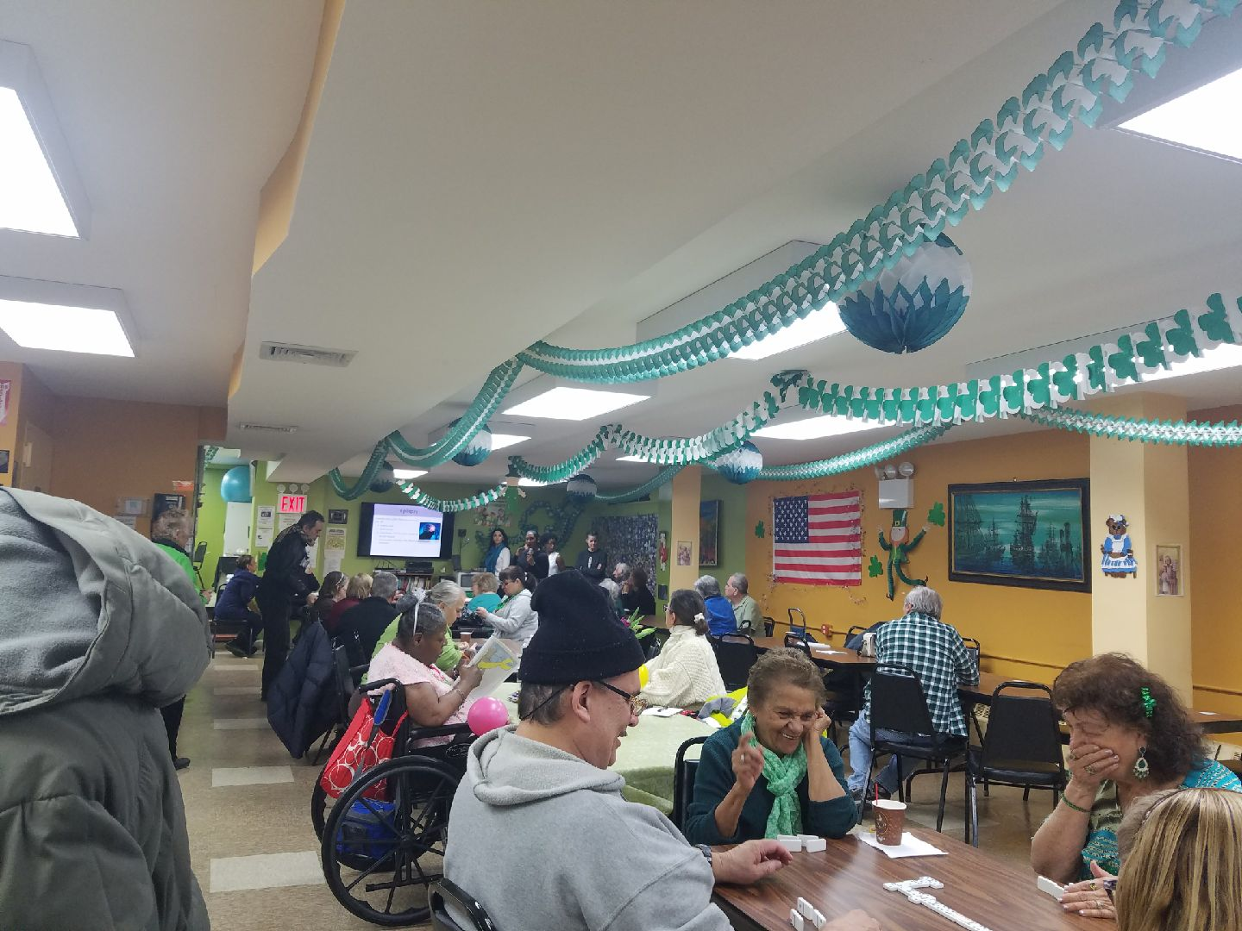
Implementation
Aside from the planning of the program, the actual implementation of it is extremely important; a plan is only successful if it is carried out correctly to accomplish the main goal (for the most part). With this being said, our main focus is to ensure that the goals are thoroughly understood by the target population to ensure that is working in one direction; better oral health.
The first thing we did was to educate about the oral manifestations (oral cancer, denture stomatitis, herpes, apthus ulcers) that occur in the oral cavity. Secondly, we provided knowledge about the link between the oral cavity and systemic conditions such as diabetes, hypertension, high cholesterol, and epilepsy, and prescribed medications with corresponding side effects. Thirdly, we described how oral health can impact nutrition, and a lack of food variety can impact their general health. Lastly, oral home instruction was presented and inclusive of denture care. To create an urgency and sense of distraction from the idea that there are routines being retaught (mainly because some individuals will lose interest as they will feel it is unnecessary), we decided to incorporate “tools” that are known to entice people and get their attention; giving us an eager-to-learn audience.
The “tools” that we used to entice the crowd into giving us their attention were actually product samples that were essential to be introduced in this project anyway, so it was like taking out two birds with one stone. To be more specific, we first chose to gather them into the cafeteria of the facility, that way we delivered a presentation to everyone involved. We designed a PowerPoint presentation that covered the dietary aspect of the program (the third goal) which we presented and spoke about for about an hour (give or take 10 minutes). This presentation covered the facts about drinking water, limiting the consumption of artificial sugars, and consuming wholesome foods with natural nutrients like fruits and vegetables. After this, we presented a selection of oral hygiene products that should be used when following the program such as Sensodyne tooth paste for patients with sensitive gums and recession, Prevident 5000 toothpaste (which was not given out because it requires a prescription), soft-bristle toothbrushes, Polygrip and Polydent for those who have dentures, and biotene mouth rinse. In addition to the actual products that will assist in the implementation of the program, we also administered a questionnaire which was designed to gauge the the target population so that we can understand their hygiene habits.
The actual disbursement of the hygiene products like toothpaste and toothbrushes was carried out in a way that we believe not only captured the interest of the audience, but also created a desire to own and use them. With the help of the staff, were were able to create a raffle which would reward the winner, a person who is drawn at random, with an option to have any hygiene product of their choice. The reason for this was not only to introduce the people in the target population with the products they need to follow.

Evaluation
Now that the implementation has been planned out, it is essential that we gauge its effectiveness in the target population. A survey was given at in the middle of the presentation, before we spoke about daily oral-self care and results were analyzed. We learned that majority of the elders visit a dentist regularly, and clean their dentures on a daily basis. Also, about half suffer from dry mouth and very few sleep with their dentures. With those learnings, yearly visits to the facility for re-education of these topics, as well as any updated, age-related dental topics should be provided.
The main goal was to raise awareness and teach the elderly population about proper oral hygiene methods and this was accomplished based on the results of their involvement and interaction with our presentation. In particular, we noticed some had mistaken information about denture care, i.e. using Listerine to disinfect. This community was not knowledgeable on the different products offered in their demographic to address specific needs such as Biotene for dry mouth, or a soft bristle toothbrush (instead of other).
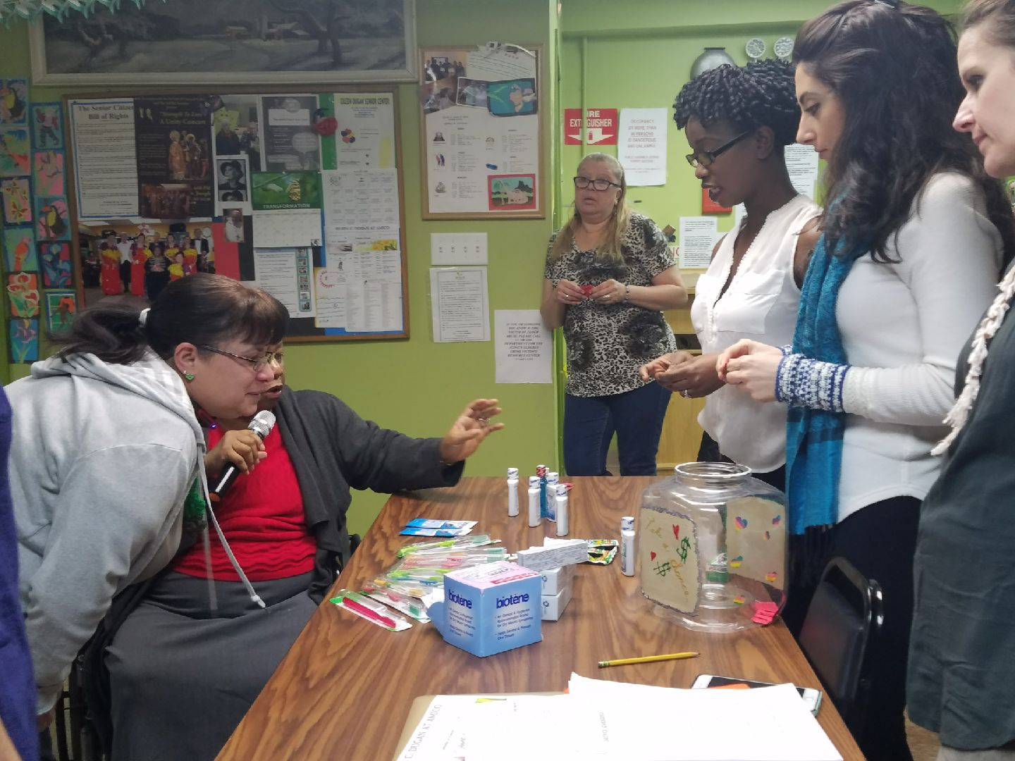

Conclusion
The result of the program showed that there was a significant lack of information for this demographic audience. Improving oral health knowledge among this population is critical. Family care involvement should be a consideration among this group to help achieve the above stated goals.

References

AZ Family Dental. "Ways to Maintain Dental Health for Senior Citizens." Maintaining Dental Health for Elderly | Common Conditions. AZ Family Dental, 1 Sept. 2016. Web. 04 Apr. 2017. Available from: CINAHL Complete, Ipswich, MA. Accessed April 4, 2017.

Khanagar S, Naganandini S, Tuteja J, Naik S, Satish G, Divya K. Improving Oral Hygiene in Institutionalised Elderly by Educating Their Caretakers in Bangalore City, India: a Randomised Control Trial. Canadian Geriatrics Journal [serial online]. September 2015;18(3):136-143. Available from: CINAHL Complete, Ipswich, MA. Accessed April 4, 2017.

Pena, Willie. "Oral Care Tips for Older Adults." Oral Care Tips for Older Adults. Colgate-Palmolive Company, 01 Feb. 2013. Web. 04 Apr. 2017. Available from: CINAHL Complete, Ipswich, MA. Accessed April 4, 2017.

Tze-Fang W, Chiu-Mieh H, Chyuan C, Shu Y. Effect of oral health education programs for caregivers on oral hygiene of the elderly: A systemic review and meta-analysis. International Journal Of Nursing Studies [serial online]. June 2015;52(6):1090-1096. Available from: CINAHL Complete, Ipswich, MA. Accessed April 4, 2017.

