Meeting Minutes

Date: September 29, 2015

Attendance: Dr. Xiao, Design Team

- CAD Team Leader, Nestor sketched a rough design of the trike on the board.
- Everyone has agreed on the design, length of the frame and wheel sizes.
- Each CAD team member has volunteer or assign to find the following items (either from Grabcad or any other sources):

Item | Person In-charge
Power Transmission | Anna, Justen, Issa
Breaks (disc, etc) | Justen, Derrick
Wheels | Himanshu
Bike | Nestor
Controls | Derrick, Lin
Seats | Diego

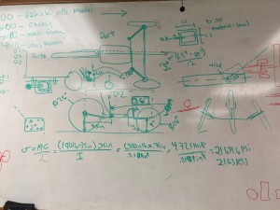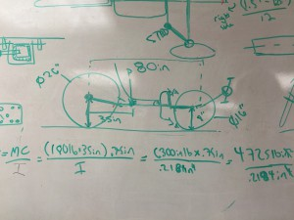

Action items:
- Discuss the intermediate design report- CAD works, manufacturing plan
- Decide on the part list!

