HW 2
2.2 Silicon has three naturally occurring isotopes: 92.23% of 28Si, with an atomic weight of 27.9769 amu, 4.68% of 29Si, with an atomic weight of 28.9765 amu, and 3.09% of 30Si, with an atomic weight of 29.9738 amu. On the basis of these data, confirm that the average atomic weight of Si is 28.0854 amu.
2.16 The atomic radii of Mg2+ and F − ions are 0.072 and 0.133 nm, respectively. (a) Calculate the force of attraction between these two ions at their equilibrium interionic separation (i.e., when the ions just touch one another). (b) What is the force of repulsion at this same separation distance
2.22 (a) Briefly cite the main differences among ionic, covalent, and metallic bonding. (b) State the Pauli exclusion principle.
2.24 Explain why hydrogen fluoride (HF) has a higher boiling temperature than hydrogen chloride (HCl) (19.4 vs. –85°C), even though HF has a lower molecular weight.
2.27 What type(s) of bonding would be expected for each of the following materials: solid xenon, calcium fluoride (CaF2), bronze, cadmium telluride (CdTe), rubber, and tungsten?
3.1 What is the difference between atomic structure and crystal structure?
3.6 Show that the atomic packing factor for HCP is 0.74.
3.24 Sketch a unit cell for the face-centered orthorhombic crystal structure.
3.47 Determine the Miller indices for the planes shown in the following unit cell:
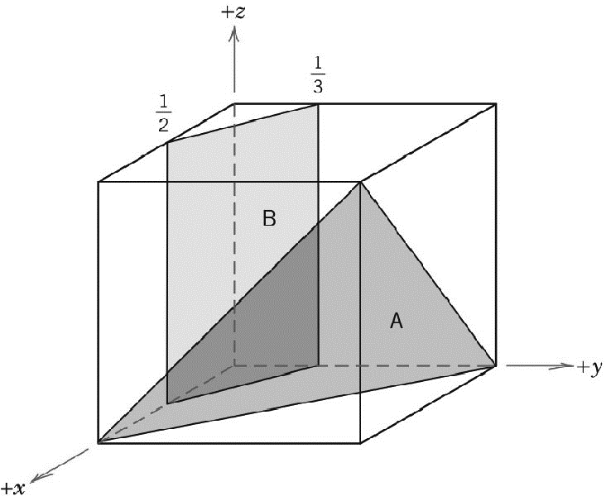
3.61 (a) Derive planar density expressions for BCC (100) and (110) planes in terms of the atomic radius R.
(b) Compute and compare planar density values for these same two planes for molybdenum (Mo).

