14.4 (a) Compute the repeat unit molecular weight of polypropylene.

(b) Compute the number-average molecular weight for a polypropylene for which the degree of polymerization is 15,000.

14.14 (a) Is it possible to grind up and reuse phenol-formaldehyde? Why or why not?

(b) Is it possible to grind up and reuse polypropylene? Why or why not?

14.18 An alternating copolymer is known to have a number-average molecular weight of 100,000 g/mol and a degree of polymerization of 2210. If one of the repeat units is ethylene, which of styrene, propylene, tetrafluoroethylene, and vinyl chloride is the other repeat unit? Why?

14.22 Explain briefly why the tendency of a polymer to crystallize decreases with increasing molecular weight.

14.25 The density and associated percent crystallinity for two poly(ethylene terephthalate) materials are as follows:

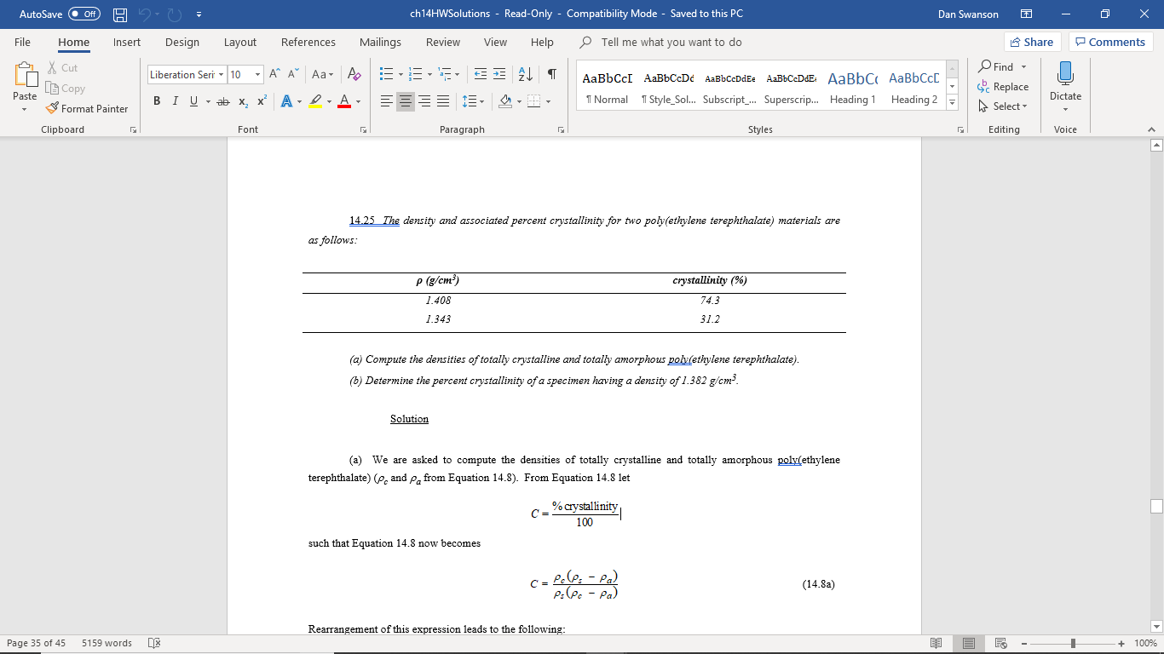

(a) Compute the densities of totally crystalline and totally amorphous poly(ethylene terephthalate).

(b) Determine the percent crystallinity of a specimen having a density of 1.382 g/cm3.

15.5 In your own words, briefly describe the phenomenon of viscoelasticity.

15.14 Briefly explain how each of the following influences the tensile modulus of a semicrystalline polymer and why:

(a) molecular weight

(b) degree of crystallinity

(c) deformation by drawing

(d) annealing of an undeformed material

(e) annealing of a drawn material

15.17 The tensile strength and number-average molecular weight for two poly(methyl methacrylate) materials are as follows:

|  |  |
| --- | --- |
| ***Tensile Strength (MPa)*** | ***Number-Average Molecular Weight (g/mol)*** |
| *50* | *30,000* |
| *150* | *50,000* |

Estimate the tensile strength at a number-average molecular weight of 40,000 g/mol.

15.25 Fifteen kilograms of polychloroprene is vulcanized with 5.2 kg of sulfur. What fraction of the possible crosslink sites is bonded to sulfur crosslinks, assuming that, on the average, 5.5 sulfur atoms participate in each crosslink?

15.29 In a manner similar to Equation 15.4, demonstrate how vulcanization may occur in a chloroprene rubber.