18.10 (a) Calculate the drift velocity of electrons in silicon at room temperature and when the magnitude of the electric field is 500 V/m.

(b) Under these circumstances, how long does it take an electron to traverse a 25-mm (1-in.) length of crystal?

18.16 Tin bronze has a composition of 89 wt% Cu and 11 wt% Sn and consists of two phases at room temperature: an α phase, which is copper containing a very small amount of tin in solid solution, and an ε phase, which consists of approximately 37 wt% Sn. Compute the room-temperature conductivity of this alloy given the following data:

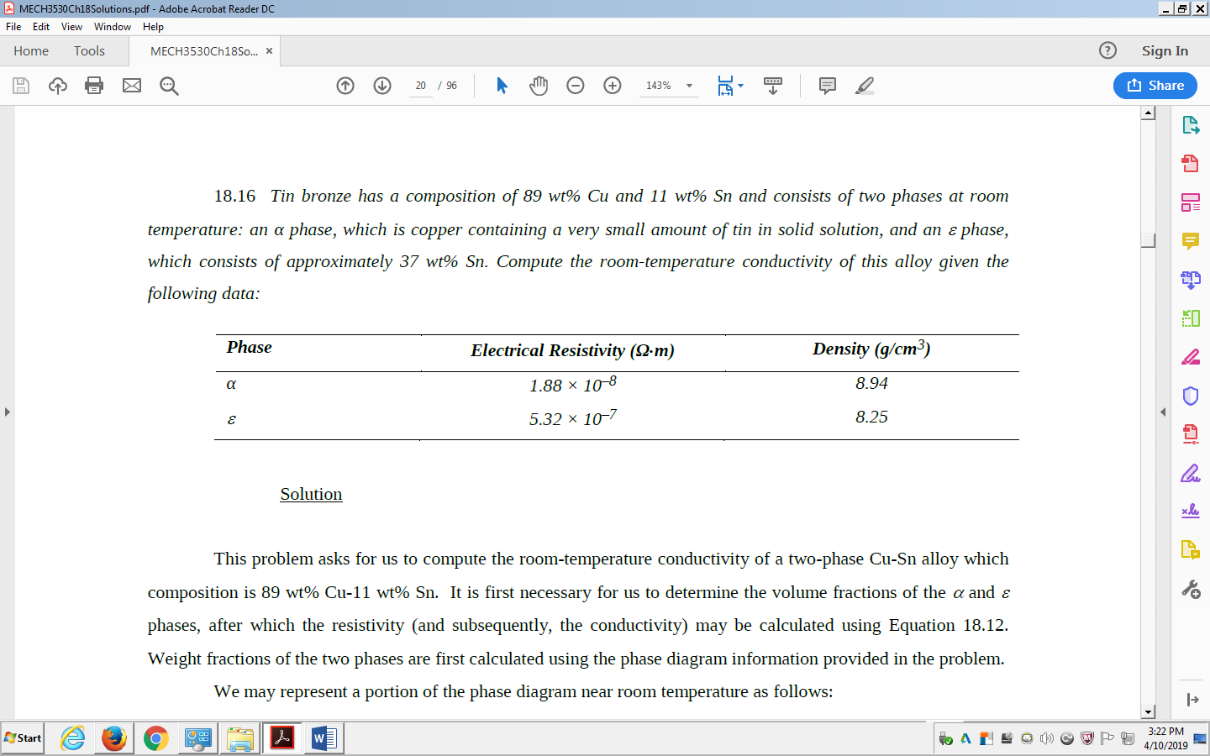

18.30 Germanium to which 1024 m–3 As atoms have been added is an extrinsic semiconductor at room temperature, and virtually all the As atoms may be thought of as being ionized (i.e., one charge carrier exists for each As atom).

(a) Is this material n-type or p-type?

(b) Calculate the electrical conductivity of this material, assuming electron and hole mobilities of 0.1 and 0.05 m2/V-s, respectively.

18.40 Estimate the electrical conductivity at 135°C of silicon that has been doped with 1024 m–3 of aluminum atoms.

18.54 The polarization P of a dielectric material positioned within a parallel-plate capacitor is to be 4.0 × 10–6 C/m2.

(a) What must be the dielectric constant if an electric field of 105 V/m is applied?

(b) What will be the dielectric displacement D?

19.2 To what temperature would 10 lbm of a brass specimen at 25°C (77°F) be raised if 65 Btu of heat is supplied?

19.10 Compute the density for iron at 700°C, given that its room-temperature density is 7.870 g/cm3. Assume that the volume coefficient of thermal expansion, αv, is equal to 3αl.

19.18 (a) Briefly explain why porosity decreases the thermal conductivity of ceramic and polymeric materials, rendering them more thermally insulative.

(b) Briefly explain how the degree of crystallinity affects the thermal conductivity of polymeric materials and why.

19.24 (a) Briefly explain why thermal stresses may be introduced into a structure by rapid heating or cooling.

(b) For cooling, what is the nature of the surface stresses?

(c) For heating, what is the nature of the surface stresses?

19.28 The two ends of a cylindrical rod of nickel 120.00 mm long and 12.000 mm in diameter are maintained rigid. If the rod is initially at 70°C, to what temperature must it be cooled in order to have a 0.023-mm reduction in diameter?