1. Calculate the composition, in weight percent, of an alloy that contains 105 kg of iron, 0.2 kg of carbon, and 1.0 kg of chromium.

Solution

The concentration, in weight percent, of an element in an alloy may be computed using Equation 4.3b. For this alloy, the concentration of iron (*C*Fe) is just





Similarly, for carbon



And for chromium



2. A cylindrical specimen of stainless steel having a diameter of 12.8 mm (0.505 in.) and a gauge length of 50.800 mm (2.000 in.) is pulled in tension. Use the load–elongation characteristics shown in the following table to complete parts (a) through (f).

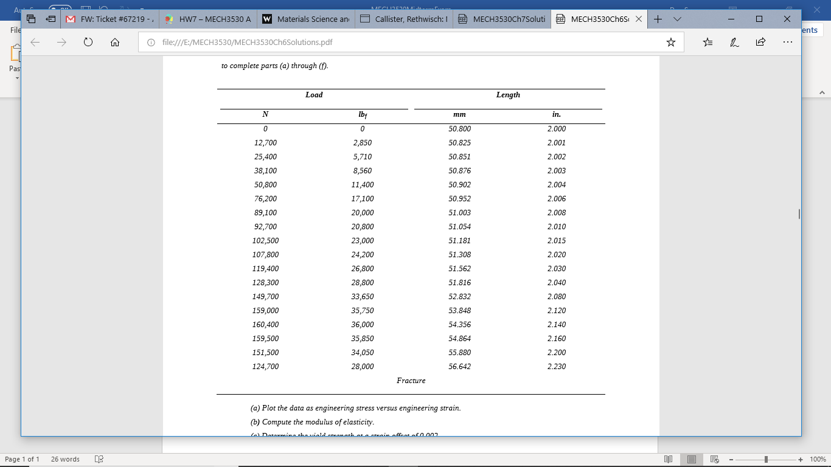

(a) Plot the data as engineering stress versus engineering strain. (b) Compute the modulus of elasticity. (c) Determine the yield strength at a strain offset of 0.002. (d) Determine the tensile strength of this alloy. (e) What is the approximate ductility, in percent elongation? (f) Compute the modulus of resilience.







3. Steady-state creep rate data are given in the following table for some alloy taken at 200°C (473 K): 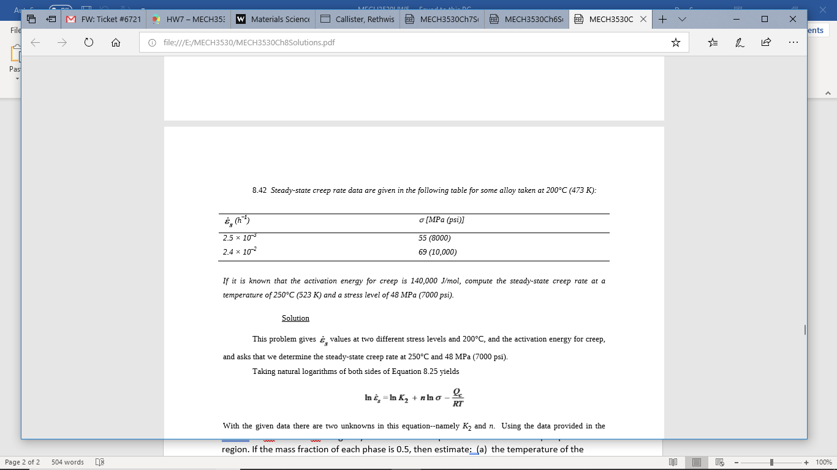

If it is known that the activation energy for creep is 140,000 J/mol, compute the steady-state creep rate at a temperature of 250°C (523 K) and a stress level of 48 MPa (7000 psi).

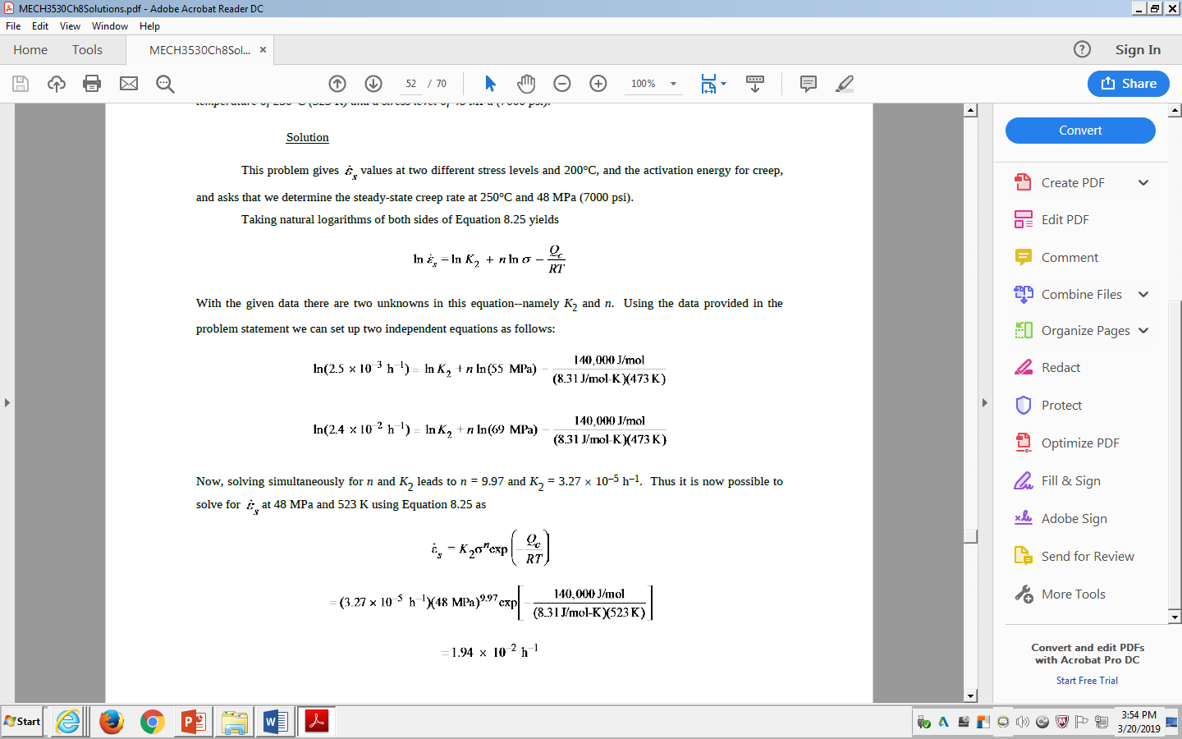

4. A three-point bending test is performed on a spinel (MgAl2O4) specimen having a rectangular cross section of height d = 3.8 mm (0.15 in.) and width b = 9 mm (0.35 in.); the distance between support points is 25 mm (1.0 in.).

(a) Compute the flexural strength if the load at fracture is 350 N (80 lbf).

(b) The point of maximum deflection Δy occurs at the center of the specimen and is described by



where E is the modulus of elasticity and I is the cross-sectional moment of inertia. Compute Δy at a load of 310 N (70 lbf).

Solution

(a) For this portion of the problem we are asked to compute the flexural strength for a spinel specimen that is subjected to a three-point bending test. The flexural strength for a rectangular cross-section (Equation 12.7a) is just



for a rectangular cross-section. Incorporating values for the parameters in this equation that are provided in the problem statement, gives the following flexural strength:



(b) We are now asked to compute the maximum deflection using Equation 12.11. From Table 12.5, the elastic modulus (*E*) for spinel is 260 GPa (38 × 106 psi). Also, the moment of inertia for a rectangular cross section (Figure 12.30) is just



Incorporating this expression for *I* into Equation 12.11 and also the value for *E*, and values of *F, L*, *b*, and *d* given in the problem statement [310 N, 25 mm (25 × 10−3 m), 9 mm (9 × 10−3 m), and 3.8 mm (3.8 10−3 m), respectively] the value of *y* is computed as follows:





