Homework 1

Q1. The case-to-ambient thermal resistance of a power transistor that has a maximum power rating of 15 W is given to be 25o C/W. If the case temperature of the transistor is not to exceed 80o C, determine the power at which this transistor can be operated safely in an environment at 40o C

Q2. A 40-W power transistor is to be cooled by attaching it to one of the commercially available heat sinks shown in Table 3–6. Select a heat sink that will allow the case temperature of the transistor not to exceed 90o C in the ambient air at 20o C.
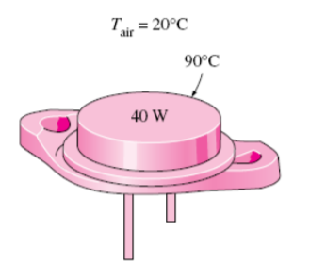
Q3. Steam in a heating system flows through tubes whose outer diameter is 5 cm and whose walls are maintained at a temperature of 180o C. Circular aluminum alloy 2024-T6 fins (k = 186 W/m·o C) of outer diameter 6 cm and constant thickness 1 mm are attached to the tube. The space between the fins is 3 mm, and thus there are 250 fins per meter length of the tube. Heat is transferred to the surrounding air at T∞ = 25o C, with a heat transfer coefficient of 40 W/m2 · o C. Determine the increase in heat transfer.
