Marvin Clarke
June 6,2017
Culmination Proposal
Project Description
My concentration in the Emerging Media department is Media Design where I would like to work as a UI/UX designer or a graphic designer. This department has also taught me how to program microcontrollers, electronics and 3D model. For my culimation I would use my knowledge of programming and 3D modeling to create a remote controlled shape display that reacts to music.
This project helps me to become creative both physically and digitally using programming software. Most designers only focus on using design software to create their artwork as for my project I am able to design a product using an arduino microcontroller to make the remote control which is the physical component and have the remote control react to shapes on a screen using Max MSP which is the digital component.
Methods
My project is a remote controlled shape display that reacts to music. The remote control will be a keypad that will use to display shapes that will be displayed on a computer monitor that will perform motions such as bouncing, spinning, rotating and other similar motions that will also move to the sound of user chosen music. These functions will happen at the same time. I will be using only eleven buttons on a 12 button remote and buttons one to eight will have their own shape, its own motions and its own sound file that move to the beat of the sound file. One added effect is that the user is able to see their self on a webcam and the video can be placed on a shape that will perform the same functions. The video effect will be programmed on the ninth button. Button ten and eleven will control the volume one button is up and the other is down. I chose this project because I want the user to interact with this display instead of just viewing a shape display. To program the remote I would need the software called Arduino. Arduino is an open-source electronics platform based on easy-to-use hardware and software. Arduino boards are microcontrollers that read inputs such as a flashing LED, turning on a switch and turn it into an output. The user gives instructions to the microcontroller so that the board can perform a function. The arduino will be programmed to make sure that the buttons on the remote can be pressed. To make sure that the shapes and video are able to be displayed using the remote I will be using a program called Max MSP/Jitter. Max MSP allows people to create unique synths or a various delays. Max Jitter fusions audio and video controls to create video processing routing and feedback systems. I will be using a 3D design and printing app called Tinkercad to print a housing for the arduino and the remote. To program the remote I will be using Arduino code that I found on the web and reconfigure it to fit my needs of the project and to program the shape and video display I would use YouTube tutorials.
Below is a chart that shows what task I would have to perform and a rough estimate as to how much time I would need to complete each task. These times and tasks are subject to change as the project progresses.
Task | Time To Complete Task
Measuring | 30 minutes
Modeling | 1-2 hours
Printing | 2-3 hours
Programming & Testing Code | 2-3 hours
Both Shape display and Remote | 2-3 days

Setting Up Materials | 1-2 hours
Testing Materials | 2-3 hours
Project Deliverables
The diagram below shows how the remote would function. If the users presses the number one once the user clicks using a mouse to chose a shape and a color. The user presses number one a second time a prompt will appear where the click to choose a specific music track and the shape will move to the music also following a chosen motion. The number one is pressed a third time everything is turned off. These functions will operate on all nine buttons.

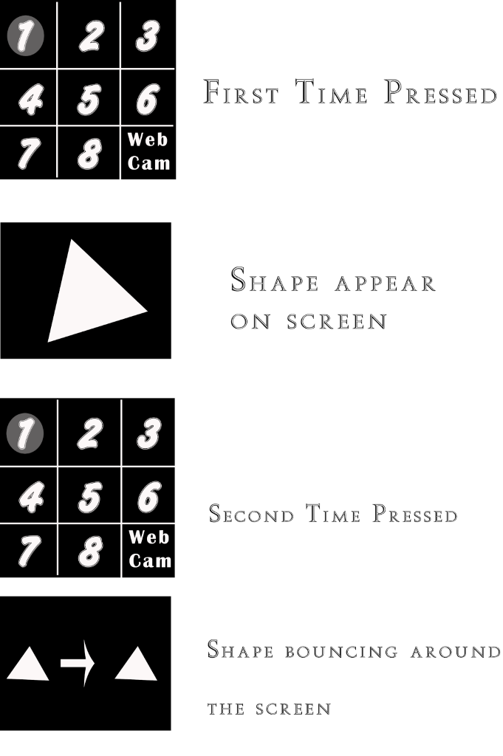

Design documents
Weekly progress reports on Open lab with screenshots of both the Max patch and the Arduino code
Wiring Diagram for the remote (Arduino diagram)
Complete Max patch and Arduino code (uploaded to Openlab)
Poster Display the overall project
Open lab portfolio where the patch, code, diagram and others resources for the project will be uploaded

Calendar
Below is a rough estimate of how many months it would take to complete the project.
Milestone | Date
Design document/specification complete | September 1
Coding the button presses for the remote | September 8
Coding up one shape and one song in the Max patch | September 15
Add the volume function | October 8
Add the webcam's functionality | October 11
4 songs and shapes added to the Max  patch | October 15
All the songs and shapes coded in the patch | October 22

Milestone(Continued) | Date
Demonstrate fully functional prototype to Kevin | October 23
Preparing 3D model for printing | October 30
1st version of the remote completed | November 7
Demonstrate revised prototype, including 3d printed remote to Kevin | November 14
Final revisions completed | November 28

Required resources and Budget
I will be needing a 3D printing in order to print the casing for the remote and the arduino so I will be using the school's machine. I will download arduino and Max MSP software for the programming and I would have to purchase the arduino, remote and additional tools needed. Below is the list of products I will need to purchase and I did not include Max MSP, Tinkercad & Arduino software because they are free software. For the final presentation poster I would get it printed from staples depending on the sizer of the poster I would be paying $29.99 for a 24 x 26 inch poster but if I am able to print it in the school I will use that method instead.
Product | Price
Arduino Mega 2560 R3 from Sparkfun.com | $45.95(each if needed)
3x4 phone styled matrix keypad from adafruit.com | $7.50(each if needed)
Jumpers(Male to Male) from adafruit.com | $1.95(each if needed)
Breadboard from sparkfun.com(If needed) | $4.95 (each if needed)
Arduino stackable header kit R3 from sparkfun.com | $1.50 (each if needed)
Proposed Table of Contents
- Introduction
- Methods- Programming and testing process
- Project Budget - Estimate vs Actual
- Project Calendar- Estimate vs Actual
- Completed Paperwork – Materials, Completion of Code, Coding & Testing time, Photo/Video of final process
- Conclusion

