The effectiveness of two different genomic-DNA extraction protocols for extracting DNA from Zonocerus variegated grasshopper for genomic studies.
As part of the genomic study of the variegated grasshopper, Zonocerus Variegatus we had extracted DNA from two different Zonocerus Variegatus grasshopper using two protocols namely, a simplified arthropod genomic-DNA extraction and a traditional Phenol/chloroform genomic-DNA extraction. Moreover because RNA in insect samples then denature rather more quickly or readily than DNA, we have decided to extract the insects DNA using both a simplified inexpensive and non-hazardous protocol and a traditional protocol. Subsequently, the extracted DNA samples will be sequenced using primer sets 12s, 18s and Mitochondrial DNA (MtDNA). In order to determine the identification of the grasshopper through the Barcode of the Life Database, a universal barcoding primers specific for the mitochondrial DNA will be used. The Mentee will participate in all aspects from DNA extraction through PCR amplification and possibly sequencing if time permits.
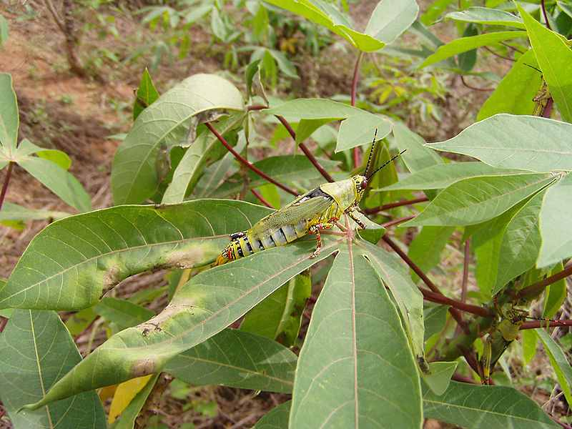

Female Zonocerus variegatus grasshopper photographed on a cassava plant
Introduction and Background
Zonocerus variegatus (Linnaeus, 1758), a variegated grasshopper or stink locust belonging to the order of Orthoptera, family of Pyrgomorphidae, is a popular agricultural pest in West and Central Africa (Chapman et al.; 1976; Kekenou et al. 2006).
According to farmers, groundnut, cassava and vegetables are the most susceptible crops to Z. variegatus; however, of all the crops cassava is the most vulnerable.
In addition to being an agricultural pest, Zonocerus variegatus grasshoppers are very beneficial to the people of West Africa because they provide high nutritional value when eaten after being fried and are considered delicacies. These variegated grasshoppers also provide substantial amounts of minerals and proteins, specifically essential amino acids. Studies, however, revealed that although grasshoppers contain substantial amount nutrients, the presence of fungal species identified exposes consumers to the probable toxic metabolites produced by those fungi.

AIM/Purpose

To determine which of the two extraction protocols, a simplified arthropod genomic-DNA or a traditional Phenol/Chloroform genomic-DNA extraction protocol is the most effective method for extracting Zonocerus Variegatus DNA for PCR-base specimen identification.

Genomic DNA Phenol/Chloroform extraction and Clean-up
In two different locations in Nigeria, two variegated grasshoppers of the Zonocerus Variegatus species were collected and grounded, and shipped to City College of Technology, United States. The grounded samples were sieved or sifted to remove the chitin of the arthropods and prevent inhibition.
At room temperature, 30-60 mg of each sample, 120-240 µl of DNA extraction buffer and 3-6 µl of Proteinase K (10mg/ml) were transferred into sterile eppendorf tubes and incubated at 65⁰C for overnight. Next, 30 µl of 5M sodium acetate were added to the samples, mixed well by inverting and incubated on ice for 30 minutes. The suspensions were then spun at 10, 000 rpm for 10 minutes and supernatants were transferred into new tubes where equal volumes of PCI were added. The solution were mixed by inverting the tubes several times and spun at 4000 rpm for 5 minutes. Next, the upper aqueous phases the contained the nucleic acids were then transferred into new tubes, where equal volumes of chloroform were added to each tube and mixed by inverting several times. The suspensions were spun again at 4000 rpm for 5 minutes and the upper aqueous layers were transferred into new tubes. To the tubes, two volumes of ice-cold 95-100% ethanol were added, inverted several times and allowed to precipitate at -20⁰C for 10 minutes. The samples were then spun at high speed to collect the DNA; the ethanol from each sample was gently poured off and the pellets were resuspended in 0.5 ml of TE buffer solution. 0.3 ml of 5 M sodium acetate and 1 ml of 100% ethanol were added to the resuspended DNA and placed at -20⁰C for 10 minutes. Finally, the tubes were spun at top speed; the ethanol supernatants were gently poured off, and the resulting pellets were resuspended 100 µl TE buffer.
DNA amplification and sequencing reaction
The extracted genomic DNA will be PCR amplification and sequenced using primer sets 12s, 18s and Mitochondrial DNA (mtDNA) to determine the identification of the grasshoppers.
Results and Discussion
Prior to using a traditional Phenol/Chloroform extraction protocol for genomic DNA, a simplified arthropod extraction protocol was used but was unsuccessful in yielding high quality DNA. Currently, the results for this project are inconclusive and subsequently will be continued for concrete data in the upcoming semester.

