‣The effects of poor dental care range from tooth decay and cavities to gingivitis, periodontitis, and tooth loss.
‣The increase in these negative effects can
create an opportunity for systemic disease
that cause oral disease into a whole body disease.
‣This is evident in the case of periodontal disease
and reactivating latent HIV, primarily the
interaction of P. gingivalis and latent HIV

PLAQUE RELATED GINGIVITIS
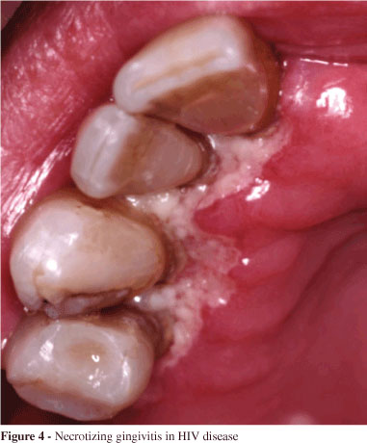
HIV PERIODONTITIS
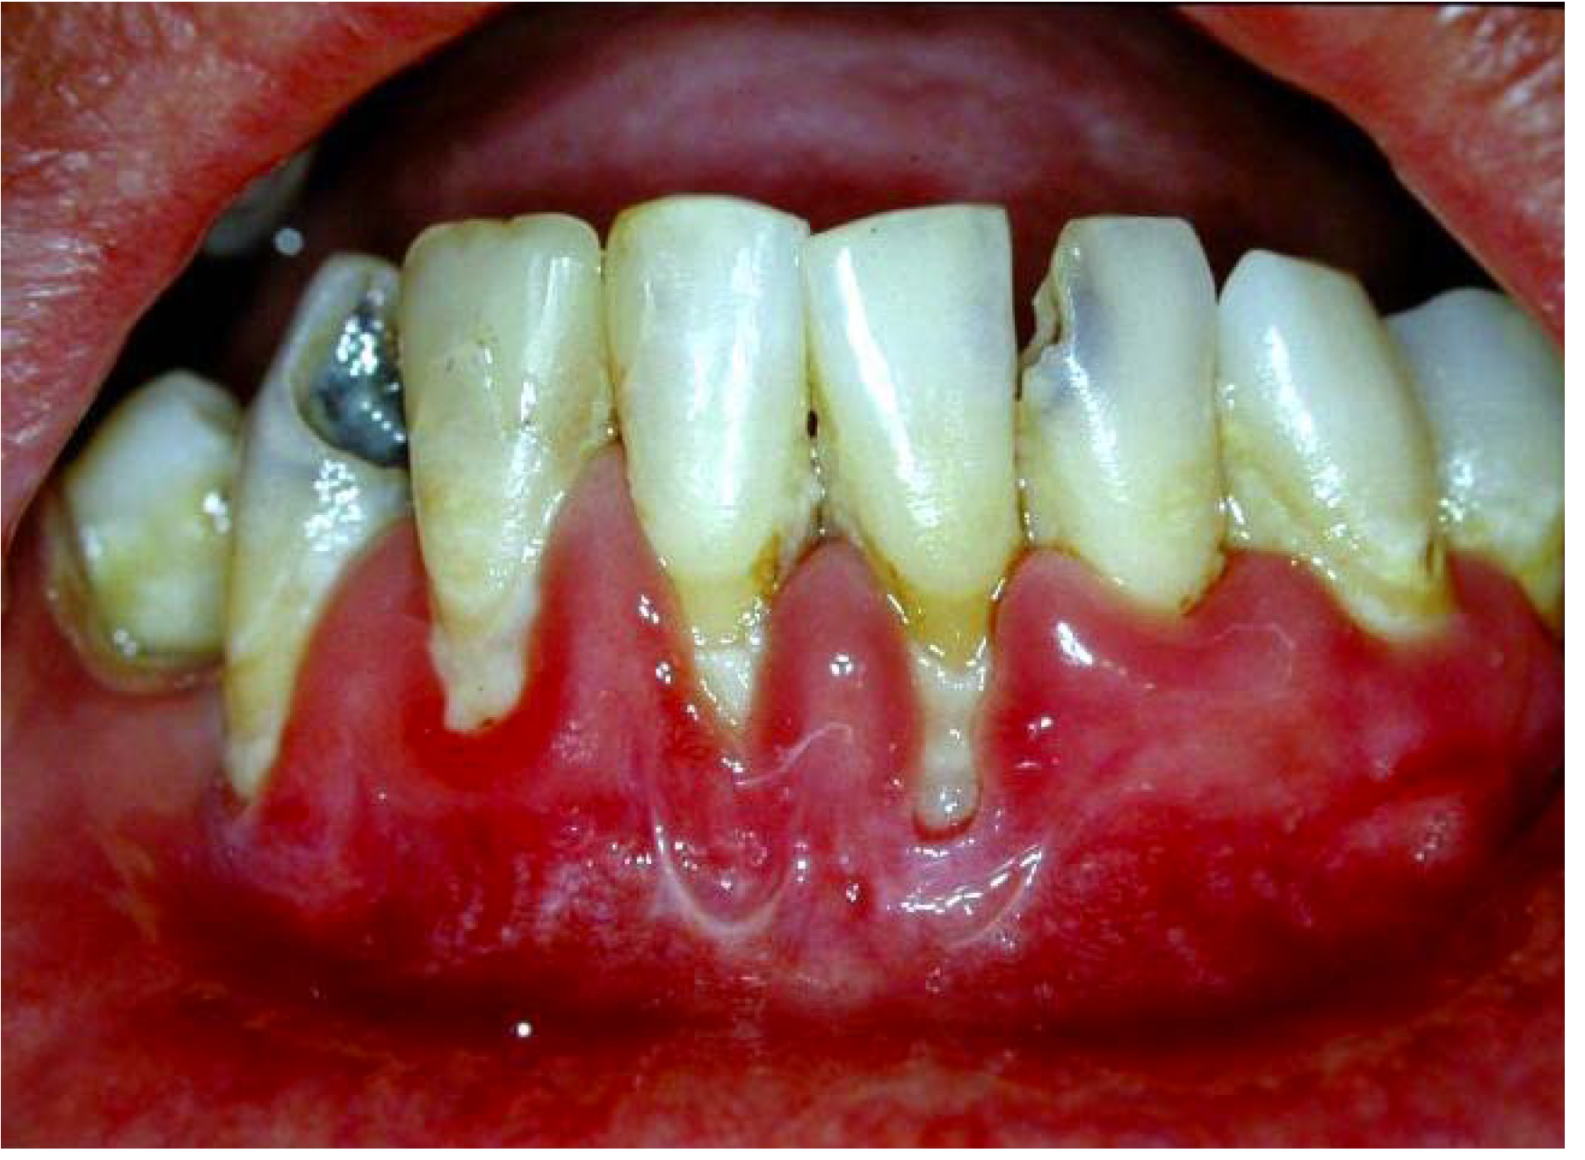

ROLE OF THE DENTAL HYGIENIST
- Education about appropriate oral health self- care.
- Provide periodic oral examinations.
- Provide early intervention and preventive care services.
- Demonstrate to the patient that you want to provide him/her with the best treatment.
- Ensure patients’ comfort so he/she feel motivated to revisit to assess his/her progress.
- Maintain proper infection control to prevent spread of the disease.

REFERENCES

BRUSH YOUR TEETH, LET HIV SLEEP
Linking the periodontopathic bacterium

P. gin
P. gingivalis with the reactivation of
Flatten
Latent HIV in infected individuals.
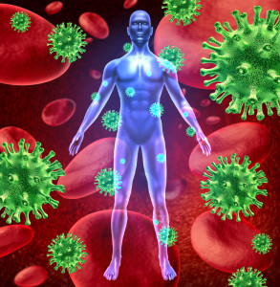
Presenters: Kelly Panayiotou, Kevin Rojas, and Melanie
Clre
Clare
EFFECTS OF POOR ORAL CARE

WHAT IS P. GINGIVALIS? Direct link between P. gingivalis and HIV WHAT IS HIV?
‣P. gingivalis is a gram-negative anaerobic ‣ P. gingivalis can activate TLR2, TLR4 and ‣HIV (human immunodeficiency virus) is a bacterium belonging to the phylum TLR9 influencing the production of cytokines lentivirus that is known to cause acquired
Bacteroidetes and is known cause of and chemokines. These TLRs are involved in immunodeficiency syndrome (AIDS), a
gingivitis (inflammation of the gingiva) and HIV-1 reactivation condition that specifically affects humans
periodontitis (inflammation of the suppressing their immune system
periodontium or other supporting tissues). destroying important cells that fight
‣It is normally found within the mouth, GI disease and infection.
tract and colon. ‣HIV is transmitted via bodily fluids inside
‣This microbe works with other the blood stream and infects the key
bacteria to create plaque biofilm component of the immune system,
including by not limited to cell known as
macrophage.
‣The virus works its way into the nucleus
the cell macrophage by penetrating the
nuclear pore complex, integrating it-
self into the cell’s DNA subsequently
replicating and spreading throughout
the body.

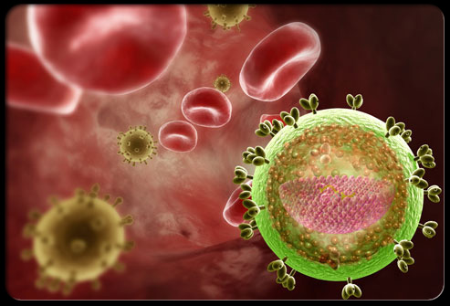
REACTIVATION OF LATENT HIV 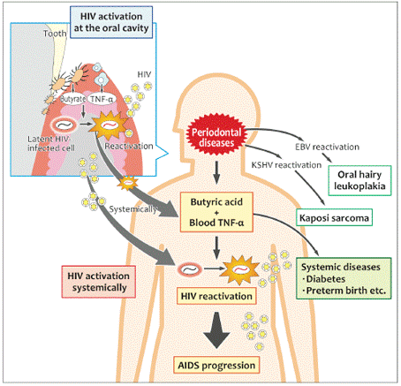

MECHANISM OF THE REACTIVATION
LATENT HIV VIA P.GINGIVALIS `

subgingivally replacing the existing gram- 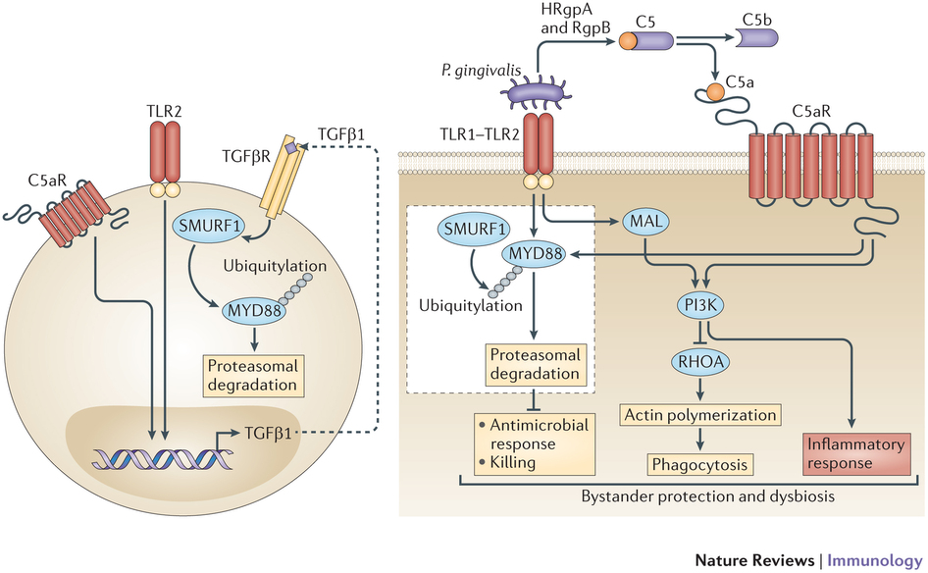
positive facultative bacteria with gram-
negative anaerobic bacteria.
‣Consequently, eliciting an inflammatory
response that results in the detachment of the
gums from the teeth.

PLAQUE BIOFILM IN THE MOUTH
