**Python Challenge**

For 5 points on your next exam: Come to the front of the room and roll a die. If you get a

1: Code the Binary Search Algorithm into Python

2: Code the Insertion Sort Algorithm into Python

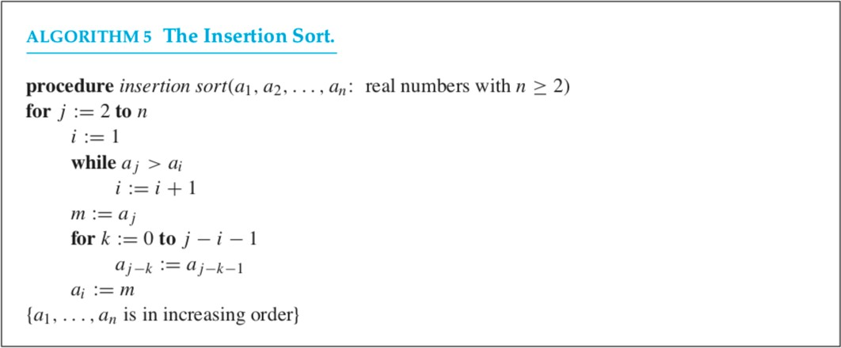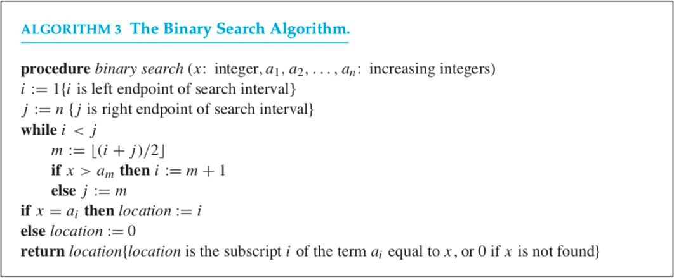3: Code the Bubble Sort Algorithm in Python

4: Code the Greedy Change Making Algorithm into Python

Show your sort algorithm works by sorting a=[3,4,6,7,2,2,5].

Show your search algorithm works by searching a for 7.

Show your change making algorithm works by making change for n=699 cents.

