New York City College of Technology
Calculus 1 /Handout
Student Name
Homework: Watch the video
https: https://youtu.be/aYQH08OWr4U?t=21//www.youtube.com/watch?v=iEXGCOru2as
Work on the desmos activity and complete this worksheet at the same time.
Problem: A Skydiver Jumps from a plane without a parachute. (The green skydiver). The plane continues at the same altitude (2500 ft) with an instant rate of (speed) 440 ft per second) At what rate is the distance between the airplane and the skydiver increasing if the skydiver is at 13,000ft altitude and he reads the angle on his magnetic angle locator of 60 degrees from his body to the plane

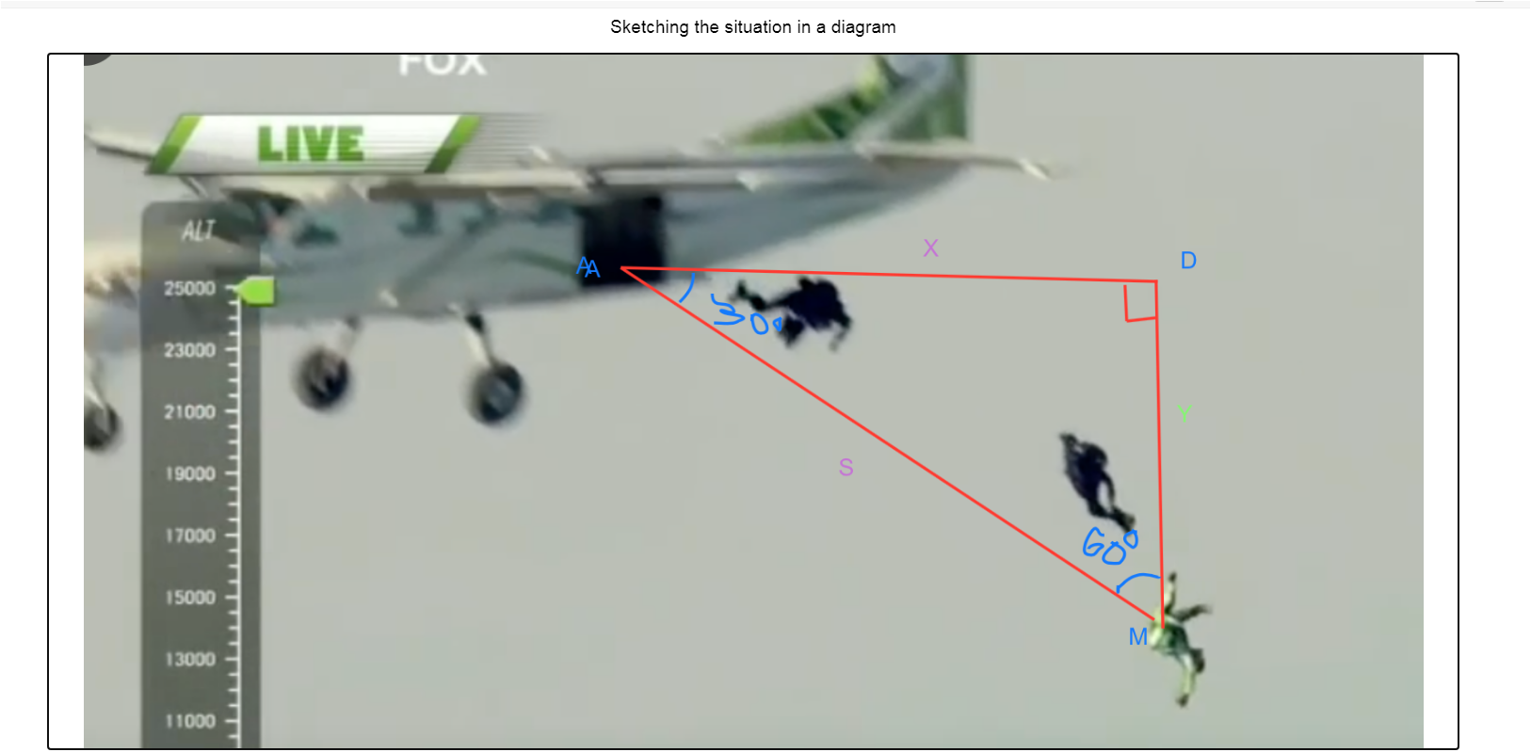
Step by step we will answer these questions:
1) Determine all the given parameters, measure and what you are asked to solve for.
2) Write the main relation that can help you connect the known and unknown parameters. (quantities)
3) Using related rates and implicit differentiation calculating the rate in which the distance between the airplane and the skydiver is increasing.
Step 1)
Challenge 1
Sketching the situation Finding displacement of the skydiver knowing his positions and other elements in the triangle.
Think about geometry only for a moment:
What do you know in the given triangle?
What is the distance in feet between the skydiver man (M) and the dropping point (D)?
There are six elements of the triangle, three sides, and three angles. List all of them and write all that you know with their measures:
AD=_ < A=_
AM=_ < D=_
DM=_ < M=_
Did you find: (Monitoring the progress of the students)
AD=_ < A=_ 30 degrees
AM=_ < D=_ 90 degrees
DM=_12,000 ft < M=_ 60 degrees
(2500-13000=12,000 ft)

Challenge 2:
Write all that you know and what you don’t to calculate what you are asked for.

Did you write:
From given information in the problem and the sketch we know:
a) All the angles in the triangle.
b) y=MD=12,000ft
c) `\frac{dx}{dt}=440\ \frac{ft}{\sec}`
I am asked to find: `\frac{ds}{dt}\ =?` at the moment when angle M is 60 degrees.
AD=_ < A=_ 30 degrees
AM=_ < D=_ 90 degrees
DM=_12,000 ft < M=_ 60 degrees
Step 2)
Challenge 3:
Write the main relationship between sides in the triangle
Did you write:
$x^{2}+y^{2}=s^{2}$ ? (Pythagorean theorem)
Challenge 4: Differentiate using implicit differentiation
Substitute y=12,000f
$x^{2}+{12,000}^{2}=s^{2}$
Step 3)
Challenge 5: Differentiate using implicit differentiation with respect to time: $2x\frac{dx}{dt}=2s\frac{ds}{dt}$
Challenge 6 :
Look for all measures involved. Do you have everything you need to calculate ds/dt?
Find all you need to solve for $\frac{ⅆs}{ⅆt}$
It turns out that you need to solve the triangle for x and s at the considered moment.
So, solve for x and s if you can.
Based on geometry from a theorem we know that:
The opposite leg of 30ᵒ angle in a right triangle is half of the hypotenuse.
From there we can say that $s=2y$
We need to calculate the x as well.
In the equation found from challenge 4 we substitute s=24,000 ft
X=20,784.61 ft
So, did you find:
S=24,000 ft and x≈20,784.61
Challenge 7 :
Substitute in the differentiated equations all you know and solve for ds/dt.
$2x\frac{dx}{dt}=2s\frac{ds}{dt}$
Solve for $\frac{ds}{dt}$ divide by 2s both sides of the equation
Challenge 8:
Substitute in the differentiated equations all you know to calculate ds/dt.
substituting all we know or we found:
$\frac{ds}{dt}≈381.1\frac{ft}{sec}$
Conclusions:
What did you learn today? Did your question from the first slide get answered?
If yes, share your thoughts.
If not, would you be able to answer it on your own when you go home and study more?
Try to do that, and if you cannot answer it bring it to class next session.
Create your own activity similar to the one that we worked on today and bring it to class.
https://teacher.desmos.com/activitybuilder/custom/5e133541de57050e8d7c07ce
Hey, students!
Go to student.desmos.com
and type in:
KA56QG
You can also share this link with your students:

