MAT 1372 Stat w/ Prob classwk 17 Spring 2012

**6.3 NORMAL RANDOM VARIABLES**

A normal random variable is a continuous random variable with a density function that is a bell-shaped density curve symmetric about the mean μ. Its variability is measured by the standard deviation σ.

If μ=0 and σ=1, we have the **standard normal distribution** and the density function is



1. Changing μ

amounts to a horizontal shift and we get 

## Changing σ

is a more complicated change:

* horizontal compression and vertical stretch if 0<σ<1 or
* vertical compression and horizontal stretch if σ>1.

The density function is 

## Changing μ and σ

is a simultaneous horizontal shift and vertical/horizontal compression/stretch. The density function is (note the error in the book, p. 267)

If we keep μ fixed at 2, fix the horizontal and vertical scales, but vary the σ, we get



1. This is our starting point; the classical “bell-shaped” curve.
2. when σ is diminished, the height of the peak is increased to compensate for the smaller width (area under density function must always be same, namely 1).
3. When σ is increased, the height of the peak is diminished to compensate for the larger width.

In subsequent depictions of the density function, we will always use a graph similar to (b), but we will adjust the labels (including the scales) for a given μ and σ.

## Analyzing the area under the curve

Many applications amount to finding the area under different parts of the curve. The following picture will be important:

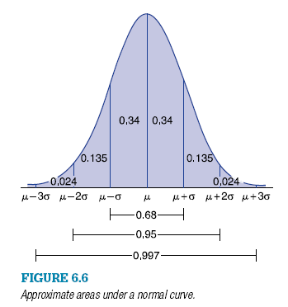

* 68% of the area is within one SD of the mean: 
* 95% of the area is within two SD of the mean: 
* 99.7% of the area is within three SD of the mean: 

Z is used to indicate the standard normal distribution (μ=0 and σ=1):

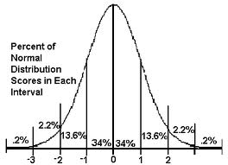

**4.** *P*{*Z* > −1} is approximately

**(a)** 0.50 **(b)** 0.95 **(c)** 0.84 **(d)** 0.16

Hint: Easiest to do complement, i.e.,*P*{*Z* > −1}=1−*P*{*Z* < −1}

**6.** *P*{*Z* > 3} is approximately

**(a)** 0.30 **(b)** 0.05 **(c)** 0.002 **(d)** 0.99

**17.** If *X* is normal with μ=100 and σ= 2, and

*Y* is normal with μ=100 and σ= 4,

is *X* or *Y* more likely to

1. Exceed 104 **(b)** Exceed 96 **(c)** Exceed 100

X: Y:

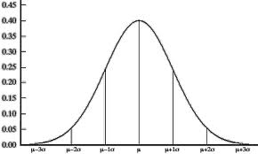

96 98 100 102 104 96 100 104

From the above diagrams, we see

(a) Y is more likely to exceed 104

(b) X is more likely to exceed 96

(c) X and Y have equal probability of exceeding 100.

**18.** If *X* is normal with μ=100 and σ= 2, and

*Y* is normal with μ=105 and σ= 10,

is *X* or *Y* more likely to

Exceed 105 **(b)** Be less than 95

X: Y:



96 98 100 102 104 95 105 115

From the above diagrams, we see

(a) Y is more likely to exceed 105

(b) Y is more likely to be less than 95

Additional Exercises (a>0)

1. Use *P*{*Z* < *0*}=0.5 to show

*P*{0< *Z* < *a*} = *P*{*Z* < *a*} − 0.5

1. Use complements & the fact that *P*{*Z* < −a} = *P*{*Z* > a} to show that

*P*{*Z* > −a} = *P*{*Z* < a}

1. Find the value of the question mark:

*P*{−2 < *Z* < 1} = *P*{-1 < *Z* <?}

Use the fact that *P*{-a<*Z* < 0} = *P*{0<*Z* <a} to show that your answer is correct.

1. Write down a similar fact to the above and prove it.

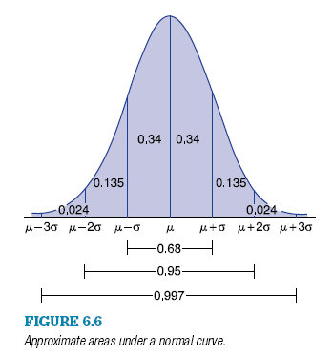**6.5 FINDING NORMAL PROBABILITIES (via STANDARD NORMAL and NORMSDIST)**

Given an inequality for a normal random variable, we “standardize” by subtracting the mean and dividing by the standard deviation

**Example**: Suppose that μ=70 and σ=10, what chance did someone have of getting a 90? An 85?

Since 90 is 2 standard deviations from the mean, using the graph, we see that the chance of getting a 90 is .5-(.34+.135)=.025=2.5%

85 is 1.5 std devs away from the mean, so the chart only tells us that is between 2.5% and 16%. More formally, we standardize:



To get the probability, we think complement



And use the Excel function 1-NORMSDIST(1.5) to get 0.066807 or about 6.7%

**2.** If *X* is normal with mean 10 and standard deviation 3, find

**(a)** *P*{*X* > 12} **(c)** *P*{8 < *X* < 11} **(e)** *P*{|*X* − 10| > 5}

**6.** The life of a certain automobile tire is normally distributed with mean

35,000 miles and standard deviation 5000 miles.

1. What proportion of such tires last between 30,000 and 40,000 miles?

*P*{|*Z* | < 1}

1. What proportion of such tires last over 40,000 miles?

*P*{*Z*  >1}

1. What proportion last over 50,000 miles?

*P*{*Z*  >3}

**7.** Suppose you purchased such a tire as described in Prob. 6. If the

tire is in working condition after 40,000 miles, what is the conditional

probability that it will still be working after an additional 10,000 miles?

*P*{*Z*  >3}/ *P*{*Z*  >1}