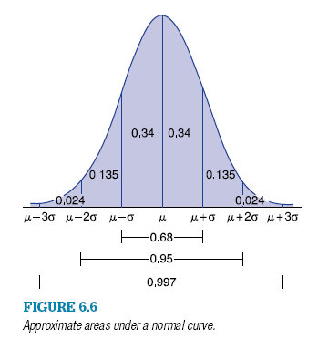
MAT 1372-6556 Statistics with Probability Quiz 15 Fall 2012 Do without the aid of technology!
1. The heights of a certain population of males are normally distributed with mean 69 inches and standard deviation 6.5 inches. Approximate the proportion of this population whose height is more than 62.5 inches.
- Begin by labeling the locations of 69 and 62.5 on the graph to the right.
- Shade the area that corresponds to the question.
- Find the proportion by using the fact that half the area is to the right of the midline.

- Using NORMDIST(x,mean,standard_dev,cumulative) and thinking complement, what is an Excel function to find the answer?

2. a) Find the value of the question mark:
P{−2 < Z < −1} = P{1 < Z <?}

Shade and label the picture of the standard normal curve
to the right to show that your answer is correct.

b) Find the value of the question mark:
P{Z > 1} = P{Z < ?}.

Shade and label the picture of the standard normal curve to the left to show that your answer is correct.

