New York City College of Technology MAT1372 Practice_Exam II, Halleck, Fall 2012
Show all work and answers in blue book [except for 5 a)]. Turn in exam sheet together with blue book! For 1-6, you may use your formula sheet and scientific calculator. You may use graphing calculator but not advanced features such as binomial probabilities.
For 7, you may use Excel. Write down any Excel commands that you use.
Part I By hand (calculator ok):
1. (10 pts) A random variable has the following probability distribution:
X -2 -1 1 2
P(X) 0.3 0.2 0.3 ?
Find a) the probability when X=2: P(2)=1-(.3+.2+.3)=.2
b) the mean: E(X)= -2*.3+-1*.2+1*.3+2*.2=-.1
c) the standard deviation V(X)= E(X^2)-mu^2=(1.2+.2+.3+.8)-(-.1)^2=2.5-.01=2.49 so SD=1.58
x^2 | 4 | 1 | 1 | 4
P(x) | 0.3 | 0.2 | 0.3 | 0.2
x^2*P(x) | 1.2 | 0.2 | 0.3 | 0.8
2. (10 pts) If a bent coin with probability of a head .3 is tossed 5 times, find the probability of getting
a) exactly 0 heads (5c0)(.3)^0(.7)^5=.168 b) exactly 1 head (5c1)(.3)^1(.7)^4=.360
c) at least 2 heads [use results from parts a) and b)]=1-(.168+.360)=.472
d) write down an excel command that you could use directly to answer c) without using answers from a and b
=1-BINOMDIST(1,5,0.3,TRUE)
3. (10 pts) The federal government has found that 70% of environmental complaints are valid. The government received 119,000 complaints last yr.
a) About how many of them are expected to be valid? (i.e. find the mean). E(X)=np=119,000*.7=83300
b) Find the standard deviation. V(X)=npq==119000*0.7*0.3=24990 so SD(X)=158

4. (10 pts) A 6 sided dice is rolled 1000 times. Let X be the random variable which consists of 1 if the roll is 1 and 0 otherwise. Let be the random variable which counts the number of 1’s in the 1000 rolls and then divides by 1000.
a) What is the expectation for X and ? E[X]=1/6, E[]=E[X]=1/6
x | 0 | 1
P(x) | 5/6 | 1/6
b) What is the variance and standard deviation for X and ?
x^2 | 0 | 1
P(x) | 5/6 | 1/6
So E[X^2]=1/6, V[X]= E(X^2)-mu^2=1/6-(1/6)^2=1/6(1-1/6)=1/6*5/6=5/36=pq and SD[X]=sqrt(5)/6
V[]=V[X]/n=5/36 /1000=1/7200 and SD[]=1/(sqrt(2)60)=sqrt(2)/120
5. (30 pts) The following data represent the number of days absent (X) and final grade (Y) in a statistics course.
a) Use the graph paper to draw the scatter plot.

b) Find and c) interpret the coefficient of correlation and/or its square
b) r=sum dev prods/sqrt(sum of xdev^2* sum of ydev^2)= -231/sqrt(82.5*726)=-.944
c) Since r is negative, the correlation is negative (trendline goes down from left to right).
Since r^2 is .891, at most 89% of the response variable may be attributed to the explanatory variable.
d) Find the equation of the regression line.
B= sum dev prods/sum of xdev^2=-231/82.5=-2.8
A=-B= 81-(-2.8)4.5=93.6
y=A+Bx=93.6-2.8x
e) Interpret the slope & y-intercept.
For every absence, the final grade decreases by 2.8 points.
A person with 0 absences should have a score of 93.6.
f) If Carol has 5 absences, what final grade can she expect?
y=93.6-2.8*5=79.6

6.(10 pts) If the a probability distribution is in the form of a right triangle with peak at 2 and x-intercept 8, find
a) height of the triangle: A=1/2bh=1/2(8-2)h=3h=1 so h=1/3
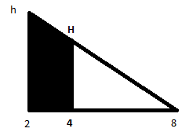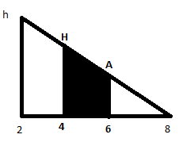
b) P(4<x) By similar triangles 4/H=6/h=6/(1/3)=18, so 18H=4 or H=2/9
A=1/2(h+H)(4-2)=1/2(1/3+2/9)(2)=5/9
c) P(4<x<6) Also by similar triangles 4/H=2/A or 4/(2/9)=18=2/A so 18A=2 or A=1/9
A=1/2(H+A)(6-4)=1/2(2/9+1/9)(2)=3/9=1/3

Part II Using Excel: For each part, draw a picture with the normal distribution with both X and Z labels.
7. (20 pts) X is normally distributed with mean -10 and standard deviation 7 (use normalized standard distribution Z).
- What is the probability that X is less than 0?X<0 x-(-10)<10 (x+10)/7<10/7 Z<10/7
=normsdist(10/7)= 0.9234363
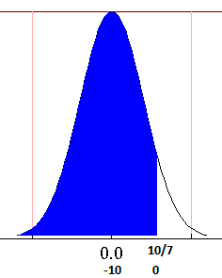
- What is the probability that X is greater than -20?
X>-20 X-(-10) >-10 (X+10)/7>-10/7 Z>-10/7
By symmetry it is the same or =1-normsdist(-10/7)= 0.9234363
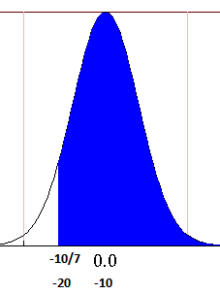
- What is the probability that X is between -5 and 5?
-5<X<5 5<X+10<15 5/7<(X+10)/7<15/7
=normsdist(15/7)-normsdist(5/7)= 0.221463
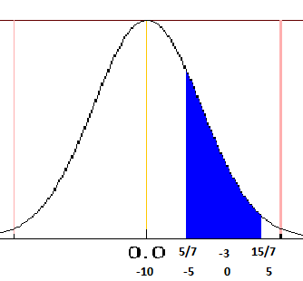
- Above what value of X are 3% of the values? (find the zscore, then convert to score).
Zscore is =normsinv(1-.03)=1.881
Score =7*normsinv(1-.03)-10=3.165555257
