MAT 1372 Stat w/ Prob classwk 23 Fall 2012

**8.2 POINT ESTIMATOR OF A POPULATION MEAN**

What is meant by a point estimator?

**Definition** *An* estimator *is a statistic whose value depends on the particular sample drawn.*

The value of the estimator, called the estimate, is used to predict the value of a population parameter.

A *point* estimator produces a single value. It could be the mean, standard deviation or some other desired statistic.

**Definition** *An estimator whose expected value is equal to the parameter it is estimating is an* unbiased *estimator of that parameter.*

For the sample mean



socan be used as an *unbiased* estimator of μ.

Recall that 

The quantity SD() is the *standard error* of as an estimator of the mean.

 is approximately normal, especially when the sample size *n* is large

So with high probability (95%), the estimate of the population mean will be correct to within ±2 standard errors.

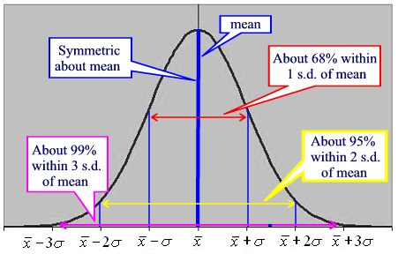

Note that the standard error decreases by the square root of the sample size: to cut the standard error in half, we must increase the sample size by a factor of 4.

**Example exercise**: Let us suppose that a poll with sample size 500 predicts Obama will get 51% of the vote in Ohio plus or minus 2%. In this situation, the standard error is 1%. If we desire to decrease the standard error in half, we should do a poll with what sample size?

**Solution**: To decrease the standard error in half, we need to increase the sample size by a factor of 4 to a total of 2000.

**4.** A random sample of nine preschoolers from a given neighborhood

yielded the following data concerning the number of hours per day

each one spent watching television:

3, 0, 5, 3.5, 1.5, 2, 3, 2.5, 2

Estimate the average number of hours per day spent watching television

by preschoolers in that neighborhood.

**6.** A proposed study for estimating the average cholesterol level of working

adults calls for a sample size of 1000. If we want to reduce

the resulting standard error by a factor of 9, what sample size is

necessary?

**8.** The following data represent the number of minutes each of a random

sample of 12 recent patients at a medical clinic spent waiting to see a

physician:

46, 38, 22, 54, 60, 36, 44, 50, 35, 66, 48, 30

Use these data to estimate the average waiting time of all patients at

this clinic.

**10.** Does (a) or (b) yield a more precise estimator of μ?

**(a)** The sample mean of a sample of size *n* from a population with mean

μ and variance σ2

**(b)** The sample mean of a sample of size 3*n* from a population with

mean μ and variance 2σ2

**(c)** How large would the sample in (b) have to be in order to match

the precision of the estimator in (a)?