MAT 1372 Stat w/ Prob classwk 17 Fall 2012

**6.3 NORMAL RANDOM VARIABLES**

A normal random variable is a continuous random variable with a density function that is a bell-shaped density curve symmetric about the mean μ. Its variability is measured by the standard deviation σ.

If μ=0 and σ=1, we have the **standard normal distribution** and the density function is



**Exercise**: *Use Excel to plot the density function. Create a table with two columns, x and y. In the x column, begin at -2, increment by .1 and finish at 2. You should have 41 rows. In the y column, use the formula, referencing the appropriate x-value. For the exponential function, use EXP. For pi, use PI.*

1. Changing the mean μ

amounts to a horizontal shift and we get 

**Exercise**: *Use Excel to plot the density function with*

μ=1 on the same plot as μ=0. Use the same x-values.

## Changing the standard deviation σ

is a more complicated change:

* horizontal compression and vertical stretch if 0<σ<1 or
* vertical compression and horizontal stretch if σ>1.

The density function is 

**Exercise**: *Use Excel to plot the density function with*

σ=2 on the same plot as σ=1. Use the same x-values.

## Changing both the mean μ and the standard deviation σ

is a simultaneous horizontal shift and vertical/horizontal compression/stretch. The density function is (note the error in the book, p. 267)

If we keep μ fixed at 2, fix the horizontal and vertical scales, but vary the σ, we get



1. when σ is diminished, the height of the peak is increased to compensate for the smaller width (area under density function must always be same, namely 1).
2. When σ is increased, the height of the peak is diminished to compensate for the larger width.

## Analyzing the area under the curve

Many applications amount to finding the area under different parts of the curve. The following picture will be important (it was introduced earlier when we discussed the empirical rule):

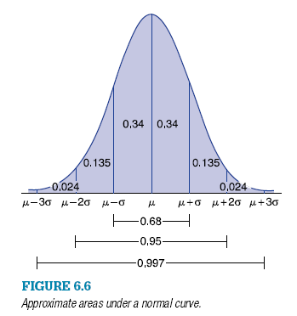

* 68% of the area is within one SD of the mean: 
* 95% of the area is within two SD of the mean: 
* 99.7% of the area is within three SD of the mean: 

Z is used to indicate the standard normal distribution (μ=0 and σ=1):

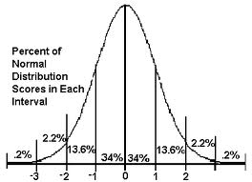

**4.** *P*{*Z* > −1} is approximately

**(a)** 0.50 **(b)** 0.95 **(c)** 0.84 **(d)** 0.16

Hint: Easiest to do complement, i.e.,*P*{*Z* > −1}=1−*P*{*Z* < −1}

**6.** *P*{*Z* > 3} is approximately

**(a)** 0.30 **(b)** 0.05 **(c)** 0.002 **(d)** 0.99

**17.** If *X* is normal with μ=100 and σ= 2, and

*Y* is normal with μ=100 and σ= 4,

is *X* or *Y* more likely to

1. Exceed 104 **(b)** Exceed 96 **(c)** Exceed 100

X: Y:

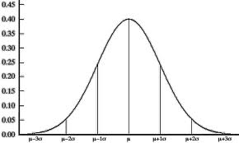

96 98 100 102 104 96 100 104

From the above diagrams, we see

(a) Y is more likely to exceed 104

(b) X is more likely to exceed 96

(c) X and Y have equal probability of exceeding 100.

**18.** If *X* is normal with μ=100 and σ= 2, and

*Y* is normal with μ=105 and σ= 10,

is *X* or *Y* more likely to

Exceed 105 **(b)** Be less than 95

X: Y:



96 98 100 102 104 95 105 115

From the above diagrams, we see

(a) Y is more likely to exceed 105

(b) Y is more likely to be less than 95

Additional Exercises

1. Use *P*{*Z* < *0*}=0.5 and diagram(s) to show

*P*{0< *Z* < *1.5*} = *P*{*Z* < *1.5*} − 0.5

1. Use complements, diagrams & the fact that *P*{*Z* < −.5} = *P*{*Z* > .5} to show that

*P*{*Z* > −.5} = *P*{*Z* < .5}

1. Draw the appropriate diagrams to find the value of the question mark:

*P*{−2 < *Z* < 1} = *P*{-1 < *Z* <?}

Use the fact that *P*{-a<*Z* < 0} = *P*{0<*Z* <a} for any a>0 to show that your answer is correct.