Intro
We have noticed that the internet is becoming a part of our lives now especially for college students and that we might even be addicted to it. So we decided to answer our own question, “How addicted are we to the internet?” Our assumption was that most college students are addicted to the internet, but to be more specific we wondered if age has any relation to internet addiction and we do think there is. We believe that younger students will have a higher level of addiction to the internet while older students will have a lower level of addiction or less than the younger students since as students get older they will have less leisure time therefore spending less time on the internet. So we think there will be a negative correlation that will be moderate, moderate because we think that for most people even as you get older you won’t really let go of that internet that much.

Population
To begin our experiment we took a survey of high school and college students ranging from 15 to 25 years of age. For high school students we went back to our high schools and randomly selected anyone as long as they were 15 years or older. For college students we did the same except it was at city tech and we made sure they were 25 or below.

Variables
Our variables would be the score that each person scored from our survey, the number of people that scored the same score or the frequency of the scores and the age of each person. The scores will be in a range of 0 to 40 where 40 is the highest level of internet addiction and 0 is the lowest and we will mark three separate intervals in this range to determine the level of addiction where 0 to 10 is “not addicted”, 11 to 25 is “somewhat addicted”, 26 to 40 is “addicted”.

Data Collection
In collecting our data we used a survey with 8 questions that would determine your level of addiction to the internet. We would ask any student in our different high schools and in city tech and even though it is any random student we decided to ask a variety of students just so we can get the most accurate data. We would try to survey some older students and younger students, try to survey an equal amount of male and female and when looking for students to survey we would try not to pick students that we prefer to ask or let our own judgment pick the students. Doing this we would have a larger scope of the overall population instead of a small section of the overall population giving us a closer representation of the overall population.

Study Design
On our frequency chart or histogram we have the x-value or the input variable as the scores of the students and the y-value or the response variable as the frequency of the scores. The score of the student will be the independent variable and the frequency of the scores will be the dependent variable since it depends on the scores of the students. By doing this we will be able to see where most of the students will score in and from that we can see the level of addiction to the internet of the overall population. For our scatter plot we will see if our hypothesis is true or not by comparing the age of the students and their scores. So the x-value would be age of the students and the y-value the score of the students. We expect to see a negative correlation where the scores will slowly decrease as the age gets higher and higher. There will also be repeats on the scatter plot where the same point will be plotted on more than once, but this does not matter since it wouldn’t really affect the outcome of the graph.
Age | Score |  |  | Age | Score | Age | Score
15  15  15  15  15  16  16  16  16  16  16  16  17  17  17  18  18  18  18  18  18  18  18  18  18 | 35  37  34  37  36  39  40  35  34  32  22  18  32  26  37  31  30  27  29  25  9  24  36  39  34 | 19  19  19  19  19  19  19  19  19  19  20  20  20  20  20  20  20  20  20  20  21  21  21  21  21 | 33  32  32  31  30  34  31  24  22  12  19  18  24  25  16  15  17  19  13  15  25  26  29  27  12 | 21  21  22  22  22  22  22  22  23  23  23  23  24  24  24  24  24  25  25  25  25  25  25  25  25 | 13  14  23  24  18  16  19  10  15  25  29  30  12  14  12  11  9  9  9  8  6  5  2  7  3

Descriptive Statistics

Sample size: 75
Mean: 22.7
Standard Deviation: 10.2

Five number summary
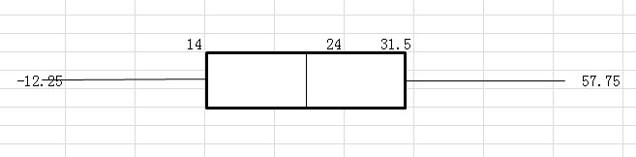

Statistical Analysis

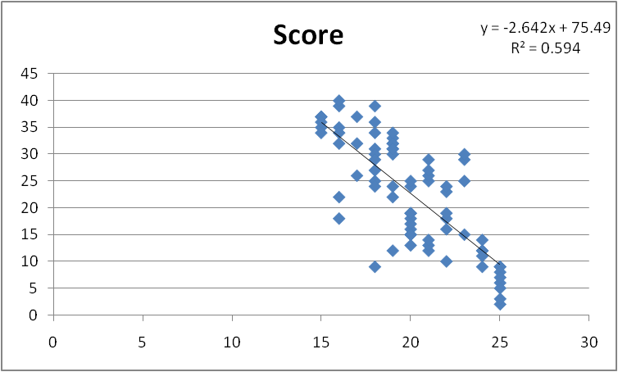

R = -0.77
- Moderate negative correlation
- As the age increases the score decreases by approximately 0.77 of its previous score
- Age does affect and moderately affects the level of internet addiction

R^2 = 0.594
- The variance between the x and y values is approximately 60%
- 60% of the time the regression line will predict the correct values

Y = -2.64x + 75.49
y= -2.64(20) + 75.49 = 22.69
If someone is 20 years of age they will have approximately an internet addiction score of 22.69

Y = -2.64x + 35.89 (actual regression line since we are starting at 15, subtracted (-2.64(15)) or 39.6 from 75.49)
This means that if you’re 15 years of age you will have approximately an internet addiction score of 35.89 and as you grow older by a year it will drop by 2.64%

Findings
Yes, our data and analysis of it does confirm our original hypothesis, which was as a student’s age increases their level of internet addiction decreases resulting in a moderate negative correlation. We obtained an R value of -0.77 which means our data has a negative correlation and since it is between the range of 0.5 to 0.8 it is a moderate negative correlation. The regression line confirms this too, as your age increases by 1 your score or level of addiction will drop by 2.64%. Therefore we have proven that as students get older they do spend less time on the internet or are less addicted to the internet.

Discussion
We have confirmed that as students grow older their level of internet addiction does decrease especially from high school students to college students ranging from 15 to 25 years old. So age does affect our level of internet addiction, but we are still not so sure about how much of an impact age affects our level of internet addiction since we have only surveyed students from 15 to 25. There are also college students that are older and other age groups we haven’t covered like below 15 years of age and over 25. We have only covered a small portion of the age group and so far the statement of “As you grow older your level of internet addiction lowers” is true.

