10/18/2021
Lesson 10 continued
Example: Find a polynomial f with the following properties:
- f has degree 3, the roots of f are precisely 4, 5, 6 and the leading coefficient of f is 7.

We know that f can be written as a product of its factors:
f(x)=d(x-c1)(x-c2)(x-c3) where c1, c2 and c3 are the roots.

f(x)=7(x-4)(x-5)(x-6)
f(x)=7(x-4)[(x-5)(x-6)]=7(x-4)[x^2-11x+30]=7x^3-105x^2+518x-840

- f has degree 3 with real coefficients, f has roots 3i, -5 (and possibly more as well),
and f(0)=90

Here we can use the “Complex Conjugates Theorem” which says that if a poly has real coefficients and a complex root then its complex conjugate must also be a root.

Roots: 3i, -3i and -5 so Factors: (x-3i), (x+3i) and (x-(-5))=(x+5)

f(x)=d(x-3i)(x+3i)(x+5)
Given f(0)=90
f(0)=d(0-3i)(0+3i)(0+5)=90
d(-3i)(3i)(5)=90
45d=90 d=2

Now we can solve for d….keep in mind that i^2=-1

f(x)=2(x-3i)(x+3i)(x+5)

- f has degree 4 with complex coefficients, f has roots i+1, 2i and 3.

Here, be careful, we cannot use the Complex Conjugates Theorem because the coefficients are COMPLEX NOT REAL!

Roots: i+1, 2i and 3 Factors: (x-(i+1)), (x-2i) and (x-3)

For a 4th degree polynomial: f(x)=d(x-c1)(x-c2)(x-c3)(x-c4) where c1, c2, c3 and c4 are the roots.

f(x)=d(x-(i+1))(x-2i)(x-3)(x-c4) where d and c4 are some complex numbers

- f has degree 5 with real coefficients, the leading coefficient is 1 and the roots are determined by its graph

See from the graph that the poly has roots at: 1, 2, 3 and 4. In fact, there is a double root at 4 because the graph touches the x-axis there and then turns around.
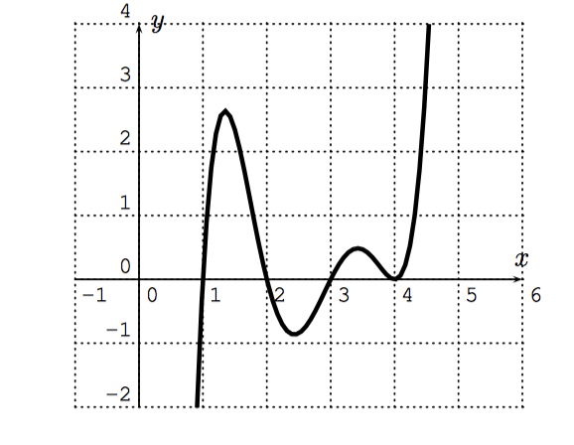
Roots: 1, 2, 3 and 4 Factors: (x-1), (x-2), (x-3), and (x-4) with multiplicity 2

f(x)=1(x-1)(x-2)(x-3)(x-4)^2

Lesson 11: Rational Functions

Recall that a rational function is a fraction of polynomials:
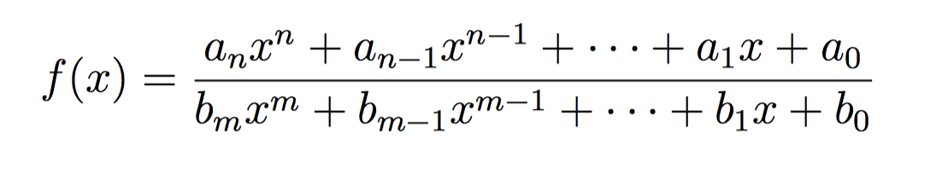
Consider the following 3 rational functions:
- degree of the numerator<degree of the denominator
Ex. f(x)=1/x
Observations: This graph has a vertical asymptotes at x=0 (where the denominator is 0). Degree of numerator =0, degree of the denominator =1 and so there is a horizonal asymptote at y=0.

- degree of the numerator=degree of the denominator
Ex. f(x)=(4x-3)/(2x+1)
We expect there to be a vertical asymptote at 2x+1=0 x=-1/2 and since the degrees are = the line y=4/2=2 should be the horizontal asymptote.
Observations: Asymptotes confirmed!

- degree of the numerator>degree of the denominator
Ex. f(x)=(2x^3+5x+2)/(x^2-7x+6)

We do not expect there to be a horizontal asymptote since the degree of numerator > degree of the denominator. Also, we can look for vertical asymptotes where the denominator =0 so x^2-7x+6=0 (use the quadratic formula or factor).
x^2-7x+6=(x-1)(x-6) so x=1 and x=6 are vertical asymptotes

