10/18
Lesson 10 continued
Ex. Find a polynomial f with the following properties:
- F has degree 3 and the roots are precisely 4, 5, 6 and the leading coefficient is 7.

Recall: Given roots of a polynomial then we have the factors:
4, 5 and 6 are roots then (x-4), (x-5) and (x-6) are factors
F(x)=7(x-4)(x-5)(x-6)=7(x-4)[x^2-11x+30]=

7[x^3-11x^2+30x-4x^2+44x-120]=7[x^3-15x^2+74x-120]=
7x^3-105x^2+518x-840=f(x)

- f(x) has degree 3 with real coefficients, f has roots 3i, -5 (and possibly other roots as well), and f(0)=90

Roots: 3i,-3i and -5 Factors: (x-3i), (x+3i) and (x-(-5))=(x+5)

Since here f(x) has real coefficients, if we have a complex root, then the complex conjugate is also a root.

f(x)=d(x-3i)(x+3i)(x+5) BUT WE CAN’T FORGET f(0)=90 this info will let us be able to figure out what the coefficient d is

f(0)=d(0-3i)(0+3i)(0+5)=90
d(3i)(-3i)(5)=90 now multiply out on the left and solve for d!!
d(-9)i^2(5)=90
d*9*5=90
45d=90
d=2

recall that i^2=-1
polynomial is f(x)=2(x-3i)(x+3i)(x+5)

- f has degree 4 with complex coefficients, f has roots i+1, 2i and 3
Since we have degree 4 the polynomial will look like:
d(x-c1)(x-c2)(x-c3)(x-c4) we know three of the roots so:

d(x-(i+1))(x-2i)(x-3)(x-c4) we don’t have any more info, so this is the polynomial we came up with that satisfied the requirements.

- f has degree 5 with real coefficients the leading coefficient is 1 and the roots are determined by its graph
We see from the graph that the roots are at: 1, 2, 3 and 4 and since the graph touches the x-axis at 4 and then turns around again, there is a root of multiplicity 2 there so:
f(x)=1(x-1)(x-2)(x-3)(x-4)^2
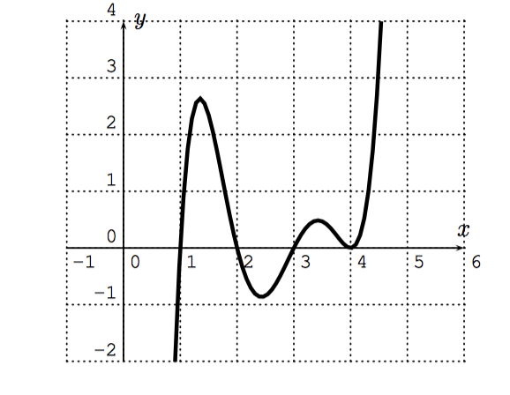
Session 11: Rational functions!
Recall that a rational function is a fraction of polynomials:
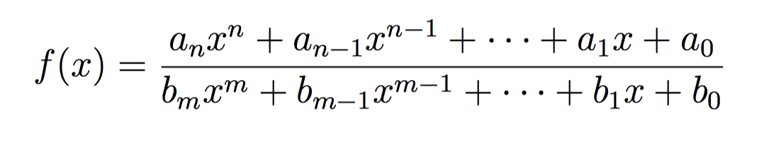
There are 3 cases:
- degree of the denominator is higher than the degree of the numerator: ex. f(x)=1/x
Observation: The graph of f(x) has both a vertical and horizontal asymptote. Look for the vertical asymptote where denominator=0.
- degree of the numerator=degree of the denominator f(x)=(4x-3)/(2x+1)
Observation: The graph of f(x) has both a vertical and horizontal asymptote, vertical x=-1/2 and horizontal y=2. The denominator 2x+1=0 x=-1/2 which is the vertical asymptote.

Look for the horizontal asymptote if the degrees are = then take the highest degree terms over each other 4x/2x and so y=4/2=2

- degree of the numerator>degree of the denominator
f(x)=(2x^3+5x+2)/(x^2-7x+6)

