**MAT 1372**

**Group 1**

**Report: 61**

**Presentation: 95**

**Total: 78**

**Intro 2**

One of the most important **key steps to achieve success in life** is to know the **meaning of success.** The true meaning of success goes far beyond the common definitions of success, such as having a lot of money, being wealthy, having a lot of tangibles and earned degrees. Again, success is varying people to people. In this group project our goal is to find the meaning of success. The marker of success we choose college degree (Qualitative) and salary (Quantitative) also the predictors of success we chose private school (qualitative), and number of years spend in college (Quantitative).

Hypothesis 1

We are hypothesizing that studying at a private institution allows one to get a higher degree which enables them to earn large amounts of money, and the earning increases with respect to the time one spends at that private institution for higher education.

Measures 1 this is where you should state your predictors and markers

In the survey of success, we ask the following queries:

1. Major in college
2. Approximate income
3. Institution (Public or Private)
4. If private, then how many years they spend in college.

Data Collection 2

Through a survey in google from, each of us sent out on social media and try to find responses. We got more than 41 responses recorded by our survey provided by Google Forms. With that, we can extract and further analyze the data received there onto Excel.

Sample Characteristics 2

When we college the data we make sure those, who are employed now at least they have a college degree and meet our requirements. I believe 41 responses are good enough for sample calculation.

Statistical Analysis 1

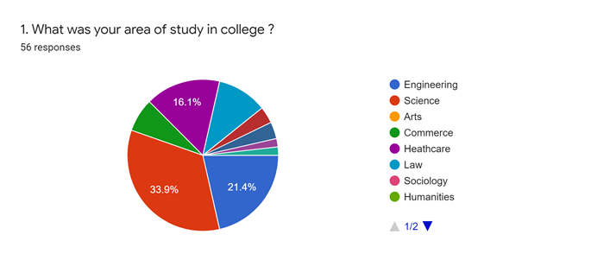

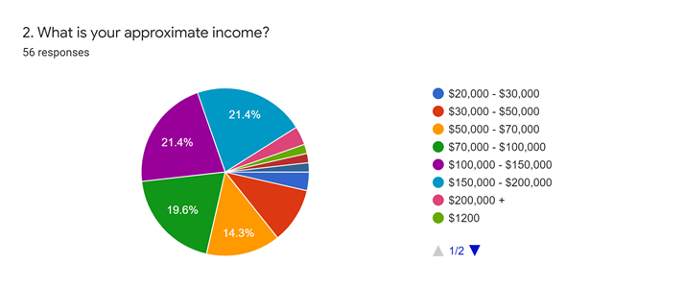

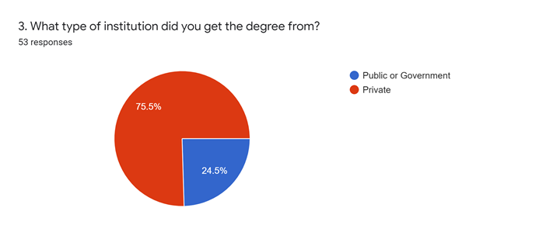

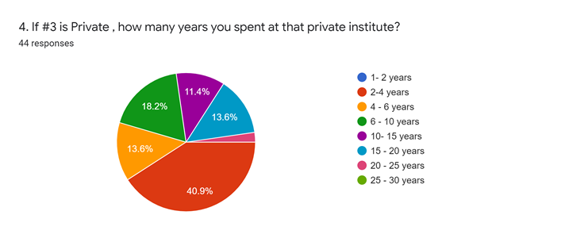

Correlation between time spent for higher education and income. Scatter plot to get regression equation and $R^{2}$ value to understand the trend of time spent for higher education and income amount. Student t-test to test our hypothesis about the mean income ( $H_{0}:μ=70,000 and H_{0}:μ≠70,000)$ Why are these hypotheses not in your hypothesis section? What was your confidence level? Rejection region? Test statistic? Etc? Where is your actual statistical analysis? Did you find basic stats such as means and s.d.s?

**Results 1**

The correlation between time spent for higher education and income was found to be r = 0.82, it’s a strong positive and linear correlation.

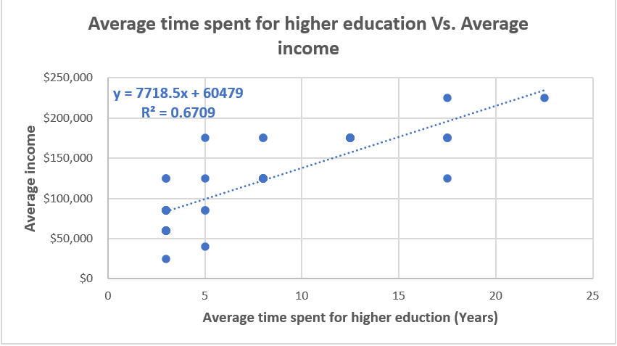

* linear regression equation of y **= 7718.5x + 60479 and R2 = 0.67**
* For 5 years of higher education, income, y= (7718.5 * 5) + 60479 = $99,071
* For 10 years of higher education at a private institute, the predicted income amount will be y = (7718.5 * 10) + 60479 = $137,664
* For 15 years of higher education, y = (7718.5 * 15) + 60479 = $176,257.
* Income increases with respect to the time spent for higher education.
* What are the results of your hypothesis test? Why mention it if you don’t actually do the test?

**Conclusion 1**

From all the data and survey, we can conclude that the success of getting high salary depends on how many years you spend in college and from which institution you get the degree. That’s also support our hypothesis.

**Implications 0**