MAT 1372-OL57

Instructor: Prof. Bonanome

12/2/20

**Report: 100**

**Presentation: 83**

**Total: 92**

Kamil, you wrote a clear and well-thought out report! Very nice work and interesting results!

What’s your definition of success? 2

Success, one of the most appraised things that a person can ever stand out about. But many people see success in their own ways, some see it in their academic achievements, some see it in how much money they make, and others even see it in material things they own. To me success means having a job that you enjoy and will keep you financially stable. I predict that I will achieve this success by working hard in school and taking many internship opportunities. However, everyone has their own view on this thing we call success, but how do these people achieve such pleasure? In my groups project we decided to take the academic route to success and determine what we believed success would be to any college student and how they reached this goal. If you are currently or ever were a college student, have you ever wondered what your other fellow classmates do to achieve the grade they receive? Maybe they study hard and take many courses to achieve their degree as soon as possible. Or maybe they slack and do not push themselves to get an A in the course and just take whatever number of classes they please. Who knows right? Well this is the reason why me and my group decided to conduct this experiment and see what other college students have to say about their academic standing. And I know you might also say “why should I worry about what other students get in a course and how many classes they took?” and the reason for that is because wouldn’t you like to know how hard people work in your class and for their degree? These types of things should be important to you so you know who you can work with in any given situation. It is something that job corporations investigate also when they decide to hire grad students that just graduated with no hands-on experience. Remember we all have a transcript for a reason!

**Hypothesis: 2**

Our hypothesis for each of the given markers and predictors was…

1. If a student studies more than 120 hours for one course in a semester then he or she should pass the course.

We used our qualitative “Pass or Fail” marker with our predictive “time spent studying for one course” in this hypothesis to determine if we are correct.

2. If a student takes 5 or less classes in a semester then they are more likely to maintain a high GPA for that semester (3.0 and above).

We used our qualitative “overall GPA score for the semester” marker with our “classes taken in a semester” predictor to determine if our hypothesis is true.

**Measures: 2**

In our experiment we made two markers and two predictors to see what results we will get from this experiment. These markers and predictors are…

Marker: Qualitative-Pass or Fail a class and overall GPA score for the semester

Predictive: Quantitative -Time spent studying for one course and number of classes taken in a semester

With these markers and predictors, our goal is to determine what effect does hours studying for a course and how many classes you take a semester have on your GPA and if you pass or fail the course.

Our other measures for this experiment are as follows…

* Each type of data that we took was all raw numbers and single point.
* All our results were recorded into a google excel file so that we can all keep track of our results
* Our “Pass or Fail the course” data was dependent on “number of hours studied for a class” (Pass or Fail the course vs Number of hours studied for a class)
* Our “GPA score for the semester” was dependent on “number of classes taken in the semester” (GPA score for the semester vs Number of classes taken in the semester)

These measurements were taken in raw numbers and in single point because we wanted the data to be simple and straight forward for the observer to understand what effect each of these tables have on each other.

**Data collection: 2**

We collected our data by creating a survey that contained four straight forward questions and this survey recorded everyone’s response on a excel sheet that we will use to proceed with our experiment. In order to obtain these results my group has posted the link to the survey on social media stating “If you are a former college student that took classes last semester would you please take a moment of your time to answer this quick survey.” We also asked our statistics class during office hours and class time if they can join in on the survey, so we had more subjects.

**Sample Characteristics: 2**

We managed to obtain 36 college students results in the survey and we did not question what degree, age, or gender each student was because that should not affect the results in any way. (As long as you were attending school last semester then that is all that mattered. We do believe that this sample size was not fully enough to strengthen our argument since there are so many college students that attend City Tech alone but our sample size did have at least a whole class room size of participants so it at least should show the nature of what we are seeking. Here is a link to the survey so you can see how it looks like…

Survey: <https://forms.gle/x3Sqtp6D8XupL4pt9>

**Statistical Analysis: 2**

For our “How Many Classes Did you take last semester?” and “What was your GPA for that semester?” Data we used a scatter plot to indicate how many classes a student took and what their GPA was for the course. The X axis was “the number of classes taken” and the Y axis was “the students GPA”. The graph was titled as “Number of classes taken vs GPA for the semester.” We selected this graph because it will help show the range of how far apart each student's GPA is for the number of classes that they took. Also, we added the correlation coefficient into this scatter plot to determine what type of correlation we have. Getting all this data together by using a scatter plot will help us see the data clearly as well as easily compare the data to each other.

For our “How Many Hours Did You Study for One Class? (For the Whole Semester)” and “Did you pass the course?” data we decided to take a different approach with this data because after getting these results we saw that everyone claimed to have passed the course that they took. So, we decided that it would be best to make a pie chart of this data and group the number of hours studied by the amount of people that said they studied each amount. Therefore, the pie chart will allow us to visually see the amount of people for each amount of time studied since all participants in the survey said that they had passed the course they took. The title of the graph was “Hours students studied to pass a course” the X value for the data was “the number of hours the student said they studied” and the Y value was “the number of students that studied for that number of hours.” We think this is the best approach because the graph will show the differences in the amount of studying each student did for the course they took. But we also considered merging our results with “hours spent studying for a class through out the semester” and “GPA for that semester” because it would show a great relationship on how the amount of hours studied has an effect on a students GPA. We would also use a scatter plot for this data where we would show “hours spent studying for a class” as our X values and “GPA for the semester” as our Y values. This graph would be very good to use especially when adding the correlation coefficient in it so that the graph could show how strong or weak these results are.

**Results:**

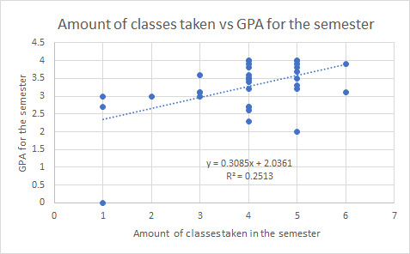

Fig1

As you can see in Fig 1, we had a lot of different values for classes taken and the GPA for the semester. Our correlation for this graph was also a weak positive correlation with the value of 0.501298 so sadly our results don’t hold much weight into the argument when it comes down to the amount of classes taken in a semester and the GPA that they received for the semester. Also my regression line with the value of “y=0.3085x+2.0361” indicates how there is no clear linear relationship in my graph.

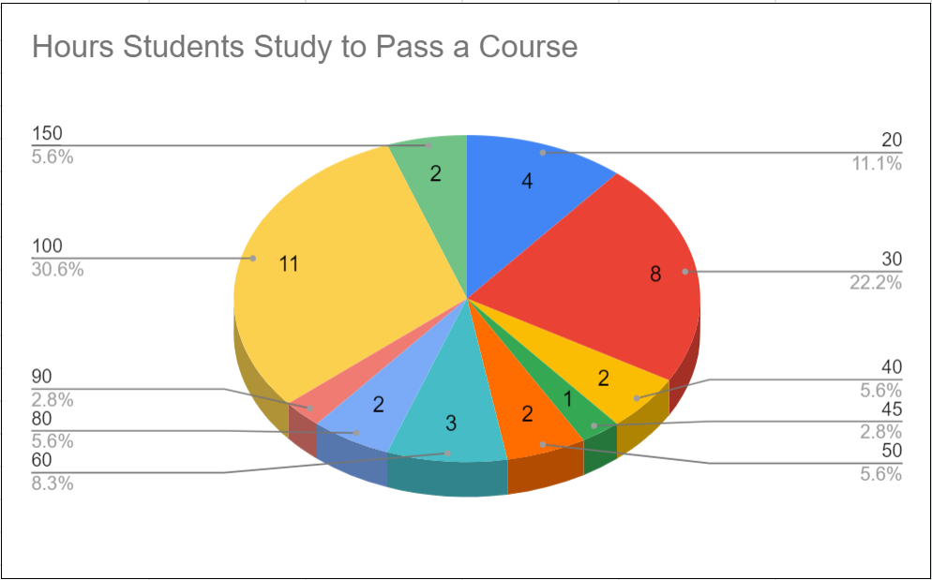

Fig 2

In Fig 2 you can see how much time each college student took to study and pass their course. Majority of the people who participated for this survey take less than 90 hours to ensure themselves with a passing grade.

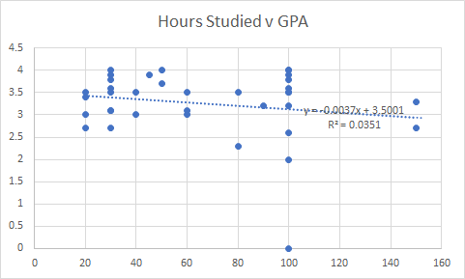  
Fig 3

Lastly in Fig 3, the total amount of hours studied for the semester vs the student’s GPA gave a different approach on how the scatter plot looked compared to Fig 1. The correlation in this graph was weaker than it was in Fig 1 and has a negative correlation with a value of 0.18735. So, this indicates that these two variables do not play a role together. Also, this regression line with the value of “y=-0.0037x+3.5001” indicates that there is no linear relationship.

The Mean to each one of my results is as follows…

* Hours studied for a class: 66
* Number of classes taken: 4
* GPA: 3.3

**Conclusion: 2**

In Conclusion, due to the results that I have received. Both of my hypothesis’s were not supported by my data collected from this experiment because there’s no direct relationship between “hours studied for a class through out the semester” and “Passing or Failing the course” and also there’s no relationship between “amount of classes taken a semester” and “GPA for that semester.” Due to the correlations being weak and the regression lines not having a linear relationship.

**Implications: 2**

My data although proves that there are many more contributing factors when it comes down to passing or failing, GPA, amount of time studied, and number of courses taken. One factor may be the different types of courses and level of difficulty for that course. These factors can also come into play because depending on the difficulty of the class you may need to study to understand the criteria. I also believe that my data would have supported my hypothesis’s better if certain student may have answered more honestly and gave a better answer for the number of hours studied for the course, they took last semester. The reason I believe this is because I feel like many people would be embarrassed to admit that they have failed a course or if they have a low GPA. And as for the hours studied I don’t think people gave their 100% amount of studying for the course due to them maybe not remembering how many hours they actually studied, which is understandable since it was a while ago so for future reference it may be a better idea to try and get a more recent result for that kind of question.