Sergio Sanchez
Internship Journal

Journal Entry 1: September 2, 2015
I started updating my portfolio as well as my resume today. My internship search is still going, I asked a few of my peers if there were any internship positions available that they know of, no such luck for the week. I began looking at the procrastination survey as well as the Emotional Intelligence quiz and was curious about my results. I try to balance both being concentrated and dozing off on work. I can be disorganized but would always try to come back to finish. I think this reflects me pretty well.
"You're an Average Procrastinator!
You rank in the middle 50% of the population in terms of your level of procrastination. That is, when it comes to putting things off, you do so at times even though you know you shouldn't. Likely, you are about average in terms of conscientiousness and self-discipline. Probably, your work doesn't consistently engage you or perhaps you are surrounded by a few easily available and more enticing temptations. These temptations may initially seem rewarding, but in the longer-term, you possibly see a few of them as a waste of time. Though you likely still get your work done, you could probably could do it sooner and experience less stress. You may want to reduce what procrastination you do commit. If so, here are three tips that have been scientifically shown to work."

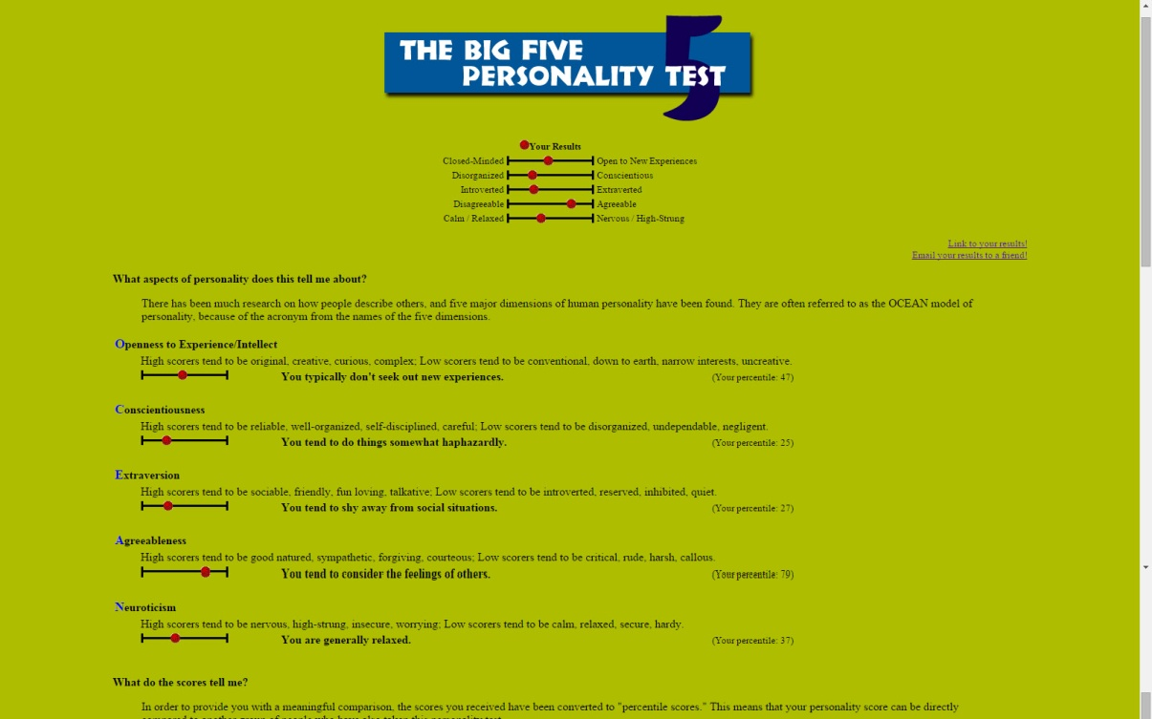
I read upon "The Opinion Article" that was given in class, it is true of what it says. The article discusses the education-to-work model, where the education can lead to getting jobs. Of course employers are looking for applicants that can deliver in what they are seeking, but since there are many applicants there's an expectation that one of them will be overqualified. A degree and GPA, in my opinion, shouldn't show how much a person has skills in. It's all about experience and education now, how much can the applicant do for the employer adequately.

Journal Entry 2: September 9, 2015
A friend of mine started internship at a branding company, and to my surprise they had more internship positions available. The company is called Crystal McKenzie Inc. and they are looking for students who can organize and plan events. I brushed up on my cover letter and resume right away, the application ends on October. This being my first internship to sign up for, I became nervous and wanted to make sure my application was enough. I asked my friend to review them, and I'm glad I did. I had some punctuation errors, and my cover letter was very short. I'm planning on getting a professor to review what I have and make final adjustments before handing in everything to the employer.
There was very little free time this week due to the influx of work I had to complete. Most of my week consisted of me staring onto my computer and paper either researching or writing. However, I got to learn about supply and demand in my Microeconomics class. It gave me a small taste of how the market works, and can be used for any product or service. I'm sure I will have to take it into consideration when designing or branding for a company.

