April 6th, 2015
Community Health
Wednesday Group

SMOKING CESSATION IN HIGH SCHOOL
STUDENTS
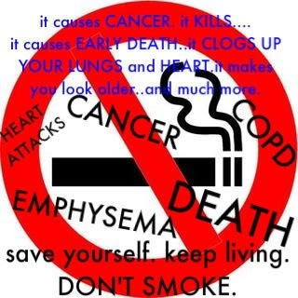
BY: Amall Saleh, Revital Tsypkin, Danielle Rainone, Audry Hines, Milena Ivanov, Marva Charles

Introduction
Of the 45 million adult smokers in the United States today, most began smoking during their pre-teen years. If something is not done, most of these smokers will continue to smoke well into their adult years and this will lead to numerous health issues and decreased self-confidence due to the discoloration of their teeth. Nearly a quarter of young people continue to smoke despite the efforts of public health agencies to curb the habit. However, more than two-thirds of these smokers has expressed the desire to stop smoking. Very little effort was made in the development of programs to address the desire of these young people to quit smoking.

