Mark Zhang 5/20/17
Digital Media
Professor Goetz
Cooper Hewett Report
Hi, as you know my name is Mark Zhang and in this report, I will be discussing about 3 of the objects that I’ve saved during my visit at the Cooper Hewett Museum. These 3 objects are the Chanin Building Pair Of Gates, the Desk and Bookcase with Side Chair and Blotter, and the Staircase Model(France). Of all the objects I saved, I loved the designs of these 3.
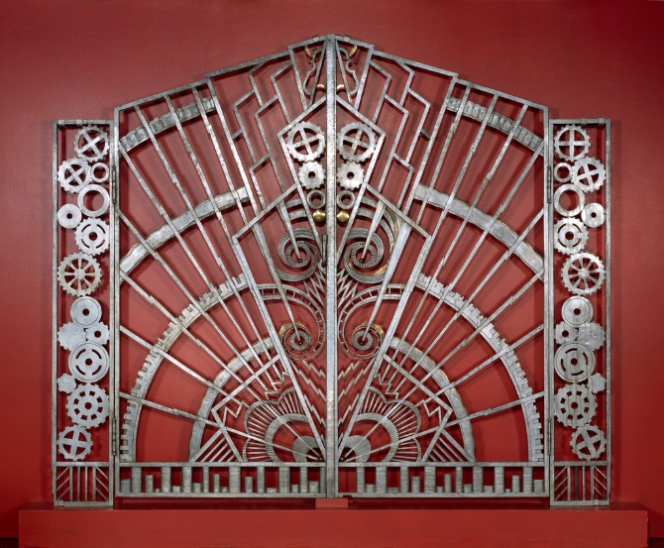
Starting with the Chanin Building Pair Of Gates designed by René Paul Chambellan and dated at 1928, it is a made with wrought iron and bronze. This gate was designed for the entrance of the Chanin Building’s executive office in New York. As you can see it has a lot of gear-like designs put into the design. I loved this gate design. The center where the gate meets as it closes reminds me of person with the background looking like the sun shining brightly throughout the sky. The bottom of the gate however looked like buildings plead next to each other in a 2-dimensional viewpoint.
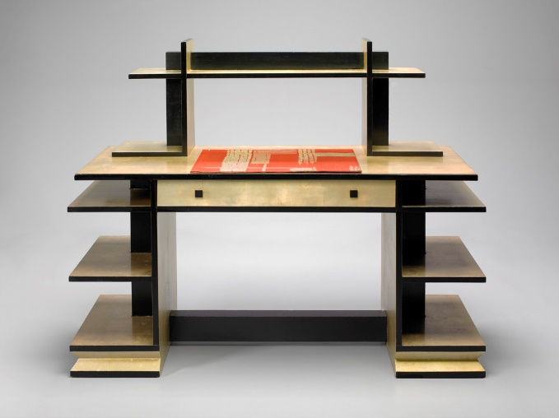
Next, we have the Desk and Bookcase with Side Chair and Blotter designed by Paul T. Frankl and Paul Rodier dated at 1927. This design caught my eyes the moment I saw it. Even though this was designed 90 years ago, it almost looked like it came from a time much further ahead of its actual making. Had the material been made of glass and metal instead of mainly wood, I would have thought that it would have come from the future. The design looks much more sophisticated than the simple or royal looking designs from the early 1920s. This one however, is full of right angles and it doesn’t seem to even have cabinets except the one drawer beneath the main desk.

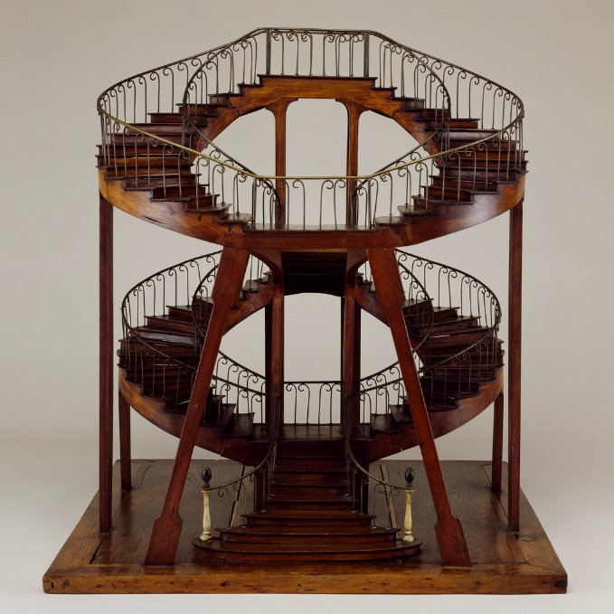
Lastly, we have the Staircase Model(France) which dates to the 18th century and acquired in the year 2007. This is a triple height staircase that looks far different than the normal old stairs I’ve seen. It is in the shape of a spiral. The support beams on the stairs remind me of an insect (trying not insult the design), based on the picture version. The loop reminds me of the infinity or 8 from a viewpoint taken to look like a bit above the ground level.

There are much more objects in the exhibit which were also fantastic to look at, but I had a tough decision to make coming down to these 3 objects. There was also a little store there, but as expected, a lot of the products are overwhelmingly expensive ranging from as low as $5 to even to hundreds. The exhibit had a beautiful layout to it (as expected of a design exhibit).

