Andreieva Marharyta 09.21.2021
ID:24044539
COMD1112
Logo Research Paper

“Chupa Chups” Logo Research
“Chupa Chups” is a Spanish brand of lollipop, and other confectionery sold in over 150 countries around the world. The brand was founded in 1958 by Enric Bernat, which produced an apple jam. Later, they started to sell sweets after watching at children, they were their main customers. In the article “Brand history: Chupa Chups” by Oksana Rizova in “The Outlook” website, she wrote that Enric Bernat studied children’s “I want”, and parent’s “you should”, and Enric Bernat finally came up with lollipops candies, which he called Goal, and look like a ball. Moreover, Bernat had his own an original strategy of selling his products, the sellers placed the lollipops on the counters so that they were at the level of the hands and eyes of the children so that they could be better seen by the main audience, this strategy worked. Before 1969, the logo was understandable for everyone. In 1958, The very first logo for the lollipops featured only a light red “Chups” inscription in a custom cursive typeface. The lettering was placed on a white background and had no additional details. The Chupa Chups logo was designed by the surrealist artist Salvador Dalí in 1969.

I chose this logo, because Chupa-Chups logo looks really unusual and the author of the logo was an interesting person, who is famous as artist, not only as designer. Moreover, Salvador Dali is one of my favorite artists, who created a Cupa-Chups logo in 1969.
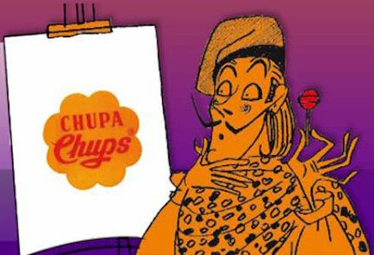

How we can see on the picture that in 1958 was created the first logo, it wasn’t so creative. There was just the red word “Chups”, which had only an interesting type. In 1961, to this logo was added a black word “Chupa”, and the yellow background. After 2 years, they changed the type of these two words, and they changed yellow background to white.
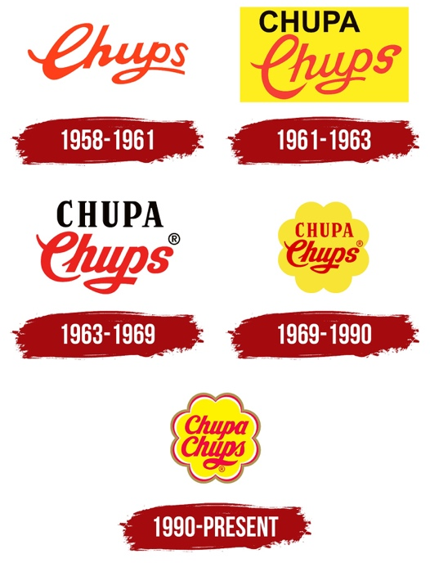

“In 1969, Dali was approached to design a new Chupa Chups logo, and the result became as instantly recognizable as his melting clocks. Dali incorporated the Chupa Chups name into a brightly colored daisy shape. Always keenly aware of branding, Dali suggested that the logo be placed on top of the lolly instead of the side so that it could always be seen intact.”

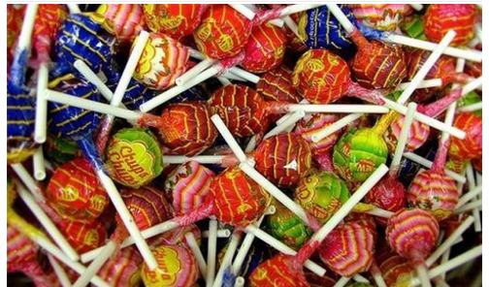

The custom sans-serif cursive of the Chupa Chups visual identity looks sleek and elegant. The font was unique and created for the brand, but very similar to typefaces such as Skate Bold and Bolero, but with different lines and outlines. The red and yellow color scheme of the brand's visual identity grabs attention, evoking feelings of energy, happiness, joy and fun. The white and gray details of the logo outline give the entire composition a professional look, emphasizing quality and reliability.

Its first marketing campaign was the logo with the slogan "Es redondo y dura mucho, Chupa Chups", which translates from Spanish as "It's round and long-lasting". After some time, Madonna was hired to advertise the product. In 80s, “Chupa Chups” created an anti-smoking slogan as “Smoke Chupa Chups”, they tried to attract adult customers. However, nowadays, the slogan is “Stop smoking, start sucking,” with certain packaging designed as a parody to cigarette packs. Also, designers added to the logo two colors of the background, they are yellow and red (and there are two additional colors, they are white and gray). They did it for interesting the children’s audience. So, Salvador Dali evidenced that artists can be not only artists or painters, they also can be good designers too. Moreover, he showed to us that drawing is not work by hand, it is work by brain too. Of course, I think he gave a motivation for a lot of artists, who want to become a designer.

Nowadays, a lot of people who prefer to draw, they become designers. I think that there is why art and drawing develop every day. Artists try to earn money on their work, so people found a lot of ways, where artists can show their creativity and drawing skills. In my mind, now, skills in drawing are really demanded. There are some professions, where person should have creativity skills: architect, graphic designer, fashion designer, art director, tattoo artist, creative director, artist, nail artist, and more. Salvador Dali evidenced that artists can not only draw their painting, they can create amazing logos, as Dali did. His logo looks unusual and memorable for all people. Fortunately, people realize that artist isn’t poor men now, who don’t have money for food. Artists found new ways to earn.

Finally, people realized that drawing isn’t a work only by hands (except copying, and stamping in production). Real designers and artists create their works, they try to image their final version of their work, and only then start to do. They real work is to create what they imagine, and explain their minds, which they want to show to the audience. Before starting, they have to think about what to create, how to start, and what they required for that. This process can take some time. Moreover, for their work they need to have money for materials. Unfortunately, a lot of people don’t understand that, and don’t appreciate art and work of artists. In my opinion, that Salvador Dali one of artists, who showed to us that his logo developed the company “Chupa-Chups”, and it is the evidence of the art importance. Furthermore, he became not only a famous artist, he also became a genius designer.

Dali’s logo also gave to the designers a motivation. This motivation is to create a logo, which will become a historical, and will change the company for whom he created that. We know Dali’s the most famous pictures, and “Chupa-Chups” logo is one of the most his famous work. There are a lot of famous logos as Starbucks, Coca-Cola, Nike, Chanel, Adidas, Gucci, and so on, which we see every day and want to buy their products that to wear these logos (especially logos of clothes). A lot of people will agree with me that they buy “Chupa-Chups”, not the same candy, but another company, because “Chupa-Chups” is famous brand. Moreover, people see that you bought “Chupa-Chups”, because they see the logo. This is the motivation, because designers realize how their work is important.

In conclusion, I want to write that Salvador Dali is genius artist and designer. He created great pictures, and his logo is amazing. He created unusual shape with bright colors as red and yellow. Moreover, his logo improved the company “Chupa-Chups”, which became one of the most famous candy company in the world. Dali’s work also gave a motivation to the designers and artists, and the importance of the art to all people. However, the company became a famous not only by Dali’s logo, also Enric Bernat was a genius of marketing, because he created an original strategy of selling lollipops. I guess that the success of “Chupa-Chups” was logo and marketing strategy, because the logo is really bright, which attracts children; and strategy was created for kids too.
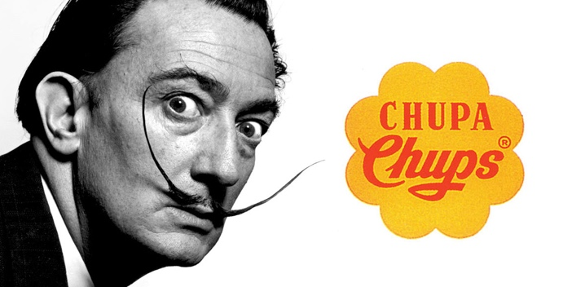

Resources:
Quoted from BBC’s Modern Masters: Dali, Chupa Chups logo (link removed, no longer live).
Rizova, Oksana, Brand History: Chupa Chups,The Outlook.com, 2021,
https://en.theoutlook.com.ua/article/4834/history-of-brand-chupa-chups.html
Chupa Chups, Chupa Chups World, 2020, www.chupachups.com
Chupa Chups, Wikipedia, 2017,https://en.wikipedia.org/wiki/Chupa_Chups
Chupa Chups Logo – Food Logo, Logo World, October 29,2021,https://logos-world.net/chupa-chups-logo/
Chupa Chups Logo, 1000Logos, December 21, 2020, https://1000logos.net/chupa-chups-logo/
The World of the Genius, Salvador Dali’s World Blog, 2009, http://salvador-dali-world.blogspot.com/2009/04/chupa-chups-logo_17.html
Famous logos: Part VII - Chupa Chups, https://www.sviiter.com/blog/famous-logos-part-6-chupa-chups
Everyday Icon #1 The Chupa Chups lollipop, Another look at the overlooked, https://www.phaidon.com/agenda/art/articles/2011/september/21/everyday-icon-1-the-chupa-chups-lollipop/

