Andreieva Marharyta 12.03.2021

ID:24044539

COMD1112

Thelma Bauer

Designer Research Paper

Jessica Walsh

Jessica Walsh is an American web-designer, art director, illustrator, and blogger. She is 35 years old, in New York (Ridgefield, Connecticut). Walsh started coding and creating a web-sites at 11 years. Jessica Walsh received a BFA degree at the Rhode Island School of Design (RISD) as graphic designer in 2008. In her interview for the Fold magazine, she said that studying at art school was uncomfortable at first, but it turned out to be one of the most valuable parts of her education. She realized the potential to merge analogue with digital work to make it more interesting. Jessica Walsh also learned the value of creative collaborations in order to achieve an idea.

After graduation from art school, she moved to New York City, where she turned down a job at Apple, where she was offered nearly $ 100,000 a year to do an internship with Paula Scher at Pentagram, where she worked for almost a year. She then worked as a junior art director at Print Magazine and has done design and illustrations featured in various books, magazines and newspapers, including the New York Times and New York Times Magazine. Reflecting on the time spent in Print magazine, Jessica calls it one of the best experiences of her career, as this is how she found and developed her personal style.

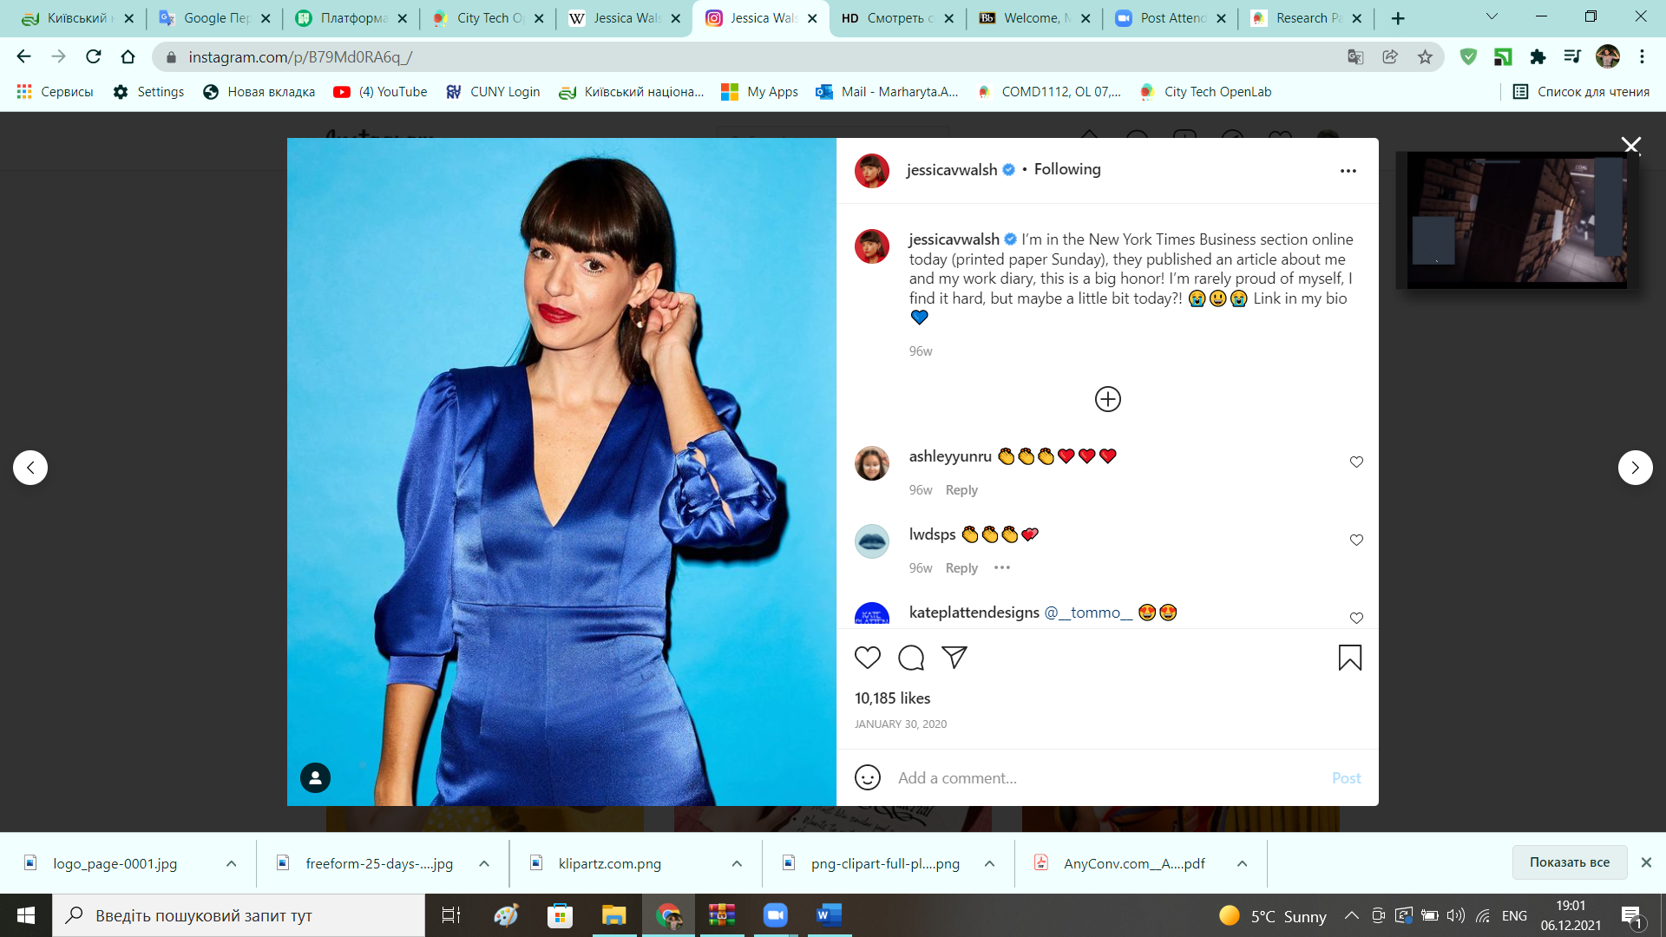

Jessica Walsh has a lot of very popuar works, which she puts into her Instagram. Moreover, this works aren’t just a beautiful pics, most of her pictures have a meaning. For instance, the last her post on Instagram, where she did a slogan “Get vaxxed!”, and her comment on this post was: “Going to get my booster shot and you?”. Designer as a blogger says her own opinion about all social problems. However, she usually does it by her visual works. Moreover, her posts reminded me an assignment from Digital Media Foundations class in CityTech, the task was “Visually Enhanced Quotes”. I had to find a quote and try to create a visual look for my ePortfolio.

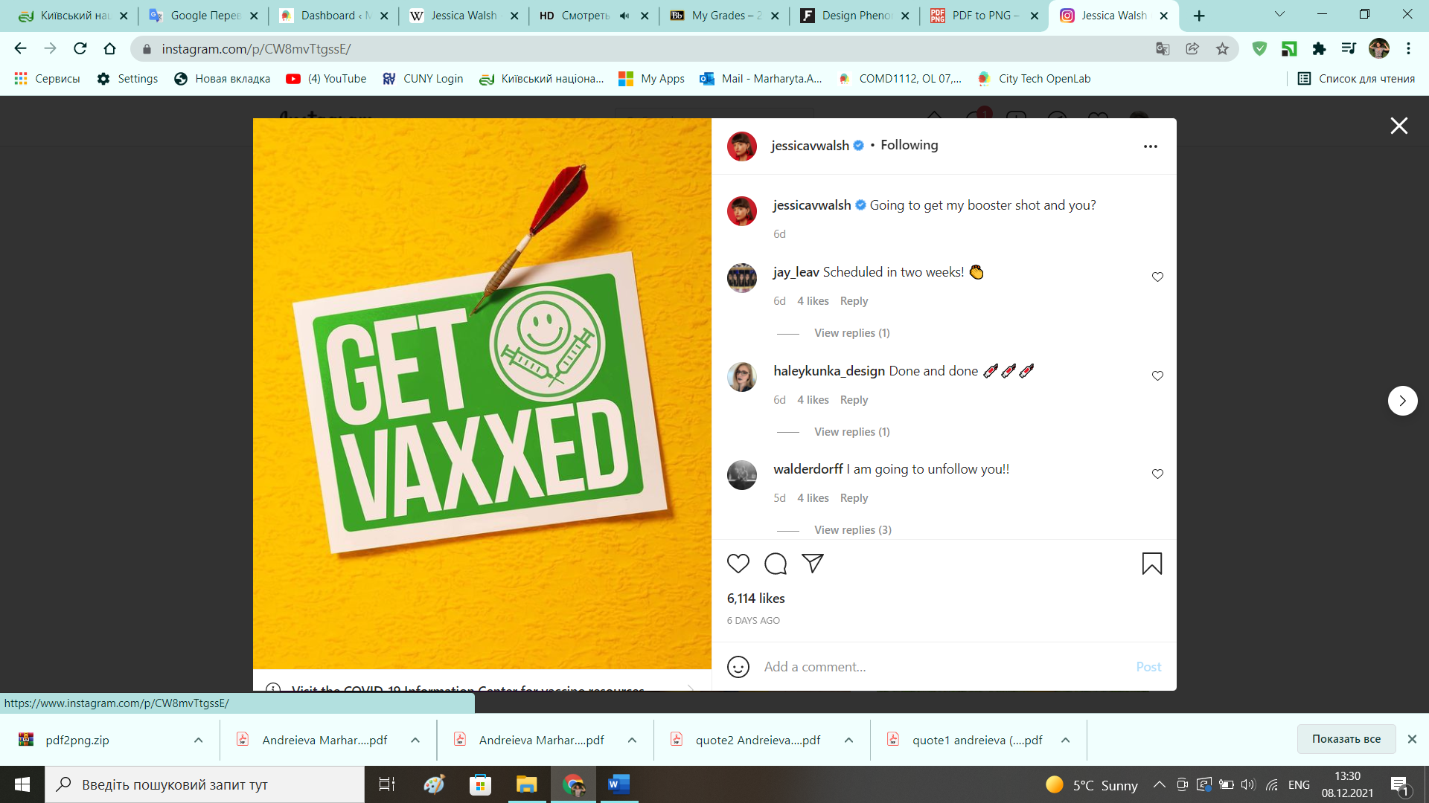

However, this posts on her Instagram are just trends, which are temporary. For Jessica’s company she and her team try to create a work that can have a long lifespan and stay relevant for a long while, especially in relation to branding. The visual language her team creates for her clients should stay fresh and relevant even after a decade.

Furthermore, Jessica Walsh is an art director of her company “&Walsh” from 2019. She also started Ladies, Wine and Design: a nonprofit company that runs free events, talks and portfolio reviews for women and nonbinary people. In New York Times magazine she said that “It was just always a dream of mine to have an agency that was entirely my own,” Ms. Walsh said. “There are so few women-founded creative agencies out there. I want to see more of them.”

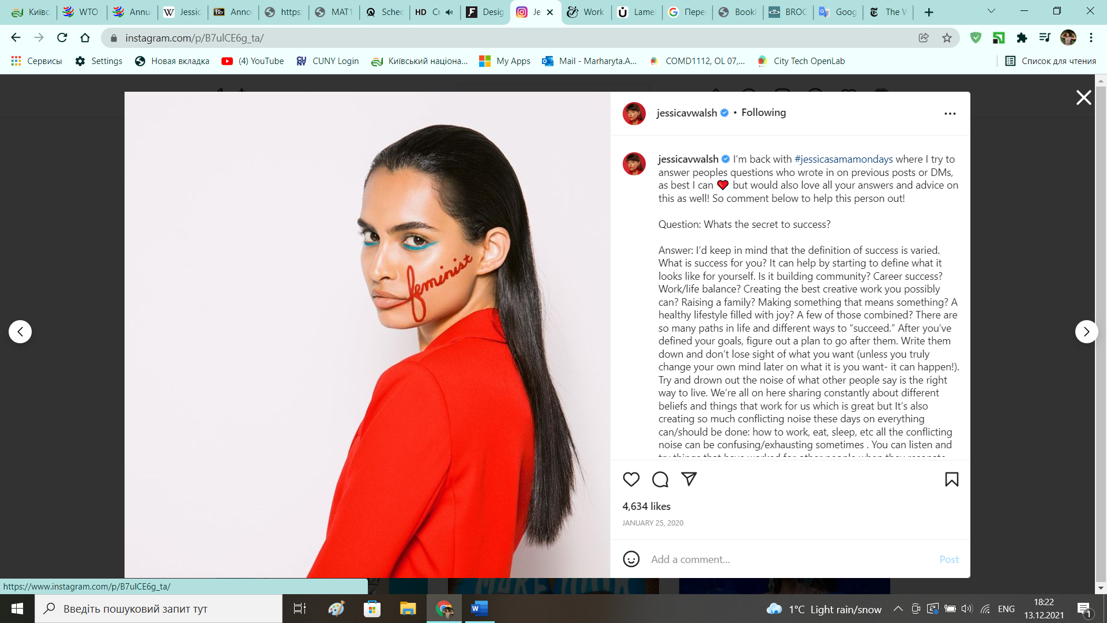

One of her the most popular works is “40 Days of Dating”. Ms. Walsh did this work with her friend Timothy Goodman. They wanted to explore their habits and fears to learn more about the nature of relationships and love. They decided to meet each other for forty days and keep a diary of each date. Also, they recorded daily experiences, created videos and made illustrations. Since launch, the blog has been visited by over twenty-five million unique people and they have received thousands of emails from people all over the world. Some people hated this project, but most people were touched and felt that they were connected to the author’s experience. So, Jessica and Timothy wrote the book, published by Abrams, and the film rights were transferred to Warner Bros, who are working on making the film based on their experience.

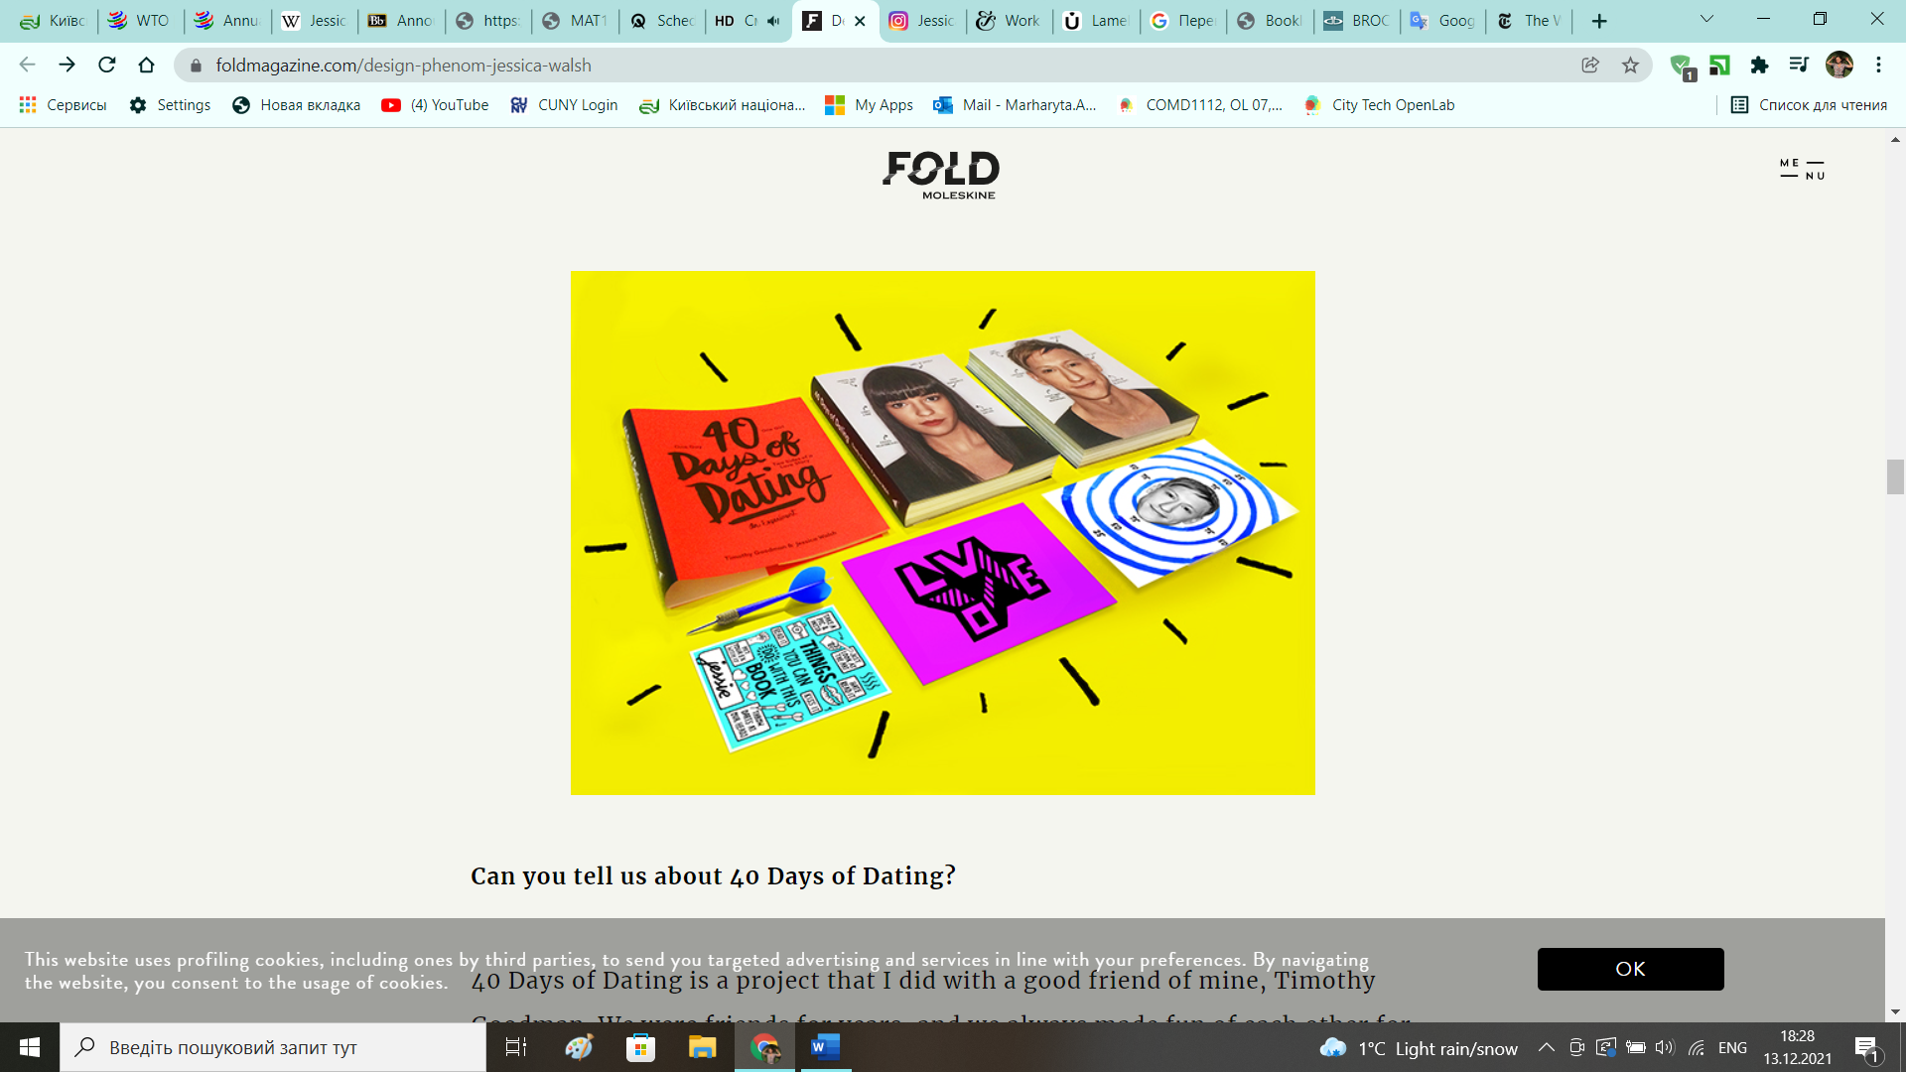

To conclude, Ms. Walsh is a hardworking woman, who keeps long hours, extended by social media. “Work is my passion and I love that work and life is intertwined,” she said. She has a lot of projects with her family and friends, she also proud of her agency. Jessica Walsh is a feminist, art director, graphic designer and blogger. Ms.Walsh is an example of modern and successful woman, who has a lot of ambitions, ideas and ways to realizing them.

Resources:

22 November 2021, “Jessica Walsh”, Wikipedia, <https://en.wikipedia.org/wiki/Jessica_Walsh>

“Design Phenom Jessica Walsh”, Fold Magazine <https://www.foldmagazine.com/design-phenom-jessica-walsh>

2020.01.30, “The Work Diary of Jessica Walsh, Designing (and Wining) Woman: Like a Boss”, Katie Robertson, New York Times, <https://www.nytimes.com/2020/01/30/business/smallbusiness/jessica-walsh-work-diary.html>

Photos from Instagram, @jessicavwalsh <https://www.instagram.com/jessicavwalsh/>

Pictures from official website, Jessica Walsh <https://andwalsh.com/>

Works from Behance portfolio, Jessica Walsh <https://www.behance.net/jessicawalsh>