Andreieva Marharyta 12.13.2021

ID:24044539

COMD1112

Thelma Bauer

Field Trip Report

This October I travelled to Berlin, where I have visited National Art Gallery. There were a lot of sculptures and pictures of German and other European artists. One of the favorite artists was a French artist Pierre-Auguste Renoir, who had there a lot of works, which I liked. However, ones of my favorite one was “Children's Afternoon at Wargemont”, “Summer”. The second artist was Edouard Manet “The house at Rueil”.

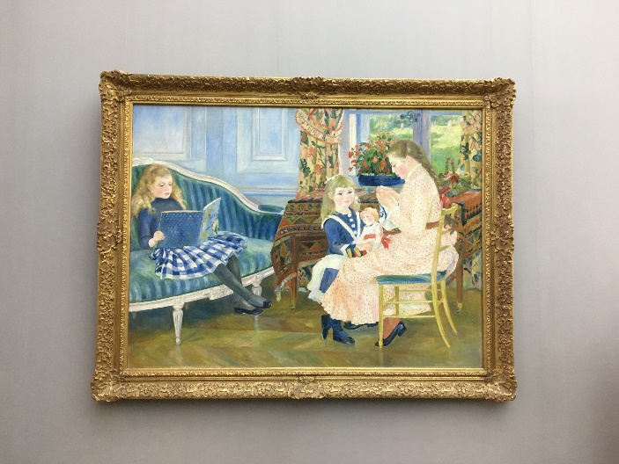

I did this photo when I was in the museum. I like the style of this artist, because it close to my style in painting. Moreover, I like the composition, there are two children and women, we can guess that she is mother. This painting has a story, we can imagine some actions, despite this isn’t an animation. On this exhibition was a lot of dark works, but I like this, because there are only bright and light colors. This work is so bright, funny, and memorable.

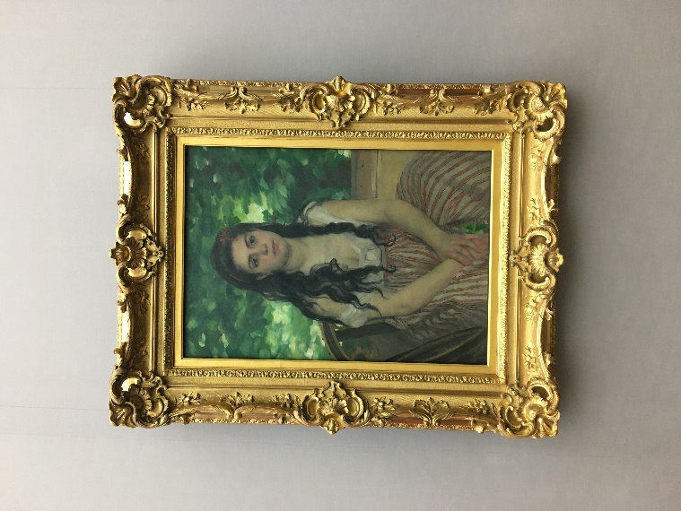

The second photo I took also in this museum. Furthermore, the author of this painting is the same. The name of the picture is “Summer”, we can see a portrait with a girl, and the background is green. My association is summer on the country house. The colors are bright as on the first painting, and we also can imagine the story of this painting.

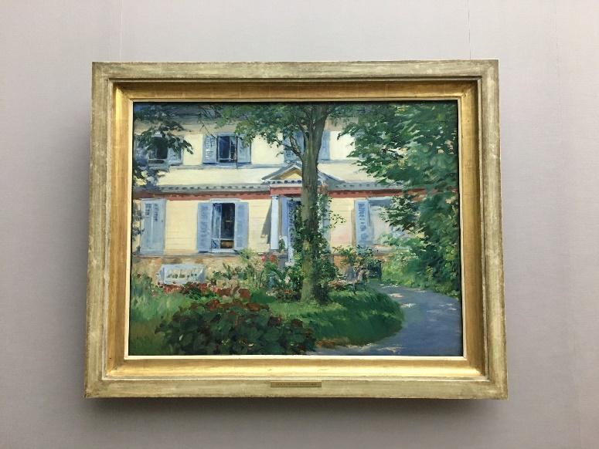

The third painting by Edouard Manet “The house at Rueil”. This artist is also French artist, he was painter and engraver. I like this work, because it has bright colors and summer mood. The landscape looks so nice, and I would live in this old house with this garden.