Maisha Khan
COMD1112
11/12/19
Field trip Assignment
UFT building was very spacious as I went in, with high ceilings with many different rooms. As we went downstairs it was very secretive on behind the scenes of how production actually works alongside with the mailroom. There was a long hallway into the print shop itself which went around to connected with the mailroom. There was many printers such as jet color printers which is for large poster production.
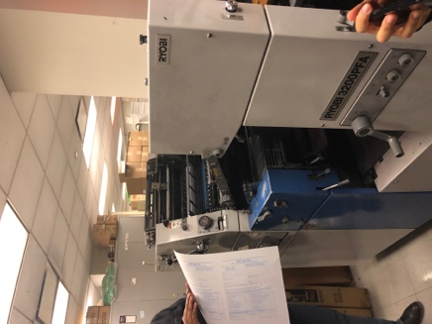
Another print machine was the Ryobi 3200 PFA which is a offset printer that prints short run productions jobs in a hurry. This printer can print both sides A3 sixe or tabloid size simultaneously at top speed. This printer is efficient and saves money and faster production which is a simple process when you get use to the printer.

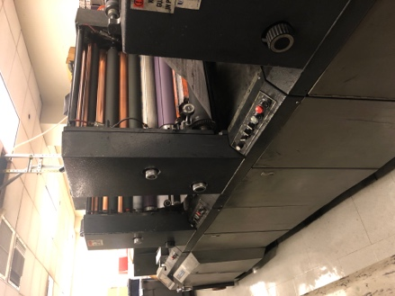
Another Printer was the mini diddie web press printing which was interesting that it printed on the first page and rotates the paper to print out the second to come out and have precuts to trim the pages to the size. It runs at high speed which makes time more flexible for printing thousands of projects. Print quality is at the best it can be with many ink train with 4 rollers that transfers it on to the sheet. This formal old fashion press allows certain changes that can be handles by whose operating the machine itself am dos also a time and money savor.

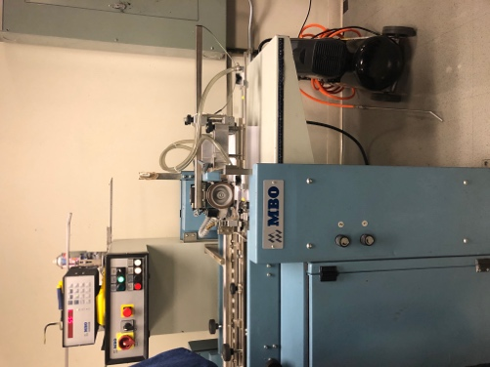
The Last machine that was interesting was the MBO folding paper machine which was a high-performance machine that folds paper into thirds half and other specifications. It was nice to see the production of how fast it goes and how well your time is preserved and how many can be made within seconds.

