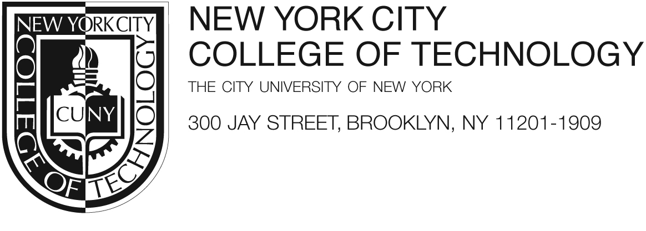
Emerging Scholars Program Application – Part IIA – Fall 2016

The Emerging Scholars Program provides a $500 stipend for full-time students (enrolled for 12 or more credits) and a $250 stipend for part-time students (enrolled in 11 or fewer credits) for conducting research with a faculty member. The purpose of the program is to provide students with an opportunity to apply what was learned in the class room to discover new knowledge, to solve real-world problems and to develop professionally while working with faculty to advance scholarly endeavors. The program includes specially designed workshops offered by the Honors Scholars and other programs and participation in a biannual poster session. Some funding for student travel to professional conferences to present results is also available. This is the second part of a two-part application, to be filled out by the student interested in participating in the Emerging Scholars program in Fall 2016.

The Application
Part I can be found at: https://www.surveymonkey.com/r/EmergingScholars

Part II of the applications includes: (1) PREA, (2) CUNYfirst Expense Reimbursement form, (3)W-9 and (4) Consent forms.
(1)PREA - Must be completed electronically and signed by both the student and faculty mentor.
(2) CUNYfirst Expense Reimbursement form - Please clearly write your name, CUNYfirst ID, address, telephone number, City Tech email address and sign the form
(3) W-9 – Please complete parts I and II and sign in part III- DO NOT INCLUDE YOUR SOCIAL SECURITY NUMBER IN W9 FORM.
(4) Consent form – Both the student and mentor must print and sign. Faculty mentoring multiple students should only submit one copy.
(5) An unofficial copy of the student’s transcript, including Fall 2016 registration.

Emerging Scholar Program Requirements
1. Undergraduate researchers are expected to attend the mandatory orientation meeting on Thursday, September 22, 2016, from 12:45-2:00 PM in Namm 1001.

2. The Emerging Scholars application deadline (Parts I AND II) is Monday, September 19, 2016. Part I should include the mentor information, project title, and project abstract by this date. Please complete part I online and submit a completed part II to: Ms. Chioma Okoye, Provost’s Office, Namm 320, Phone – 718.260.5560 OR Email: undergraduateresearch@citytech.cuny.edu –SUBJECT Line: ESP application

3. All students must also complete the responsible conduct in research online training
and submit their Collaborative Institutional Training Initiative (CITI) certificate by Wednesday,
October 27, 2016 to Ms. Chioma Okoye, Provost’s Office, Namm 320, Phone – 718.260.5560 OR email: undergraduateresearch@citytech.cuny.edu – SUBJECT LINE: CITI certification.

More information on CITI training can be found at:
https://www.citiprogram.org/

Note: When completing the certification program, students should make sure not to click that they want college credit – if they indicate that they want college credit the program will then require payment for the certification.

4. Attend the Fall 2016 Research Mixer sponsored by the Undergraduate Research Committee. Date September 15th, 2016 12:30-2:30 PM at Namm 119.

5. First-time undergraduate researchers must attend the four Group I workshops. Returning researchers must complete four workshops from Group II.

Group I: Mandatory Workshops for first time participants:

Thursday, September 29 Workshop I: Writing Abstracts for Research Projects
1-2 PM or 4-5 PM Prof. Rebecca Devers & Prof. Samar ElHitti, Namm 119

Thursday, October 13 Workshop I: Advancing Library Research Techniques
1-2 PM or 4-5 PM Prof. Tess Tobin and Prof. Monica Berger, Atrium 540 (Library 5th floor)

Thursday, October 27 Workshop I: Developing and Delivering Effective Research Presentations
1-2 PM or 4-5 PM Prof. Janet Liou-Mark, Namm 119

Thursday, November 3 Workshop I: Designing a Research Poster Presentation
1-2 PM or 4-5 PM Mr. Marvin Bennett, Namm 119

Group II: Advanced workshops for returning participants – please attend 4 different workshops:

Thursday, October 6 Workshop II: Presentation Skills (Professional Development Center)
1-2 PM or 4-5 PM Namm 119

Thursday, October 6 Workshop II: ePortfolios for Academic and Career Advancement
1-2 PM or 4-5 PM Dr. Karen Lundstrem, General 606

Thursday, October 13 Workshop II: NYC Fire Department C-14 Certificate of Fitness
1-2 PM or 4-5 PM Dr. Pamela Brown, AG 18 (for students in lab-based majors or projects only)

Thursday, October 20 Workshop II: Interviewing Skills (Professional Development Center)
1-2 PM & 4-5 PM Namm 119

Thursday, November 3 Workshop II: ePortfolios for Academic and Career Advancement
1-2 PM & 4-5 PM Dr. Karen Lundstrem, General 606

Thursday, November 10 Optional Workshop: Research Poster Design Workshop
1:00-2:15 PM Mr. Marvin Bennett, M308 (Bring your own laptops)

5. In collaboration with the faculty mentor, prepare a final abstract summarizing the accomplishments of the project. Mentors should proofread, edit, and upload it by Thursday, November 10, 2016 at a Dropbox link that will be provided later. Additionally you should prepare your poster based on your final results for a poster session event. The poster file must be uploaded to a Dropbox link by Wednesday, November 23, 2016. Signing the consent form indicates permission to publish abstracts and posters on the college website.

6. Participate in the Honors and Research Scholars poster session and award ceremony

Wednesday, November 30 Honors and Research Scholars Poster Presentation
11-4 PM Atrium Ground & First Floor

Thursday, December 1 Graduate School Fair
9:30-2 PM Namm 119

Thursday, December 1 Awards ceremony will begin at 12:30 PM
10-3 PM Atrium Amphitheater

7. Be a full-time student in good academic standing (exceptional part-time students are eligible for a $250 stipend for 25 hours of work with their mentors and attend all workshops).

To optimize the number of mentors available to students and to ensure a proper depth of focus on
scholarly work, Emerging Scholars are limited to ONE research project per semester. Undergraduate research stipends are not available to those receiving stipends from another project although they may participate in the program. Faculty mentors involving multiple students on a project should distinguish the expected roles to be performed by each student on the Pre-Research Application (PREA).

*Due to restrictions in funding, students must be US citizens or permanent residents (they must have a social security number) to receive the stipend. They must be recommended by a faculty member into the program, and be in good academic standing, i.e. not placed on academic probation. In order to be paid, a W-9 and Reimbursement Request forms must be completed and submitted with the rest of the application. Stipends are sent to the home address after the end of the semester (allow 6-8 weeks for processing). To ensure timely delivery, please verify that the college has your correct address on file. At the Awards Ceremony, you will receive a certificate for your accomplishments.

Program websites:
Undergraduate Research: http://openlab.citytech.cuny.edu/undergraduateresearch
Emerging Scholars:
http://www.citytech.cuny.edu/research/scholars-program.aspx

Undergraduate Research
Pre-Research Application (PREA)-please type and attach an unofficial transcript

1. Student Name/EMPL ID/address/email/phone ________________________________________________________________________________________________________________________________

2. Faculty Mentor Name/Department___________________________________________________________________________________________________________________________________________

3. Title of Project_______________________________________________________________________

4. Description of Project ______________________________________________________________________________________________________________________________________________________________________________________________________________________________________________________________________________________________________________________________________________________________________________________________________________________________________________________________________________________________________________________________________________________________________________________________

5. What will the student’s role be in this project? What research skills will the student employ? __________________________________________________________________________________
_______________________________________________________________________________________________________________________________________________________________________________________________________________________________________________________________________________________________________________________________________________________

6. What skills/values/knowledge learned in the classroom will the student employ? ____________________________________________________________________________________________________________________________________________________________________________________________________________________________________________________________________________________________________________________________________________________________________

7. What research skills or other knowledge will the student learn? _______________________________________________________________________________________________________________________________________________________________________________________________________________________________________________________________

8. What “soft skills” will the faculty mentor address in this experience?

- Professional skills

___ Goal setting
___ Time management
___ Professional communication/behavior

- Career planning and support

guidance in academic/career planning
networking/making connections with professionals in the discipline

9. What will the student contribute in terms of time commitment, quality of work, record keeping, preparatory work for meetings with mentor? _________________________________________________________________________________________________________________________________________________________________________________________________________________________________________________________________________________________________________________________________________________________________________________________________________________________________________

10. What will the faculty mentor contribute in terms of time commitment, frequency of meeting with student, monitoring of and feedback on student work? _______________________________________________________________________________________________________________________________________________________________________________________________________________________________________________________________

______________________________________ _______________________________________
Signature of Student/Date Signature of Faculty Mentor/Date

