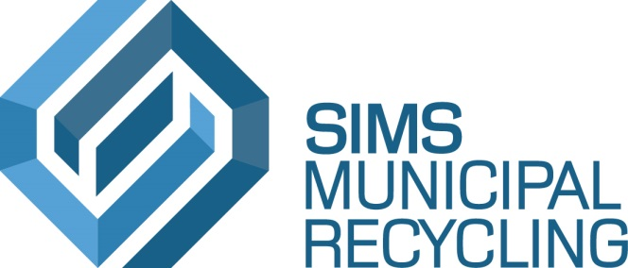

Sunset Park Material Recovery Facility

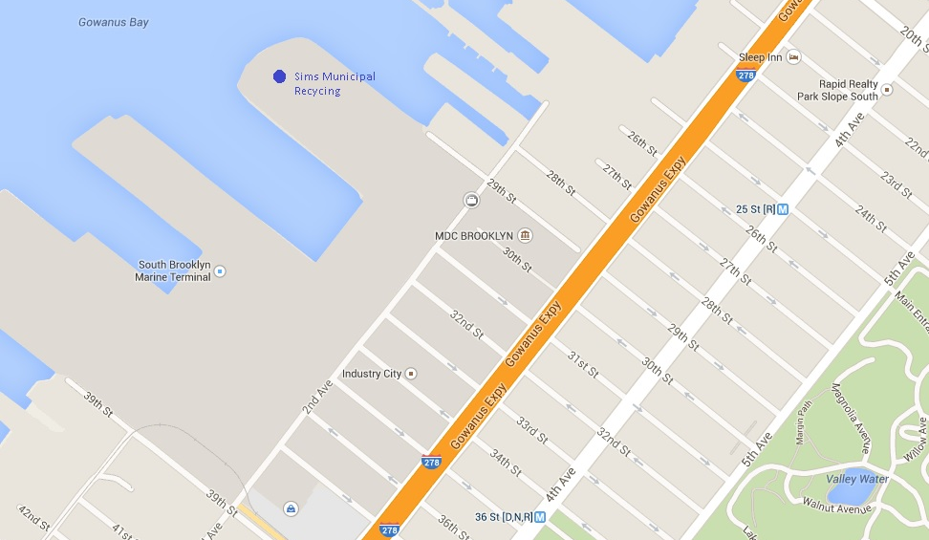
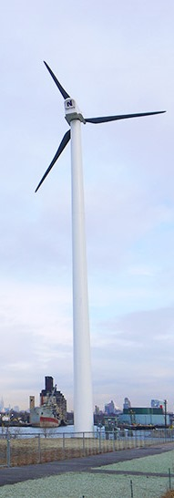

The address of our facility is 472 2nd Ave, Brooklyn, NY 11232. Be careful not to go to 472 2nd STREET.

If you take the subway, you can take the D, N, or R to 36th St. The station is at 36th St. and 4th Ave. Walk up 4th Ave. and turn left on 29th St. Walk all the way down 29th St. - past 3rd Ave, past 2nd Ave., past the gates of our facility. Walk up to the security guard booth and tell her you are here for a tour. She’ll direct you to a sidewalk on the right that will take you all the way back to our Administration Building.

If you drive and are coming from the north (Manhattan, Queens, etc.), you can take the BQE to 39th St. Turn right on 2nd Avenue and go almost to the end. Turn left on 29th St. Continue past gates to security booth.

If you drive and are coming from the south (South Brooklyn, NJ, etc.), you can take the BQE to 3rd Avenue. Go down 3rd Avenue, and turn left on 34th St. Turn right on 2nd Avenue and go almost to the end. Turn left on 29th St. Continue past gates to security booth.

** When in doubt, go towards the wind turbine! **

