Genotoxic effects of Water Pipe Smoking on Buccal Mucosa Cells

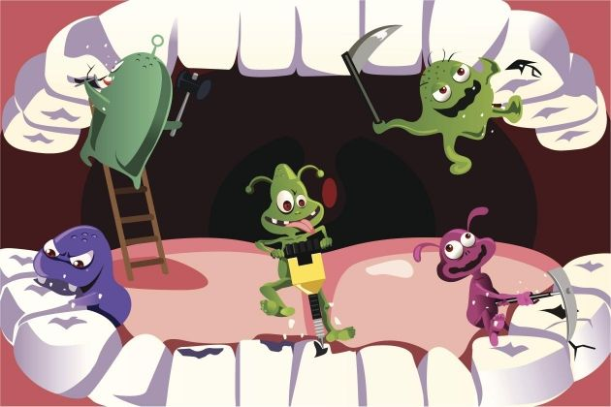

Milana Abayev
DEN-1200-D-200
Research Assignment: Part 1
04/21/2015

