Lifeng Wu
Internship Midterm Essay
Minimalism was one of the concepts that defined fashion in the 1990s among other styles. In the selected image, the outfit represents minimalism in numerous ways. The fashion sector in the 1990s contained numerous styles and influences. The uniqueness of the 1990s fashion was due to the contributions of different designers or silhouettes compared to a limited number. One of the features of the 90s minimalism aesthetic was keeping silhouettes straight (Lyu & Cho, 2004). For example, the outfit includes straight-legged pants that fit the minimalistic aesthetic. It was also important to have accessories but they needed to be selected thoughtfully and be minimalistic. The common accessories include oval sunglasses, subtle jewelry, and any other amount of detail (Lyu & Cho, 2004). The outfit includes one piece of Chanel jewelry, a pair of earrings, and oval sunglasses. Footwear normally comprised kitten heels, sneakers, black boots, and loafers. The two shoes in the image are kitten heels and denim boots. The image and outfit are a reflection of 90s fashion and minimalism.
Color is an important part of increasing the attractiveness of the performance garment. Most people are attracted by the color of a piece of clothing before they can check the price, size, or even fit it. Color is effective because it creates a mood, reveals regional and cultural differences, and can disclose changes in fashion and public perceptions (Adomaitis, 2022). Value refers to the amount of dark or light colors. An analysis of the image reveals that it is whiter compared to dark colors. Therefore, the image falls under the value of a tint. The image contains numerous colors and the main ones are black, yellow, white, red, and khaki green (Special Exhibitions Gallery, 2022). The additional colors are blue and dark brown. Yellow represents happiness, sunshine, and optimism, while red is assertive, powerful, loving, and demanding. Khaki green communicates being bilious or war and black symbolizes death, a vacuum, and sophistication among others (Adomaitis, 2022). On the other hand, white connects to innocence, clarity, hope, and many others. The color selection on the garment is very important. The matching colors on the jacket and the cap show uniformity and this makes the piece very attractive. The lighting also emphasizes the colors and this makes the performance garment stand out.
The eight elements of design can aid in analyzing the performance garment further. Lines are a key part of composition and they refer to the direction or the manner of arrangement to influence the success of the presentation (Adomaitis, 2022). Lines can be categorized as vertical, curved, horizontal, and diagonal. The image contains vertical lines based on the position of the mannequin and the attire. Rhythm is effective in leading the viewer’s vision to the subordinate object from the dominant one. The viewer’s first look at the photograph is directed toward the mannequin, the jacket, and the cap. However, one’s attention shifts to the subordinate objects at the bottom, which are the two shoes and accessories. Form refers to the width, length, and depth of a fashion item. The mannequin and the glassed headpiece are the tallest items in the image. The shoes and accessories are placed at the bottom. Balance can either be formal and symmetrical or asymmetrical and informal. The image has a symmetrical or formal balance and everything seems well put together.
Contrast juxtaposition is the combination of unexpected elements or features in a garment. For example, the combination of the jacket and the hat look quite odd, especially considering that it is a woman’s attire. The jacket and cap look very masculine, but the two pairs of shoes compliment the style. Dominance influences composition through the presence of a dominant element, which is usually the mannequin in most cases (Adomaitis, 2022). The height and positioning of the mannequin have a dominant effect. It stands out in the image and so does the attire, especially the jacket and the cap due to the vivid colors. Proportion refers to the scale, relationship size, and weight of the elements close to each other. As mentioned above, the mannequin is standing tall and close to the head attire hanging on the wall. However, on the bottom, the two optional shoes for the outfit and the accessories are placed. The proportion and placement aid the viewers in visualizing how the outfit would look altogether. Repetition occurs when an idea or motif is repeated. The jacket and the cap contain the same exact design, even with uniformity in the colors.
Texture and the appearance of the texture are also very important in displaying clothing. Texture refers to the feel or surface treatment of a fabric and its correct use can significantly increase the attractiveness of a piece of garment (Adomaitis, 2022). It falls under two categories, which are visual or physical and suggestive. Even though the clothing is meant for a woman, based on the mannequin and the type of shoes, the jacket and cap have a rough and uneven texture that connects mainly to masculinity. In addition, the clothing also has a rough visual texture that shows that it absorbs light. The jacket and the cap, especially look nubby and heavy.
Numerous factors had an influence on fashion and design in the 1990s. Music has always been a huge influence over the fashion sector and vice versa. The 1990s introduced new music and this included moving away from the pop sounds of the previous decade. For example, Nirvana, a Seattle-based brand was a huge influence on the grunge music style. Nirvana was responsible for introducing an unkempt and gritty style of dressing and this was very attractive to people that listened to their music (Chung & Geum, 2005). On the other hand, the growth of hip-hop in the 1990s was also very significant for the fashion sector. The style of hip-hop artists started being emulated by their fans across the US. A review of the performance garment reveals that it is a combination of grunge and hip-hop influence on fashion, especially with the jacket and cap representing the latter. Celebrities also contributed to the shift in fashion styles in the 1990s. The public influence of celebrities allowed them to easily influence and push new fashion trends in the decade that were adopted by their fans.
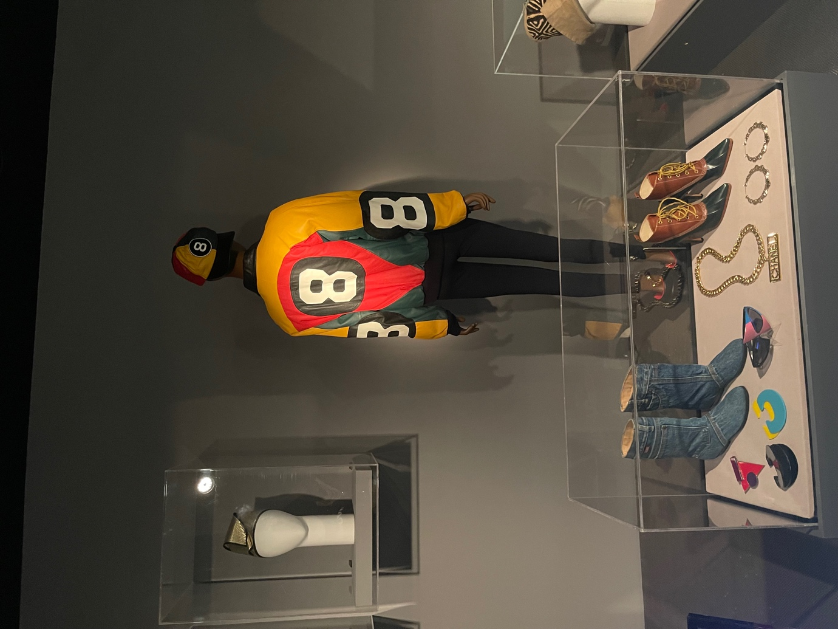

References
Adomaitis. A.D. (2022). Visual Merchandising.
Chung, Y. K., & Geum, K. S. (2005). A study on the grunge fashion of the 1990's and 2000's. Journal of the Korean Society of Clothing and Textiles, 29(3_4), 449-461.
Lyu, C. W., & Cho, K. H. (2004). A Study on Fashion Illustration Reflecting the Minimalism. Journal of Fashion Business, 8(6), 15-24.
Special Exhibitions Gallery. (2022). Reinvention & Restlessness: Fashion in the Nineties. The Museum at FIT. https://www.fitnyc.edu/museum/exhibitions/fashion-in-the-nineties.php

