Anastasia Cortez
ENG 1101 D 10
Genre Multi-Media Project Unit 3
May 1, 2020

Genre Assignment (Unit 3)
(Photo Essay)

Fashion Insites

The Pandemic’s Take on Fashion
Many individuals' styles have changed during this time. Has yours?
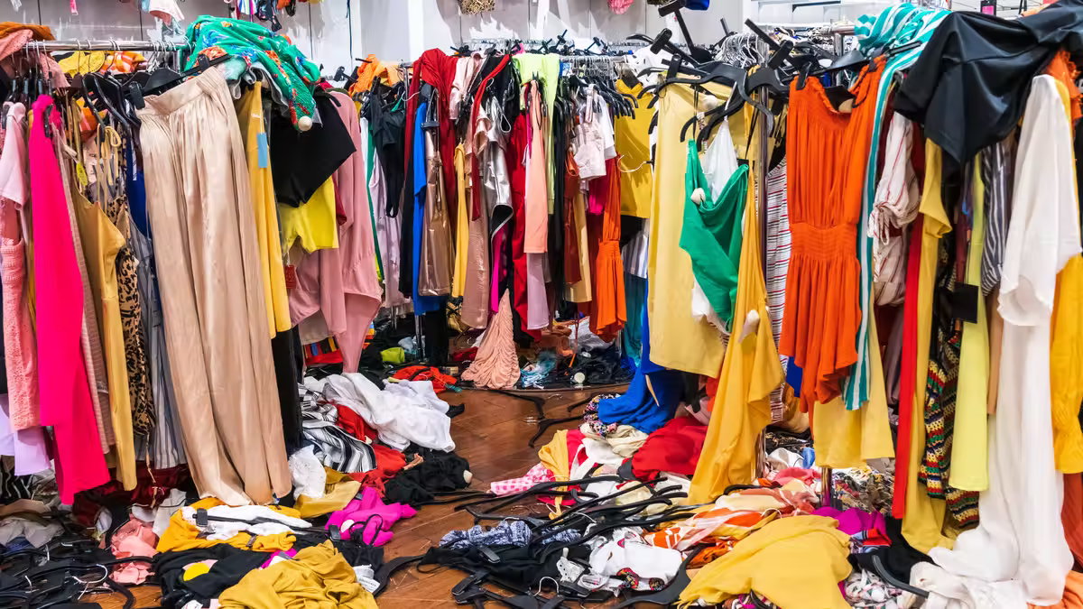
by Anastasia Ortiz on May 21, 2022
During the self-quarantine period of the pandemic many of us found ourselves recycling the same articles of clothing over and over again never taking a step into our closets. But once the real world started opening up, no one knew what to wear. Leaving our closets kind of looking like that. We didn't want to put back on those uncomfortable work pants, but we also did not want to look too unprofessional. This led to the majority of people discovering their own unique styles and completely changing their wardrobe, or maybe just pairing together different clothes.
THIS WEEK’S
TOP STORIES
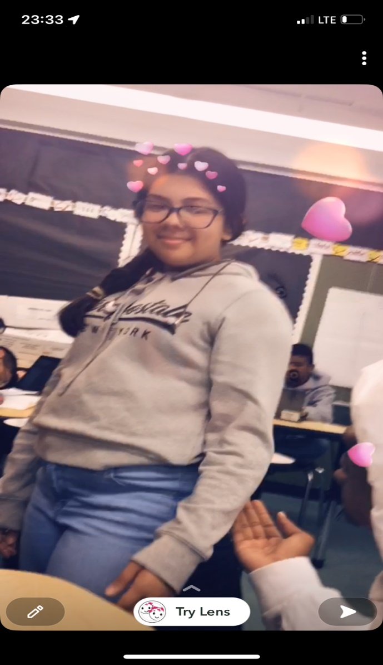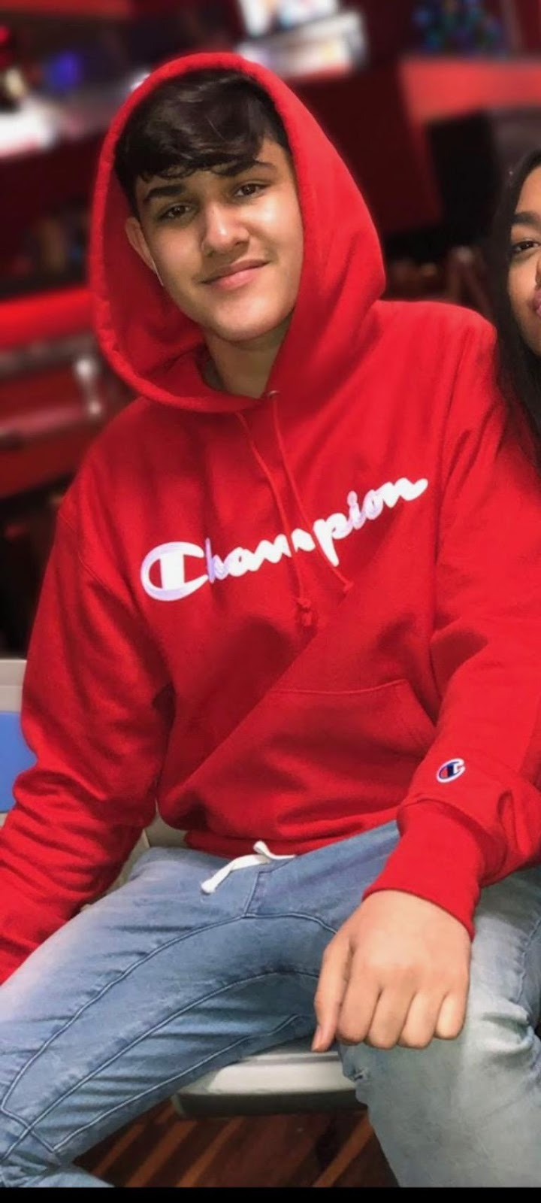
Photographed above are Jaiden Lucian and myself (During our freshman years of H.S we never really liked taking pictures of ourselves or getting them taken. My picture was screenshotted from a video and he was forced to because of a party.)
Pre-pandemic almost everyone dressed to fit in. Whether they were in a business building or just going to school. So while in High school in NYC, both my friend Jaiden Luciano and I struggled under that pressure to look like everyone else. If you’ve ever lived in New York or maybe just saw pictures on the internet before the pandemic, you would know the basic teenager style was to wear light / ripped jeans with a name brand hoodie and popular overpriced sneakers. Unfortunately for both me and my friend at the time (between 9th to mid 11th grade before lockdown) we really struggled with our body image as most teenagers do. That insecurity led to only wearing oversized t-shirts or hoodies with either jeans or sweatpants to make hiding what's underneath easier. We tried our best to fit in but we always had to deal with scrutiny from our peers that we just laughed or joked our way out of.
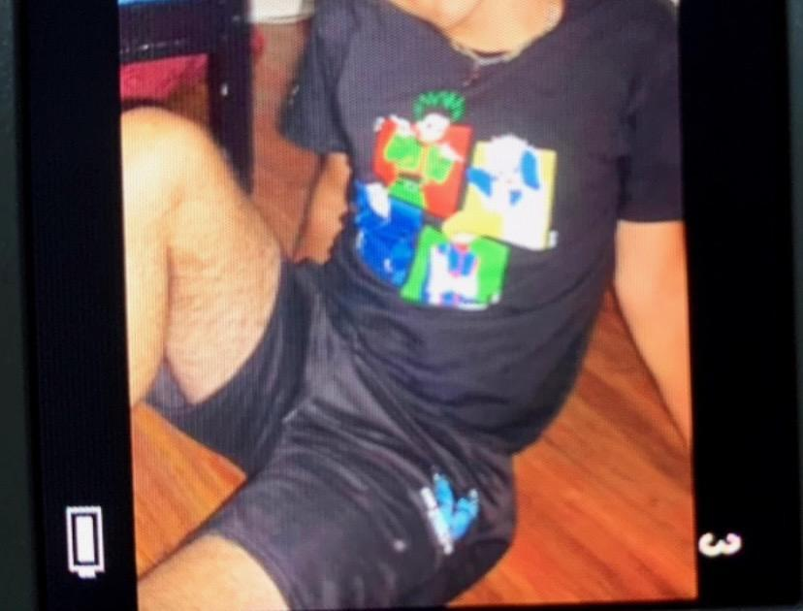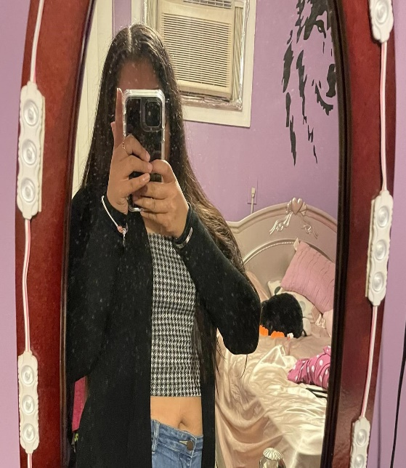
However during the quarantine, many youths including ourselves became more confident to show skin. For Jaiden it was because “it gave me time to spend alone and really think about how and why I felt negatively about myself. It also gave me time to work on eating habits and things like that.” So after some weight loss he genuinely felt happy and content with the way his body looked and didn't mind showing it off more. My change in confidence was not because of weight loss cause I'm pretty sure I still weigh the same. But it happened because I was home for so long and in the privacy of my home I didn't have to cover up for anyone. I became accustomed to being in my own skin. I also wasn't in church because it was closed for a while, meaning I didn't have to deal with them saying something was too short or tight. Plus I wasn't living with my very religious Grandma whose favorite sport was to point out my physical flaws (weight gain or loss, acne, hairstyle, clothes, etc..) And during this time of isolation I learned skills like doing makeup and different hairstyles. And though that is counterintuitive to what I said about being judged, the hair and makeup helped me feel prettier because I got more compliments and I could change things I didn't like about myself. I received less stares of judgment which allowed me to be more free and creative. But of course you don’t need makeup to be beautiful.

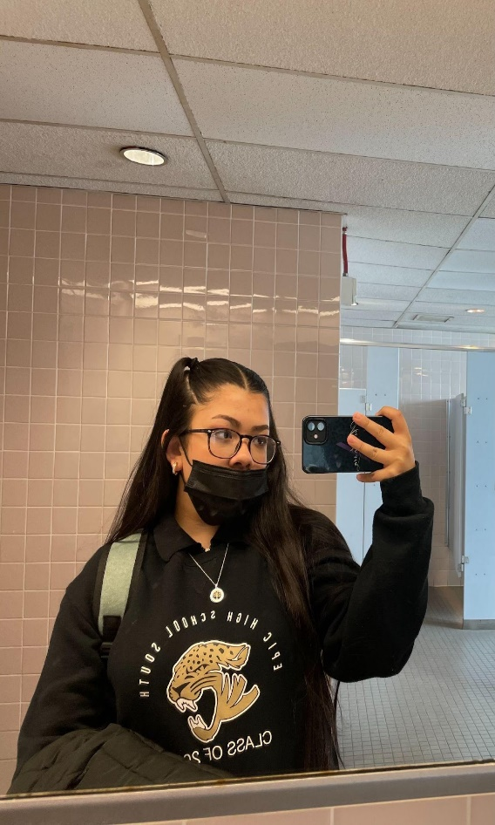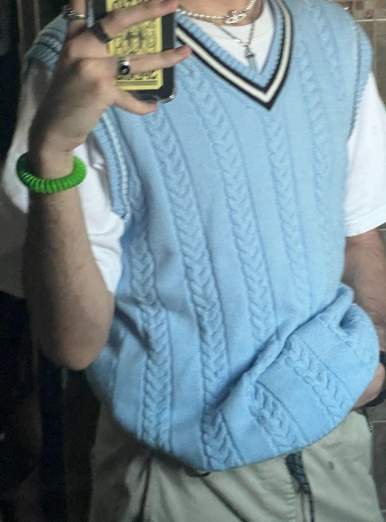

With this new found confidence, we used it to start testing out different clothing styles till we eventually found which ones suit our fashion sense best. The ones that we felt so comfortable and proud of that no one's disapproving glares would make us want to run. I started dressing slightly girly with more dark colors and he had a pretty boy/ skater boy look. But to our surprise once we came out of quarantine to a somewhat semi functioning world, not one person looked our way. Literally no one cared what Tom, Dick, or Harry was wearing. Seeing as when we started to reenter the world we were no longer in highschool and starting our first year of college it was also another big change of atmosphere. We no longer had to deal with the people we previously had to. We also had those artsy majors where most people expect you to dress differently or out of the norm. Mine being Business and Technology of Fashion, and his is literally Art.
With the change in mindset that everyone had during this time, where the only thing on everyone's minds is “are my loved ones okay?” and “what am I putting on the table for dinner?” No one cares to judge what the person next to them is wearing because their outfit will not impact your life in any way. Instead those judgemental facial expressions are hidden behind masks and no longer make people second judge their outfit choice. A quote I received from Jaiden while talking to him about his style change was “I'm not hiding anything or from anyone.” I found this to be very powerful and inspiring because we truly have nothing that we need to hide from anymore. Since everyone is now accepting, why not just be who you are?

