Final Letter Assignment Unit 3: Outline + Letter
December 1, 2021
Outline
Intro
- Identification
- Problem, crisis.
- Solution
- The purpose of writing this letter
Body
- Current situation
- Opposite ideas, reverse
- Research
- Connection between me & topic
Conclusion
- Urge
- Provides solutions

Online Learning Should Be An Option
To The Student Government Association.
Dear Student Governor:
As a CUNY student who is currently participating in online courses, I can feel the effectiveness of online learning and the convenience it brings to me. I knew that the majority of students think online learning can’t represent a physical learning experience. Due to the COVID effects and the Omicron virus that was discovered recently, we can’t make sure when our campus is going to open again. Therefore we have to find a solution to this hybrid mode and prepare for the next quarantine remote learning. Meanwhile, I think online learning is good for several students in certain situations. The purpose of writing this letter is to express what I think about remote learning. It’s important because most people have a bad impression of it and I wanted to argue about it. What I wanted to express is that online learning might be bad but there are some benefits we can apply after turning to the campus and the conveniences it brings that we can’t deny.
During the effect of the pandemic in 2021. I participated in the online courses. I realize several disadvantages of remote learning such as students won’t be able to socialize, as usual, students asking & answering questions with delays, students can’t hand in their homework without that realistic pressure that teachers give in physical classrooms. They are shy to put their selfie; they use other images to represent themselves. So are there any advantages to remote learning? I believed yes. The pandemic seems to push the progress of online studying and it makes education better.
In an NYtimes article, I discovered the benefits of remote learning provided and organized by a reporter. She interviewed several eighth grade students in her article. By reading through the situation of each kid, I figured out the benefits of remote learning. Online classrooms help introverted kids to speak in comfort, helping students avoid distraction from peers or vehicles on the street, students will gain the ability to study individually with recorded classes and materials, Students will be able to save commuting time to the school and the school will have more empty spaces on the campus. The reason why I wanted to say this is because I am currently participating in online courses and this is also the project that I have to research. It’s obvious that online learning has its advantages and it does not work for everybody. But we can’t get rid of options about remote learning.
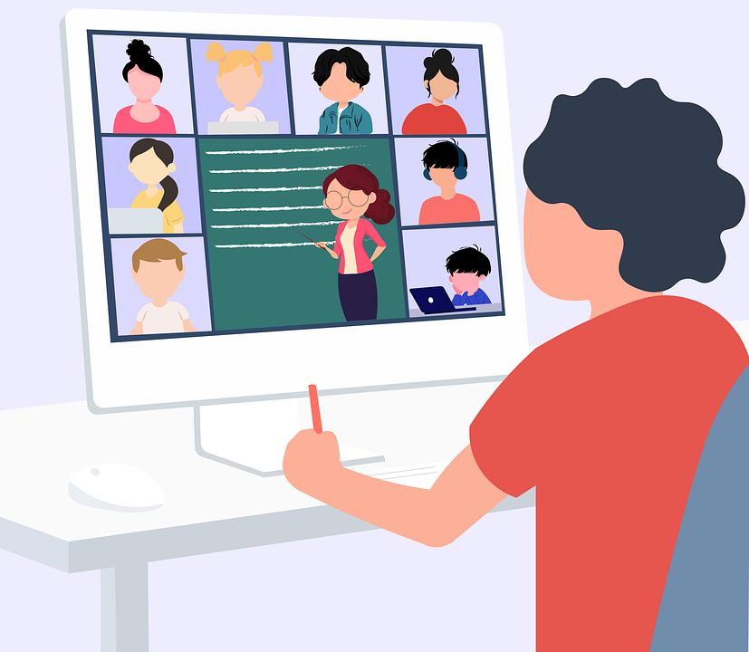
Online Learning Environment With Camera On

I suggest providing online courses as an option because it did work for some students and it’s more like a future way of learning. If we have to cancel online classes after the pandemic, at least we can be proficient in writing in WORD, and PDF files. We can’t forget the gain after the pain, then the pain will be pointless. We have to keep online learning as an option for students that have a higher GPA because they have proof that they got responsibility for completing their work. Therefore, they should have the right to choose their own schedule and work at their own pace.

Sincerely,

Fan Zhou

