Unit 3 Genre Assignment (Completed: 05/21/22)
Outline
The effects of COVID19 on Work-Life
- Some background on the most noticeable effects of COVID on life/work
  - Society
  - Personal experience with work at this time
- People focus on the physical
  - Provide details on what it means
- The transformation of the very idea of work
  - How did our ideas transform?
    - From what to what?
- Conclusion: Is it good or bad one way or another? Is it just how things are now?
Outline V2
II. Your background/experience with job searching
III. New requirements for getting hired somewhere
IV. Which jobs are ppl most likely to get hired for
V. How covid has changed our mindsets when it comes to working
VI. Conclusion
Job Hunters: What’s New?
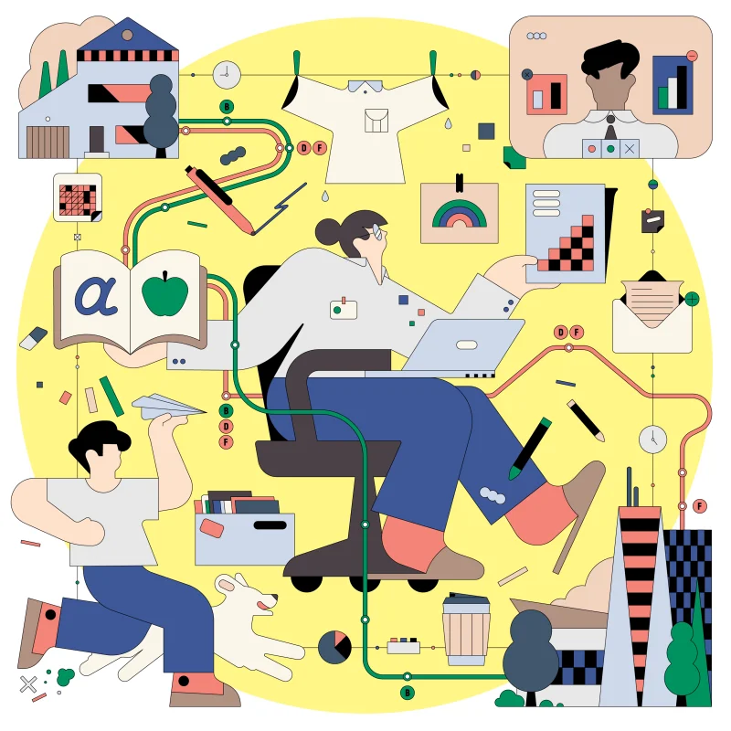

Dear Fellow Unemployed New Yorkers,

On the prowl for a side job to make some quick cash? Or are you a fresh college graduate looking to propel yourself into the workforce of your studies? Maybe you’re a college student trying to afford tuition for the new semester? Heck, you’re probably an unfortunate soul who got laid off from work due to new policies introduced because of the Covid-19 pandemic. I can assure you that I, as a struggling upper freshman of New York Citytech, can understand where you’re coming from. I’m here to educate you on how the job market has changed due to the Covid-19 Pandemic, for better and for worse.

I am a second-generation Haitian American, with my parents being the first generation from Haiti. Even though I was raised by Creole-speaking parents, I can’t speak my native tongue to save my life. And I can only understand a few phrases and words from the Creole language, while English is my forte. Even though I have Haitian blood flowing through my veins, I can never truly identify with my heritage and I feel more American than Haitian. I was raised in America, exposed to American culture, and I identify as American instead of Haitian.

Even though I identified as American, I was still subjected to the expectations of my Haitian parents, especially when it came to having a career and producing wealth. The main reason most immigrants come to America is the idea of giving your family a better life and making lots of money, with my father and mother latching onto those respective ideas. Though with my father, he also expected his children to make money for him. So at the ripe age of 16, I was pressured by both of my parents to start looking for a job, something that I didn’t care about since I was still a sophomore in High School at the time.

But to appease my parents, I wised up and took my first dive into the job searching process. It would only be until my junior year of high school that I would start my first “job”. Through a business workshop program referred to me by my brother-in-law, I received a six-week paid internship at the AIG Insurance Company in the summer of 2017. It was a…stressful job and helped me realize that desk work isn’t a good idea for me. My next job would be post-senior year in 2018, as a retail associate in a Primark store at Kings Plaza, Brooklyn.

Primark is an Irish multinational fast-fashion retailer with headquarters in Dublin, Ireland and they have just opened up a new venue in Brooklyn. There was a three-month training period that had me attending at least once a week before I and other employees were set off into the work field. Now this job was more my speed, since minimal effort to complete my tasks, which consisted of folding clothes, interacting with customers, and reorganizing shelves along with racks. I enjoyed the simplicity of my job and the small talks I engaged in with my fellow employees. Alas, I only worked there for three months due to the start of my college career in late August, which I wanted to focus all my time on.

For the next 1 ½ years I would keep myself out of the job economy as I focused on college, well into the time when the Covid-19 pandemic hit. It was in late 2020 that I decided to start job hunting again, though things had gotten extremely more difficult for me. Filling out job applications was easy, but getting an interview was near impossible, let alone getting hired. With the pandemic came new requirements and regulations, such as a certain amount of work experience and required vaccinations. I faced so many rejections that I fell into a period of depression, giving up on seeking work and seeing a decline in my grades. Thankfully, with the encouragement of my sisters, I was able to pull myself out of my rut and continue looking for a job.

My next and final job would come in the middle of my college career in 2021, as a retail associate at a Best Buy in Manhattan. This was my most recent job as I had started in October of 2021. I started with the basic training all entry-level employees got before being sent into the work field. My main tasks were similar to that of my Primark job, with the added responsibility of manning the registers. This job was a bit more intense as my superiors weren’t as lax as my Primark superiors, but I did what was asked of me and got paid for it. Unfortunately, I had to be let go in January of 2022 when a mandate was passed that required all employees to be vaccinated for them to continue working at Best Buy. And I’m not taking the vaccine for personal reasons.
Man, Covid has really rocked the job economy since it emerged, especially for New Yorkers. Did you know that New York has experienced double the unemployment rate compared to the rest of America? As stated in the article, “The ‘Double Whammy’ That Is Slowing New York City’s Job Growth” by Matthew Haag and Patrick McGeehan, “The unemployment rate in the US has plummeted to 4.2 percent, close to where it stood before the pandemic. Meanwhile, the unemployment rate in New York City is at 9.4, more than double that of the entire country”. That’s insane and according to the same article, we only gained 187,000 jobs in 2021 compared to 350,000 we gained in late 2020. (Link to the full article: https://www.nytimes.com/2021/12/14/nyregion/nyc-economy-jobless.html)

Scary, right? I know that has got me freaked out and worried about how things will turn out for my job searches in the future. But while there are some negative aspects in the job economy due to Covid, there are some positive ones as well. Let me tell you about them all:
- Covid has allowed some of us to take a step back from work and reevaluate our lives. According to the opinion article, “The Future of Work Should Mean Working Less” by Jonathan Malesic, “we ought to begin with the idea that each one of us has dignity whether we work or not. Your job, or lack of one, doesn’t define your human worth”. I believe this is a wonderful idea to have, especially in a society that places your worth on how much money you make or how far in your education you got. The same article also makes it a point to focus on what you want with your life and how much of your life you want your work to take up. (Link to the full article: https://www.nytimes.com/interactive/2021/09/23/opinion/covid-return-to-work-rto.html)
- According to the educational video, “The Future of Work after COVID-19” by McKinsey & Company, “Expect there to be a decline in low and middle-skill jobs like retail cashiers or teacher assistants. While also expecting an increase in high skill jobs such as teachers, engineers, and law enforcement officers”. This means that some jobs are going to be more valuable to society compared to others. This same video also stresses how important remote work is going to become in the future and that it's here to stay, which is honestly a good thing. Who doesn’t like the idea of being able to work from home? (Link to the video: https://www.youtube.com/watch?v=8KenNOYOiq4)
- Finally, if you’re struggling with finding work, relax. Don’t let it get to you if you don’t get that part-time job you wanted. Or if that company you wanted to start your career in doesn’t accept you. There’s always a risk of rejection, but you have to have perseverance and determination. Apply to at least 15-20 jobs a week to keep your options open, even if you’re applying to the same company. It shows them that you’re serious and may improve your chances of getting an interview and even being hired.

Sincerely,
Richard Gregory Bordes

