Haileson Smith
ENG 1101 D 10
Unit 3 Photo Essay Multi-Media Genre Project
May 1, 2022
NYC: Not Youth Compatible
When we hit the age where we decided we couldn’t stay with our parents anymore, we instinctively start looking for apartments online. Many of those apartments, however, are in a price range of 2000 – 4000 dollars which is unobtainable. During the pandemic, many people moved out of their parents houses and many new families were finding homes create new memories in. Now a lot of them are struggling to find new places to live in the city they’ve lived in for so long. In a city that never sleeps, there’s a constant adaptation being made. 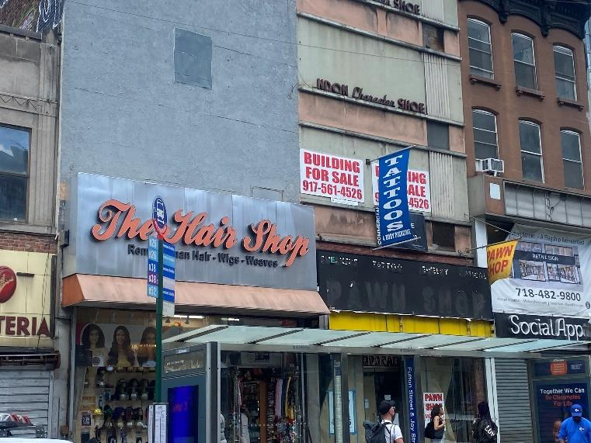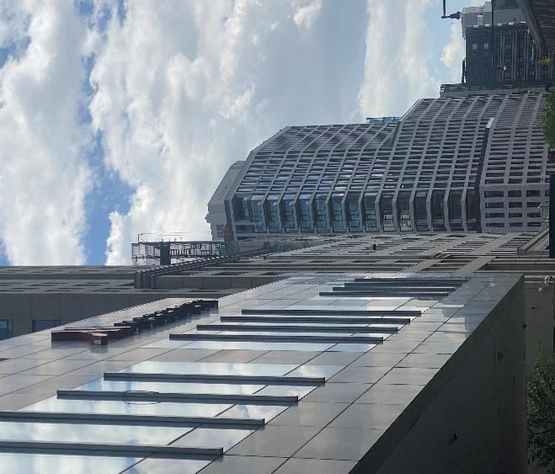
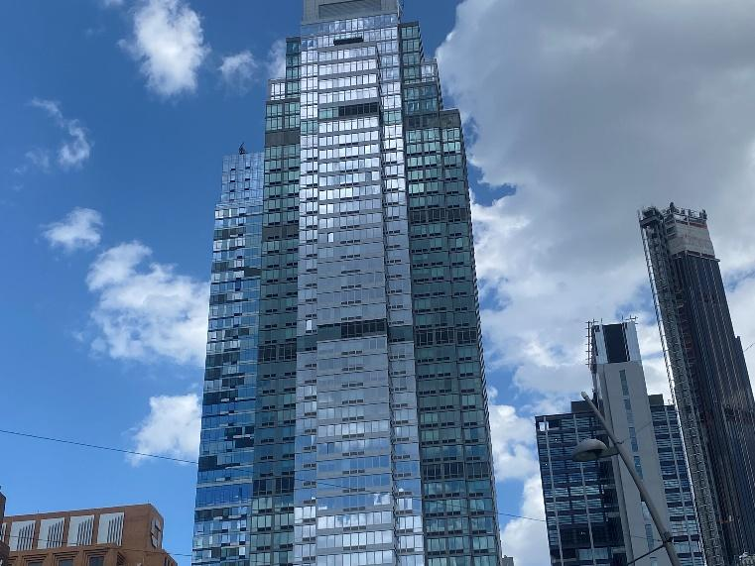These two picture were taken in the same neighborhood. The same area which is home to our school. A once bustling area where almost everyone in brooklyn has shopped and where a lot of people used to live. Now there’s sky rises and a false impression of a finacial district. 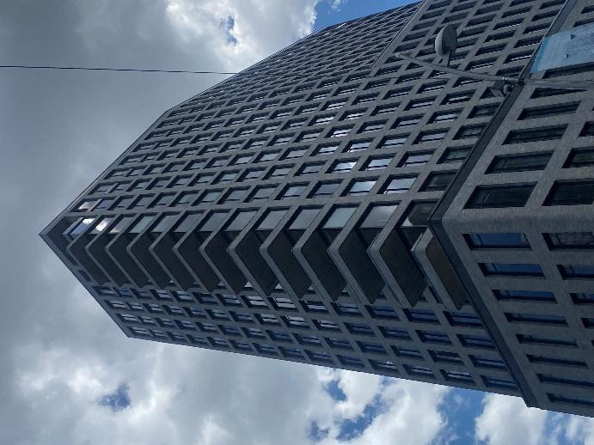
These buildings in question are not office buildings either. These buildings are actually apartments which house people using affordable housing. With this they can rent out multiple apartments to people who qualify for affordable housing while renting other apartments at market value. It gives an illusion of an affordable housing market without compromising the money made. The tenants paying full price are the real source of income and with yearly rent increases, renters with affordable housing wont be able to afford living in the building. Over the pademic theres been an increase in rental assistance. The emergency rental assistance program or ERAP is a program made for people who are in need of help with rent that are near eviction. As of March 2022, there are over 300,000 applicants who are in need. But the city cant fund these programs especially with the pandemic. With such a large influx of luxury apartments popping up all over the city, many people are forced to leave their homes and watch as their communties change into another business area. The most notable and controversial building would be 5pointz. 5Pointz was known to be the heart of graffiti in New York. Many people came from different parts of the world to see it and it was a staple in New York culture. In 2014 the building was completely painted white and in 2015 the building was demolished. In 2021, a new building was built using the same 5pointz name, though this building would look nothing like its former.
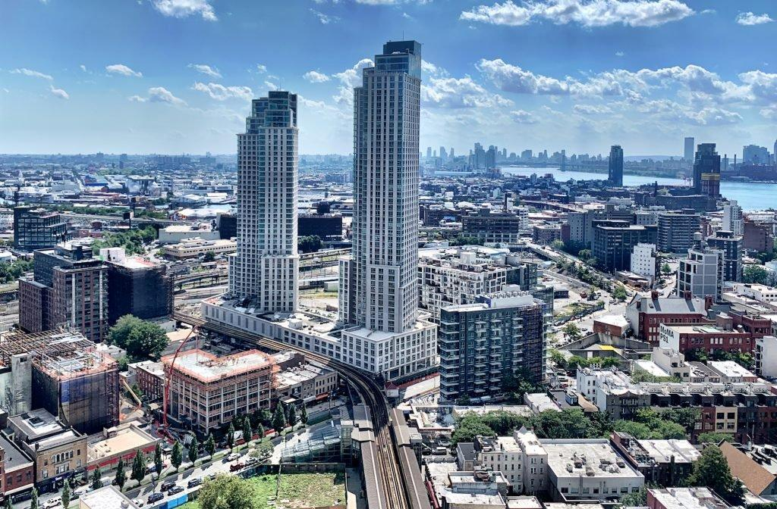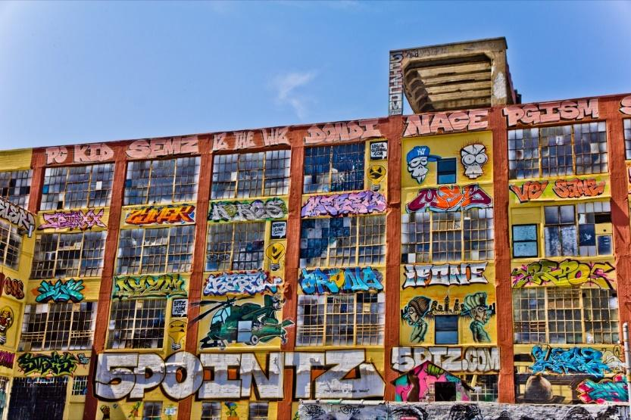
5pointz was turned into a luxury residential building with affordable housing. According to StreetEasy, a studio apartment in this building was recently rented out for $5,000. If these buildings were made to be affordable there wouldn’t be such a high price tag. Many of these luxury buildings are like this. 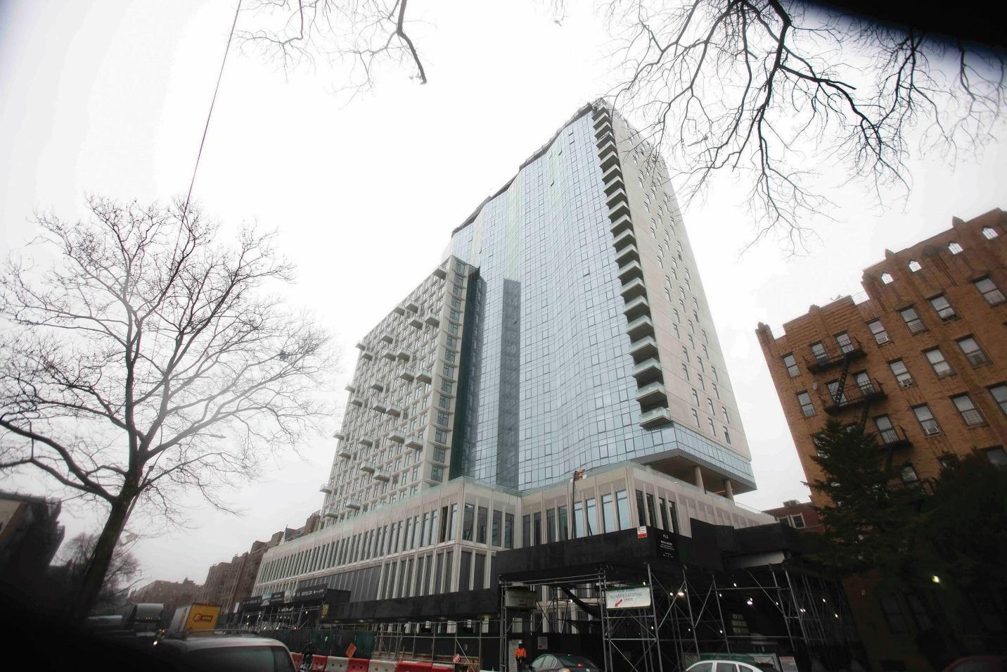
These buildings were opened during the pandemic. A lot of people were forced to move during the pandemic. So, with all these buildings around the city more people are inclined to sign up for these housing raffles. At 123 Linden Blvd, people moved in very fast over the two years it’s been open. Honestly, I wouldn’t blame anyone for wanting to live there. With all the amenities, it’s understandable. But the issue with all these buildings is that overtime the living cost increases. So, a question to be made is: Do these new residential buildings help the housing market? As a younger person in New York, my future living in this city may come to an end. We are the ones who must make a difference for our city now so that we’re comfortable in our later years.

Cited Works:
Smith, Rachel Holliday. “More Money? Pushy Landlord? Your Emergency Rental Assistance Program (ERAP) Questions Answered.” The City, 8 Mar. 2022, www.thecity.nyc/civic-newsroom/2022/3/7/22966363/new-york-city-landlord-emergency-rental-assistance-program-erap-questions-answered.
5Pointz LIC at 22–44 Jackson Ave. in Hunters Point. (2022). StreetEasy. https://streeteasy.com/building/5pointz-lic#tab_building_detail=2

