Lisa Wu
Professor Wu
ENG 1101 Co Req D 450
October 26, 2019
My Neighborhood Essay #2

Where I’m From Poem
Where I’m from, the brownstones have gardens spreading out in front. That’s why the neighborhood is called Carroll Gardens. Neighborhood parks are found every few blocks.
Where I’m from, the mom-n-pop shops have disappeared replaced by trendy cafes. I miss my Communist Bookstore where you could browse in the dusty corner shelves and find books stacked on the floor. I miss Andy’s Fruit and Vegetable Store where the old guys would just give me the over-ripe bananas for my banana bread. I miss Winn’s Discount where you could buy anything from watch batteries, to Halloween costumes, to oil decanters for reasonable prices.
Where I’m from, the sidewalk has become a battleground. Hipster moms push their princelings in big strollers and reckless unsupervised kids on scooters and skateboards careen over the sidewalk terrorizing pedestrians. Dog walking women yell at you if you don’t politely step sideways for their dogs.
Where I’m from, I’m lucky to have a rent-stabilized apartment. I wouldn’t be able to afford to live here if I had to pay the market price for rents.
Where I’m from, the local butcher store has a huge statue of a pig out front and the local pastry store makes the best cheese cakes and Italian cookies. Yes it’s an old Italian neighborhood, but the old Italians are slowly selling out to the yuppies and moving to Florida.
Where I’m from, the neighbors are connected through their politics.

My Neighborhood: Carroll Gardens Brooklyn

Carroll Gardens is one of the more desirable neighborhoods in Brooklyn. One reason is that it’s close to Manhattan. It’s four stops to the City on the F train and two stops on the 2,3 or 4,5 line. The streets are lined with trees, and every few blocks there’s a neighborhood park. People hang out on the stoops and some of the old Italians are still in the neighborhood. There’s a good community feel; it’s totally safe; and the schools are good.
Carroll Gardens is an upscale neighborhood, so I know that I am fortunate to live here and to have raised my family here. It’s only because I have a rent-stabilized apartment that I could afford to live in Carroll Gardens. I would never be able to live here otherwise. Having this kind of apartment is a lucky thing. It means I didn’t have to work full time, and I could be at home with my kids when they were small. The schools are good and so are the neighborhood parks. The flip side is that sometimes I feel like I don’t belong. People here are affluent, and sometimes the new residents are arrogant. But overall, I do like living in Carroll Gardens.
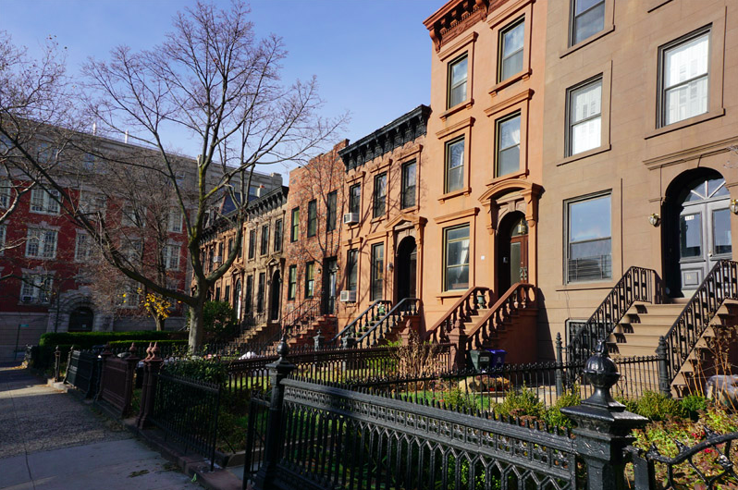

I started living in Carroll Gardens when I got married and started a family. So the places that are significant to me reflect my life there as a parent. Before I was married, I lived in many different neighborhoods and moved often. I never really had a sense of a place being my neighborhood, but when I began to be a mother, I had a more stable sense of neighborhood and home. For almost 30 years now, Carroll Gardens has become my neighborhood.
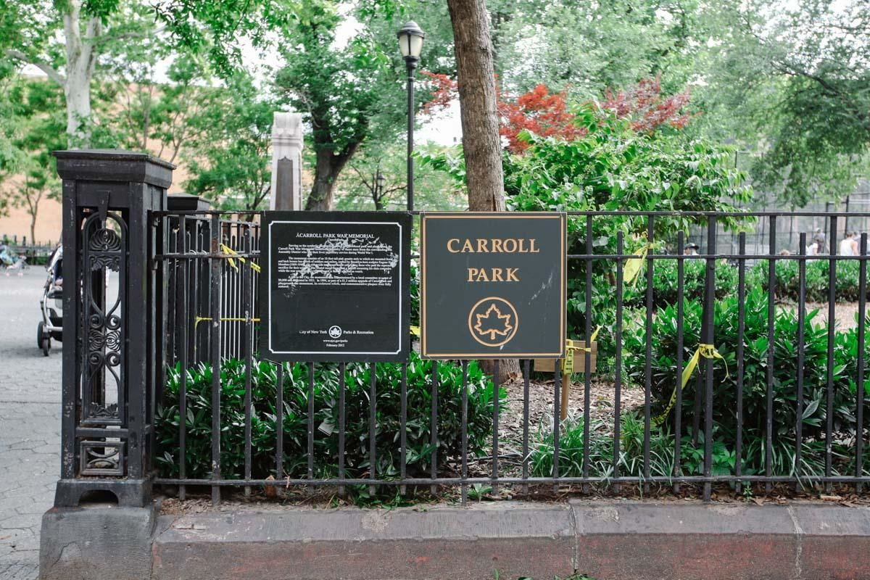
Almost every day, I took my kids to Carroll Park to run around freely and play in the playground. When you live in a small NYC apartment, your kids need a place to be free and just be kids and for us that place was Carroll Park. I even had a few birthday parties for my boys here. Once I invited the whole class for my son’s sixth birthday party. For that occasion I baked a cake in the shape of a dinosaur and served it up to about 30 kids. In the park, I made friends with other parents; we talked mostly about our problems while the kids ran around. The park is where everyone gathered and made friends.

I also spent a lot of time at the Brooklyn Public Library Carroll Gardens Branch. This library is one of the historic Carnegie Libraries funded by the Andrew Carnegie Corporation. Built in 1905, it has been around for more than a hundred years. My kids and I went to story readings, watched movies in the auditorium, and participated in arts and crafts and summer programs. Since I am a reader, I wanted my 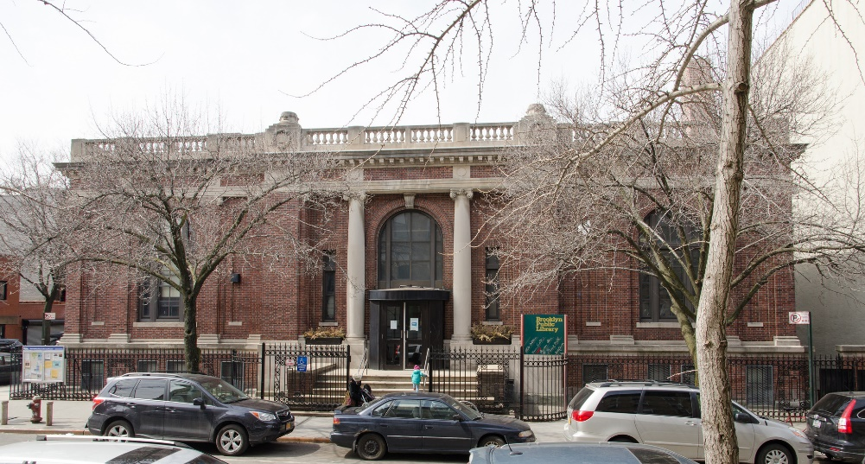

kids to love reading. Also since I am a teacher, I know how important reading is to academic development, and I wanted my kids to be good readers. We always went there to check out books and to do our homework. Today I even go to the library to concentrate on grading my student papers. We also made friends with the librarians. And to this day, we are still friends with the librarians. Just this summer we had a dinner get together with one of the librarians and her son who are now family friends.

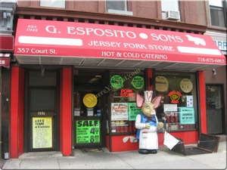
This is our neighborhood Italian butcher where I buy the best sausages for making tomato sauce. They also sell all cuts of pork, chicken, and beef, rice balls, special-shaped pastas, rice pudding, cans of tomato. The butchers at Esposito are chauvinistic, as Italian men are. They seem to wear their blood stained aprons with a sense of male pride as part of their tough guy image. They always call me “honey” or “sweetie” or “my love.” Maybe this is just their way of being friendly, but I think this attitude is old-fashioned and out of date. Of course our neighborhood is Italian, so that must explain this male chauvinism. It hasn’t scared me away; I do continue to be a customer. The best part of Esposito’s is the statue of the piggy that stands in the front of the store. All my kids had their pictures taken with him.
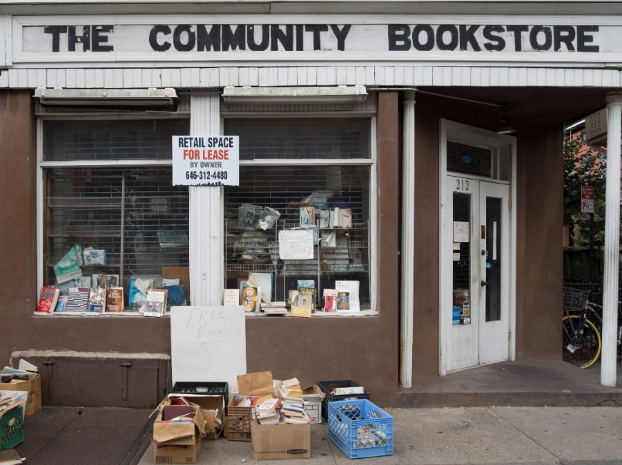

As you can imagine gentrification is happening in Carroll Gardens. Old places that I love are disappearing, and there are a lot of changes. One change that I lament is that my favorite bookstore is no more. There used to be a bookstore across the street from my old apartment on Court Street. I loved to go in there late at night; it was literally and physically across the street from me. The owner was an unkempt long-haired old hippie who always had a cigarette dangling from his lips. The place was dusty and smelled dank, musty, and smoky. The books were stacked on the floors in front of overflowing shelves. It was impossible to discover any order to the way the books were organized. Nonetheless, I loved just browsing and find anything that interested me. Finding a good book was serendipitous and that was the wonderful-ness of the place. The name of the store was The Community Bookstore, but I always called it The Communist Bookstore because the owner reminded me of Karl Marx. I miss my Communist Bookstore.

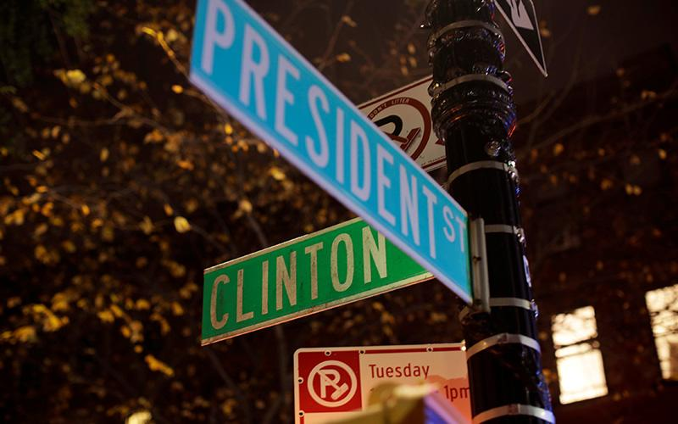

An interesting fact is that I live in Carroll Gardens, at the corner of President and Clinton. On election night 2016, our neighborhood was having a block party to welcome in the new presidency of Hilary Clinton, or so we thought. Everyone in our neighborhood was on the street that night. The kids were carrying Hilary signs; some were wearing Hilary costumes; and all the neighbors were in a festive mood. Food trucks were on the block selling hotdogs, fries, drinks, and other party food. A stage was erected on the corner with a huge TV screen broadcasting the news and the voting results state by state. Local politicians were giving speeches at the podium on stage. We were not worried one bit about the outcome. Who could have known it would turn out so differently? At 8:00 as the polls were being reported on the TV, the mood began to turn from celebratory to apprehension, to disbelief, to horror. By 10:00 all the neighbors had turned in, and I too went upstairs to my apartment. It was a sad, sad night, and it was a block party on my street that I will never forget.
The next morning I awoke, and I was depressed and in denial. I think the whole neighborhood felt that way too. All the neighbors were in collective grief and mourning on the morning after the election of Donald Trump. People in Carroll Gardens, we New Yorkers in Carroll Gardens, do not claim Trump as one of our own. So politics is one area that unites us all in the neighborhood. Carroll Gardens is a democratic, progressive community and that is one thing that connects us all in the neighborhood.
Having grown up in a small town, I am glad that my kids have grown up in NYC. From this little neighborhood, we could branch out and take advantage of all that NYC offers: better high schools in Manhattan, cultural venues all over the city, and friendships with diverse New Yorkers. A neighborhood forms who you are and gives you a strong sense of community. We are New Yorkers, but we are Brooklynites first. Looking back at my almost thirty years here, Carroll Gardens has been a good neighborhood for me. I am glad that I live in a Brooklyn neighborhood that has happy memories for me and my kids.

