Gentian Dumani
Professor Wu
Unit 3 OP-ED Piece
ENG1101 OP10

Wake up America! We need to extend the school year!
One day around the beginning of the Covid-19 pandemic I was lying in my room with my head facing towards the ceiling while listening to my teacher babbling on and on about the Civil war. I had not a single care in the world until my U.S history teacher announced an exam and I lunged myself up in a panic. I knew I was screwed because I wasn’t paying attention in her classes but I asked myself “Is it just me or is anyone even learning anything?”
My grades were dropping and I wasn’t learning shit. I wanted to know if it was just me that’s struggling or is it everyone. It was pretty hard to tell, especially when there's little to no communication between teachers and students so I took it upon myself to find out. Turns out it’s not just me, a lot of students around the United States face learning deficits. According to a report made by the Mckinsey company, students were four to five months behind where they should have been in the past and students who attended schools that were majority black or hispanic would be six months behind compared to white students. The corona virus has been devastating our education and us students and school districts need to act on it now. Once you have fallen in the quicksand it’s almost impossible to get out.
I want school districts to extend the school year. Now this might seem absurd to some students. Why would people want to attend school for longer? It may seem like a stretch but with the giant learning gap it's very necessary. In many of my remote classes I've seen the number of students drop as the year went on. My classes would have around 30 students and would shrink to just a mere 10. Many students were not learning and they could not keep up with the work the teachers assigned. Adding extra days to the school year can definitely eliminate a problem like this. With more time students will be able to go at their own pace instead of rushing for deadlines trying to hand in their work at the last second.
Learning loss can also have an impact on students' future opportunities. The door to success won’t be open forever. In the article “Extend the School Year to Counter Learning Loss” by The Editors they state that “The diminished earning potential of these students could cost the U.S. economy as much as $188 billion annually once they enter the workforce.” The article goes on to say the best way to prevent any future problems is that schools should provide students with optional summer activities to help counter learning loss. I agree with this. However, I believe that it should be enforced. If you present students with an opportunity like summer school around 90% of the school would refuse. Then what purpose do these summer classes have if no one attends them? School districts should be a little more stricter especially if many students are performing below average and nothing is being done about it.
Did you know that students in China outperform students all around the world? In a study conducted in 2018 by the Organization for Economic Co-operation and Development. They administered tests to over 79 countries and compared the results. Students from the four provinces of China ranked the highest. On the other hand, students from the United States ranked dead last.
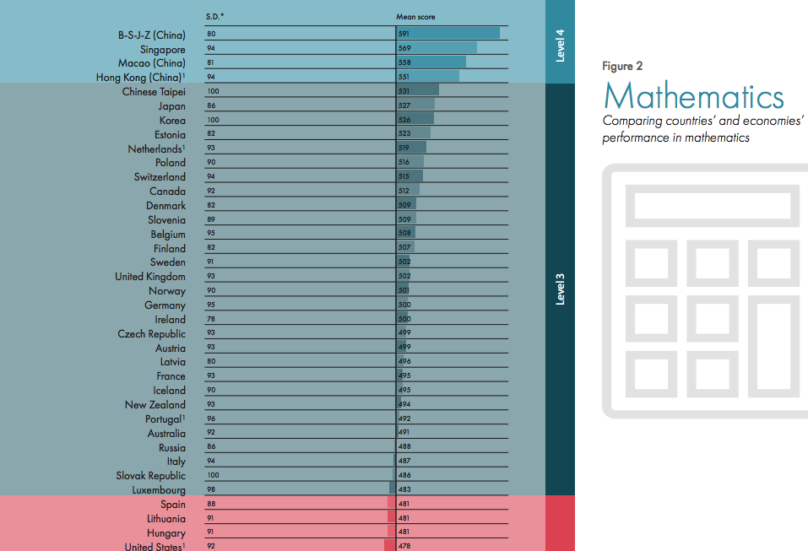
This study was obviously conducted before the Covid-19 pandemic but I can only imagine results have gotten worse since. In the article “China’s school kids beat American students in all academic categories” by Stephen Johnson he states that “the results showed American performance in reading and math has been flat since 2000. That suggests that federal initiatives like No Child Left Behind and Common Core — which have cost billions of federal and private dollars — haven’t improved education quality in the U.S.” THERE HAS BEEN NO CHANGE IN ABOUT 20 YEARS! If we want to see results we need a major change in the education system and I believe that if we extended the school year we would see that change. In China the school year and the school day is significantly longer than in the United States averaging about ten hours. That's four hours longer than the average in the United States. China has some of the smartest students in the world and if the United States extended the school year they would rank significantly higher.
Going to school for a little bit longer wont kill you. Your education is the stepping stone to your success. If that platform is missing, where are you going to go? Younger students may not realize it at first but they definitely will be aware when they struggle as time passes. Us students and school districts need to work together. We need to make a change. We need to extend the school year!

