OUTLINE:
Introduction Part
- Salutation to NBA Fan Club
- Identify myself: NBA Fan, long time for 8 years, my 3 bros, my dad and I are NBA huge fans, watching the NBA is a huge part of my family life.
- Message / purpose: Tell fans to do everything they can to help the NBA get back normal: Vaxed, attend games for real,
- Message is important because help the NBA survive, get as close to normal as possible as fast as possible.

Body part:
- Last season NBA moved to bubble Disney and other changes bc of pandemic (refer to research – link). Loss of money.
- Some problems – some important players not all vaxxed – interfered with the success of team spirit. Refer to our research.
- Loss of jobs in the stadiums
- The changes the NBA instituted for safety and to allow fans back
- Report on positives of fans coming back to the game.

CONCLUSION
- Message be patient, have faith
- What the fans can do to make things as normal as possible.
- Encourage the fans to do everything in their power to help the cause
- End on a hopeful note!

Amadou Diallo
ENG 1101CO LC44
Final Letter

Dear NBA Fan Club members,

I have been a devoted NBA fan for eight years. In fact, I belong to a family of NBA fans. My three brothers, my father, and I have heated arguments and debates about our favorite players, teams and projections for the season. Watching the games is a huge part of my family life. Being an NBA fan myself I can say that I was very disappointed and saddened when the NBA season was suspended due to the Covid-19 virus outbreak. Not only is the NBA a source of entertainment for fans, but it’s also a sport that requires the fans' energy and spirit live in the stadium and behind the TV screens for the NBA to peak.
When the NBA season was suspended due to the pandemic, I had no idea when it would be back because this was the first time something like this had happened. I was gravely disappointed for a while because the NBA gave me a source of entertainment for three hours a day several days in a week and was the reason for a lot of competitive arguments between my friends and me. I have friends who always looked forward to going to NBA games because of the excitement of watching elite players and cheering or booing alongside other fans in the arena. I have friends who bet on NBA games regularly through Fanduel as well who were upset after the suspension. I am writing to tell you to be patient about the NBA getting back to normal. It will gradually recapture the spirit that separates the NBA from all other professional sports leagues!
It is not only the fans who have suffered as a result of the Pandemic. NBA teams have been victimized as well. For example, although there are no vaccine mandates in the NBA, there is pressure on NBA players to either get vaccinated or lose privileges. While fully vaccinated players don’t have to be regularly tested and can sit together at team meals, during travels, and in the locker room, unvaccinated players face mandatory testing on all practice days and game days, and are often excluded from the gatherings of vaccinated players. Clearly, this type of discrimination negatively impacts team chemistry.
Another consequence of Covid is a diminished potential for team success, specifically with regard to the Brooklyn Nets, New York Knicks, and Golden State Warriors. In these cities (New York and San Francisco), being vaccinated is required to play in NBA games. In the case of the Nets in particular, the team has lost Kyrie Irving due to his unwillingness to get vaccinated. While the Nets were the frontrunners for the championship with Irving, they now have to reconfigure and find a way to be a successful team without this key player. This is also a loss for the audience. Irving is a major talent, and NBA fans will not be able to see him play.
On March 11, 2020, due to the pandemic, the NBA was suspended for several months. After that, the league eventually came back with games played in the bubble in Disney World, where fans were not allowed. This was the first time we would watch the NBA without any fans in attendance and the energy they brought with them. This wasn’t the NBA we fell in love with, but a new NBA we could not and will not accept. The truth is the fans of the NBA are the most important people when talking about what makes the NBA so electric. Not many people realize this, but because of the absence of fans many people lost their jobs. According to concession stand worker Leila Williams, “Thousands of people across the U.S. are jobless including myself” (Sanchez). Stadium workers have been put out of work by the thousands as an unintended consequence of this shutdown. The NBA provides countless jobs, and just like the people on the business end of the league and the players, these people have been affected too.

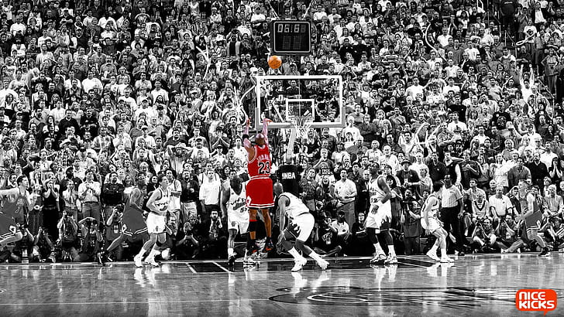 Packed arenas are now on the rebound as the NBA strives for normalcy.

Since the start of the pandemic in 2020 until now, the NBA has progressed greatly. The NBA is allowing fans back in the arenas and everybody involved in the sport is a lot more happy. This is due to the covid vaccines and the responsible actions the NBA and the people of the U.S. have taken. Before the start of this season Commissioner of the NBA, Adam Silver said, “If vaccines continue on the pace they are and they continue to be as effective as they have been against the virus and its variants, we’re hopeful that we’ll have relatively full arenas next season as well” (Reynolds). He has said since the start of the recent season that all the NBA games have involved many fans and almost full arenas. The energy that was once lost is back again and putting smiles on our faces. But the NBA isn’t back to normal just yet because the Covid virus is still a scary reality. With that being said, the NBA keeps taking bigger steps as time goes on, and I have no doubt that the NBA and my fellow fans will enable the league to return to relative normalcy in the near future. However, in order to ensure this, we must all take action!
I call upon all NBA fan club members to attend basketball games whenever possible. Increased fan attendance will re-energize NBA teams and their players, increasing much of the enthusiasm that has waned. Additionally, it will increase revenues, which are important for the game to thrive and for NBA workers to be employed. Further, I encourage all fans to get vaccinated in the hopes that the NBA can avoid any future shutdowns. It is also important for all of you to write to unvaxxed players and persuade them to get vaccinated because vaccinations are safe and effective. We do not want elite players to be sidelined due to Covid outbreaks or laws that prohibit unvaccinated players from taking the court. If we all play a role in the fight against Covid and unite in a collaborative effort to restore the game of basketball to its former greatness, we will once again enjoy the thrills of watching the incomparable drama and competitiveness that embody this sport.

Sincerely,
Amadou of the NBA Fan Club

Sanchez, Brandon. “The Importance of Fans in the NBA.” The INews Network, https://inewsnetwork.net/8170/sports/the-importance-of-fans-in-the-nba/.

Reynolds, Tim. “NBA may return to normal in ‘21-‘22, virus permitting.” Associated Press, “https://apnews.com/article/nba-basketball-adam-silver-coronavirus-pandemic-e8e99c59e32a79925b81b353bdb96e7b

