Instructions to make the Peanut Butter and Jelly Sandwhich:
Make sure all ingredients have arrived to the venue and nothing is broke. You should have:
- One(1) Jar of Peanut butter
- One(1) Jar of Raspberry Jam
- One(1) Silver knife
- Two(2) Slices of bread
- One(1) White plate
- Two(2) Plastic spoons
- One(1) Paper Towel
*If a jar is broken or something is missing please call 718-619-3507 so we can send it over*
Follow these Instructions to make the PBJ sandwich:
Step1: Lay paper towel on table.
Step2: Place the two(2) slices of bread on the towel side by side.
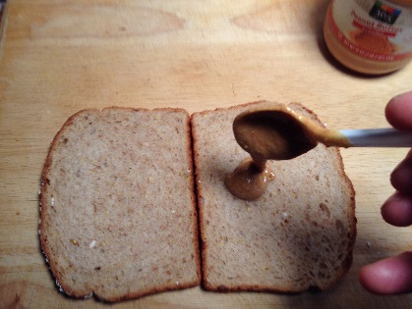
Step3: Using one plastic spoon, put 3 spoon fulls of Peanut butter on one slice of bread.
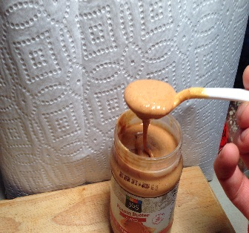
*Just like the picture*
Step4:Spread the peanut butter on the bread with back of spoon *just like picture*
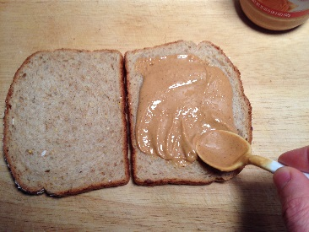
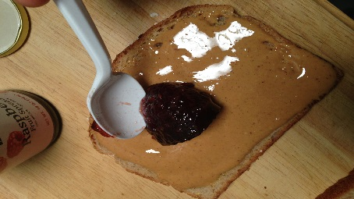
Step5: Use second plastic spoon and put 3 spoonful’s of Raspberry Jelly on top of the peanut butter.
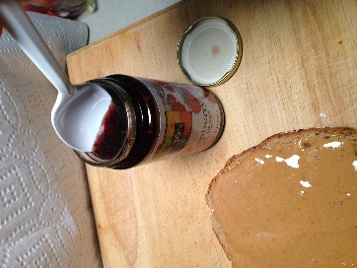

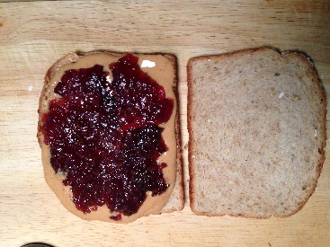
Step 6: Spread the Jelly with the back of the spoon.

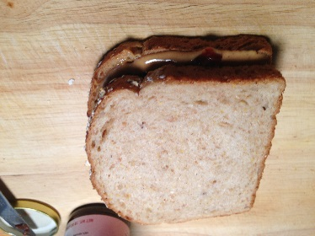
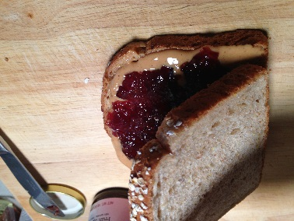
Step7: Place the other slice of bread on top of the already spread peanut butter and jelly. Push down gently to allow the peanut butter and jelly to ooze out the sides just a little.

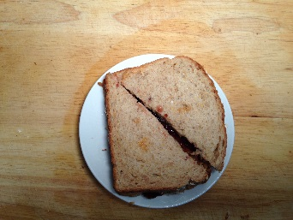
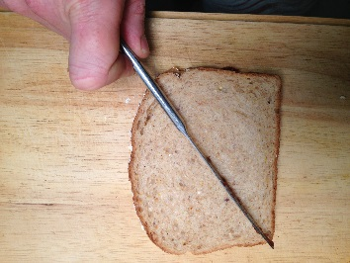
Step8: Place the Sandwich on the plate and cut a diagonal cut from one corner to the opposite corner.

Step9: Place one half of the sandwich on top of the other half and center on plate.
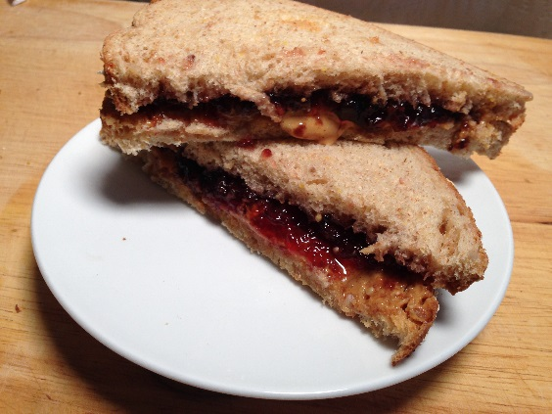
*Use picture as reference*

Step 10: Place a small amount of peanut butter on the knife and a small amount of jelly on the knife and place on plate.

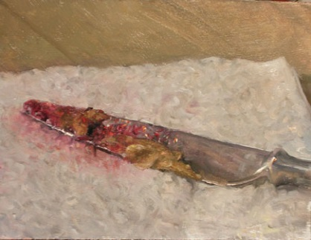
Last Step: Throw away the two plastic spoons, put in a garbage can. Throw away paper towel and put in garbage can. Replace the lid for both the peanut butter and the jelly jars. Make sure the plate is clean and the sand which looks presentable.

