Some of the images below will be a continuation from chapter thirteen How to Build a Network
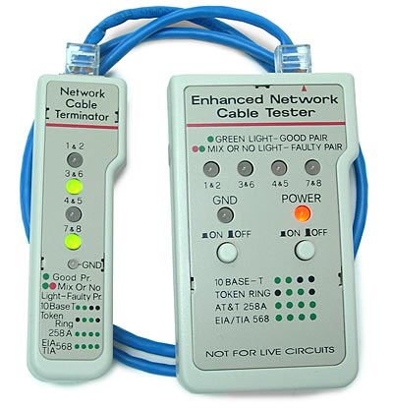
Image 1 of 3

A device that is used to test the strength and connectivity for cable or other wired

Cable Tester (optimus5.com)
Optimus 5 Search - Image. (n.d.). Retrieved November 12, 2015, from http://optimus5.com/index.php?page=search/images&search=lan cable tester&type=images

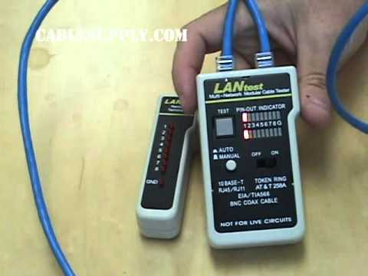
Image 2 of 3
Image two is also, a cable tester it does the same work, but looks a bit slightly different. ( I chose to use this picture this way if my students see two cable tester that look different they will know that they both do the same task).

LAN cable tester (www.youtube.com)

Cable Tester Product Review. (n.d.). Retrieved November 12, 2015, https://www.youtube.com/watch?v=bfp7oskfDXY
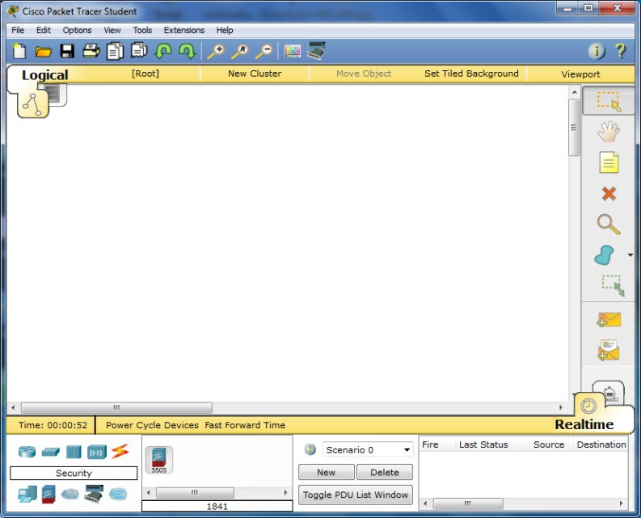
Image 2 of 3 (phongdl.uit.edu.vn)

Image two is a software application that helps students to practice how to build a network.

I chose to make this image large this way viewers will see all the detail of the software much better.

Cisco Packet Tracer Student 6.1, 6.2 (Windows). (n.d.). Retrieved November 12, 2015, from https://phongdl.uit.edu.vn/thu-thuat/windows/153-cisco-packet-tracer-student-61-windows.html

